**SURGICAL TECHNIQUES:**

Surgical techniques may differ slightly since several factors can influence the method of choice. One such factor is the age of the animal.

**Dehorning** **methods** vary by age of animal and stage of horn development.

**Disbudding methods** such as caustic paste and hot iron can only be used in calves under two months of age, before the horns attaches to the skull.

**Mechanical dehorning methods** can be used on horns at any stage of development.

Each method has advantages and disadvantages.

Please check the links attached below:

* [**Caustic Paste Disbudding**](http://www.dehorning.com/dehorning-methods/caustic-paste-disbudding)
* [**Hot-Iron Disbudding**](http://www.dehorning.com/dehorning-methods/hot-iron-disbudding)
* [**Knife Dehorning**](http://www.dehorning.com/dehorning-methods/knife-dehorning)
* [**Tube, Cup or Spoon Dehorning**](http://www.dehorning.com/dehorning-methods/tube-cup-or-spoon-dehorning)
* [**Barnes or Gouger Dehorning**](http://www.dehorning.com/dehorning-methods/barnes-or-gouger-dehorning)
* [**Keystone or Guillotine Dehorning**](http://www.dehorning.com/dehorning-methods/keystone-or-guillotine-dehorning)
* [**Obstetrical or Embryotomy Wire Dehorning**](http://www.dehorning.com/dehorning-methods/obstetrical-or-embryotomy-wire-dehorning)
* [**Hand Saw Dehorning**](http://www.dehorning.com/dehorning-methods/hand-saw-dehorning)

Table: The advantages and disadvantages of the different Dehorning methods.

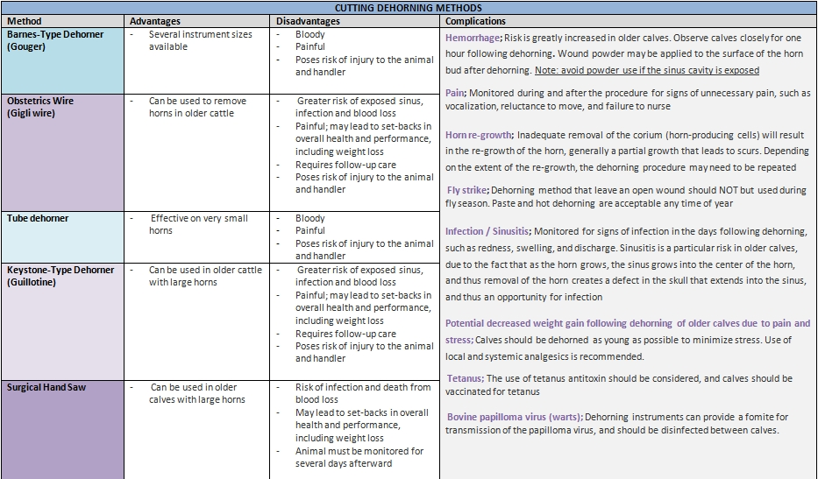

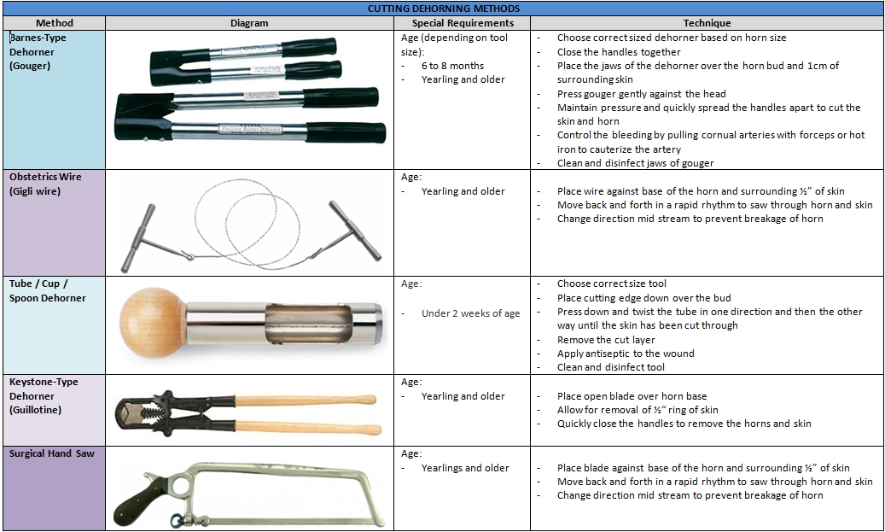

NERVE BLOCK

We proceeded to do a nerve block, specifically to **cornual branch of the lacrimal nerve.** 10mls of **2% Lidocaine** was administered under the **ridge of the frontal bone** on both the left and right side with an attempt at blocking the said nerves so that the base of each horn bud would be desensitized.

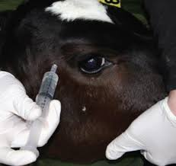   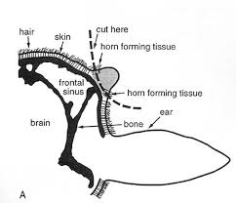

This was followed by pricking around the base of each horn with a 22 gauge needle several times within 10 mins (onset time), to confirm successful attempts of the nerve block.

N.B. Caution was observed not to exceed the toxic dosage of lidocaine calculated at 60.5 mls for this animal. Half the toxic dose was calculated to be 30.25 mls therefore we tried not to exceed this value.

This procedure was then repeated as our first attempt to completely desensitise the horn-base was unsuccessful. Even our second attempt deemed unsuccessful, which then forced us to do a ring block on each horn-bud, to which we eventually gained success.

**Persistence is key!**

The right horn bud was then removed using the Gigli wire. We then proceeded to remove the left horn via the Barnes dehorner. Both methods were bloody/involved blood. We withheld the vessels with a hemostat and the cauterizer. The cauterizer was then used to achieve a ´copper ring´ at the base of where the horns were - which indicated the killing of the germinal cell layer (successful dehorning). The excess blood was cleaned off using gauze and gauze sprayed with Tetravet (antibiotic spray) was placed into the sinuses which were now opened. Tetravet was also sprayed around the area of the horn as well as anti-screwworm spray. A second dosage of Pen/Strep was also given because of the opened sinuses.