Electric Hot Iron Dehorner

What is a Hot Iron Dehorner?

Hot iron dehorners are available in versions heated by a furnace or fire, 12-volt battery, 120-volt electricity, power packs (e.g., Buddex™). The head of the iron is a hollow circle and it fits over the horn bud. Proper application of the hot iron will destroy the horn-producing skin at the base of the horn. This technique works well for calves up to 12 weeks old. There are several sizes of dehorning irons. The proper size is one where the burner makes a complete ring around the base of the horn. For electric irons, use a short extension cord as voltage drops with a long cord, limiting the amount of heat generated by the dehorner.

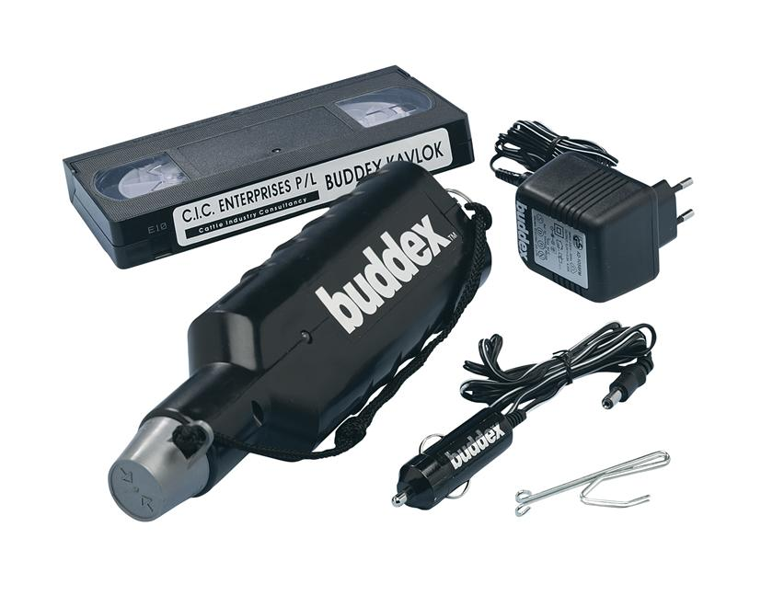*- Buddex dehorner available with power packs.*

Technique for Hot Iron Disbudding:

* Administer sedation, analgesia and local anaesthetic.
* Preheat the dehorning iron to a red colour. Both electric and gas irons work best when they are "red" hot.
* Wear gloves to protect your hands.
* Hold the calf's ear out of the way to keep it from being burned.
* Place the tip of the burner over the horn and apply slight pressure. When the burning hair begins to smoke, slowly rotate the dehorner by twisting your wrist.
* Continue the application of heat for 10-15 seconds. Do not leave the dehorner in place for much longer, especially in young calves. Heat can be transferred through the thin bones of the skull and damage the calf's brain.
* Dehorning is complete when there is a copper-coloured ring all the way around the base of the horn.
* The horn bud or button will slough off in 4 to 6 weeks.

Video link for procedure:

<https://youtu.be/bH9l4RB6r-4>

**Advantages:**

* Bloodless,
* can be used in calves up to four months of age.

**Disadvantages:**

* More painful for the animal than caustic paste
* iron may fail to get back up to heat between calves, resulting in ineffective disbudding
* requires more physical restraint of animal than paste disbudding
* poses a risk of injury to the handler.

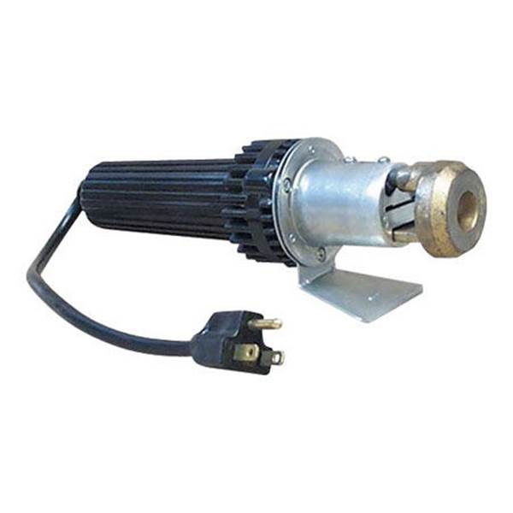 - *Electric dehorner*

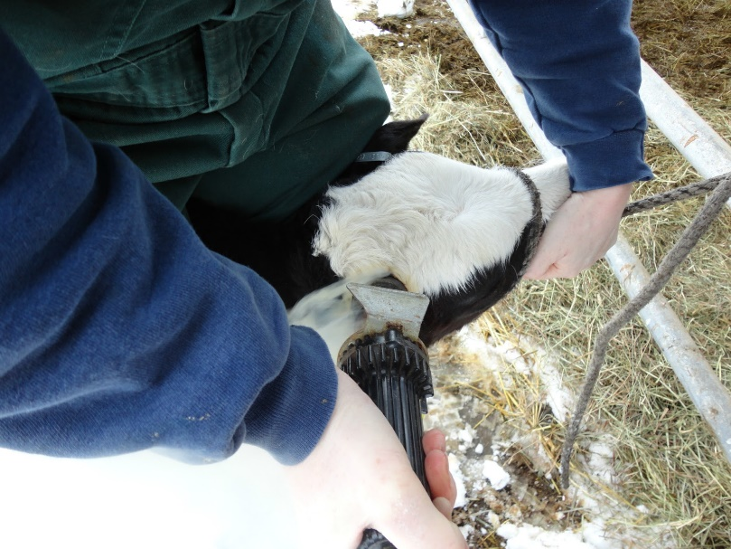 *- picture demonstrating use of an electric dehorner.*

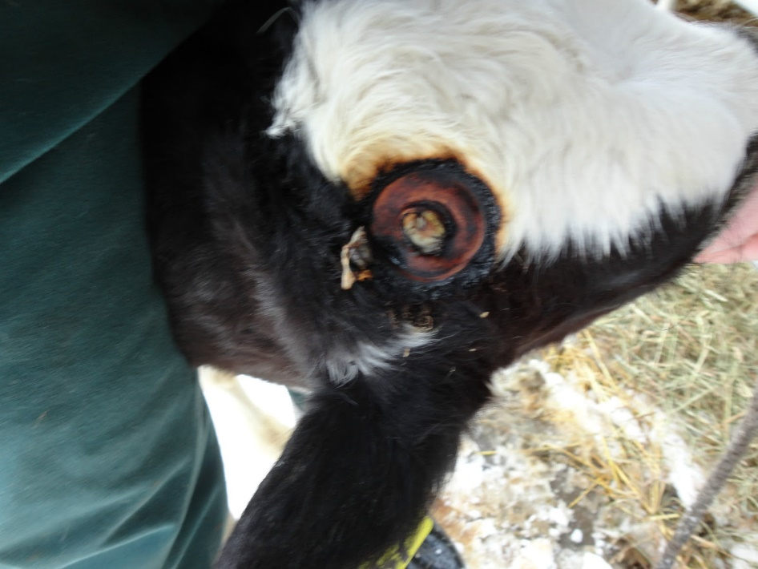 *- picture showing the copper ring all around indicating destruction to the horn producing cells and completion of thee disbudding procedure.*