Barnes “Gouger” Type Dehorner

What is a Barnes Type Dehorner?

Barnes Type dehorners are used for calves ranging in age from two to four months with horns up to four inches long. Some operators claim better dehorning with a rectangular-shaped scoop because it removes an even ring of skin around and with the horn bud. When used properly, it does not go too deep, but the dehorner can open the frontal sinus when used at the top end of the age and horn-size range. The blades must be kept sharp for best results.   
  
**Technique for use of a Barnes type Dehorner**

1. Administer sedation, analgesia and local anaesthetic.
2. Close the handles together.
3. Place the jaws of the dehorner over the horn bud. The objective is to completely remove a ring of skin surrounding the horn base. Therefore, adjust the opening as needed (Figure 7).
4. Press the gouger gently against the head. Maintain the pressure and quickly spread the handles apart to bring the blades together to remove skin and the horn bud.
5. Control bleeding by pulling the artery with forceps or using a hot iron to cauterize the artery.
6. Clean and disinfect the jaws of the gouger between calves.

*In lab, a hot iron dehorner was used to cauterize a ½ to 1 inch of ring of skin around the horn after the removal of the horn until a copper ring was formed indicating that the horn producing cells would’ve been thoroughly destroyed.

Video Link:

<https://youtu.be/Fg4qCwq58nQ>

*skip video to 2:40 for preparation and execution of dehorning using Barnes Type Dehorner

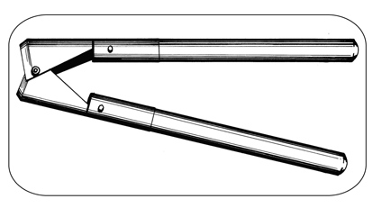*- A Barnes-type dehorner scoops the horn and horn-producing skin surrounding the horn base.*

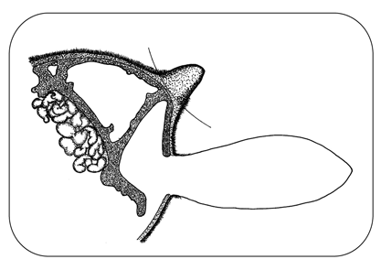- *With young calves, the Barnes-type dehorner removes horn-producing skin but does not cut into the frontal sinus as shown by the arced line in picture. In older calves with the horn attached to the skull, the dehorner cuts into the frontal sinus.*

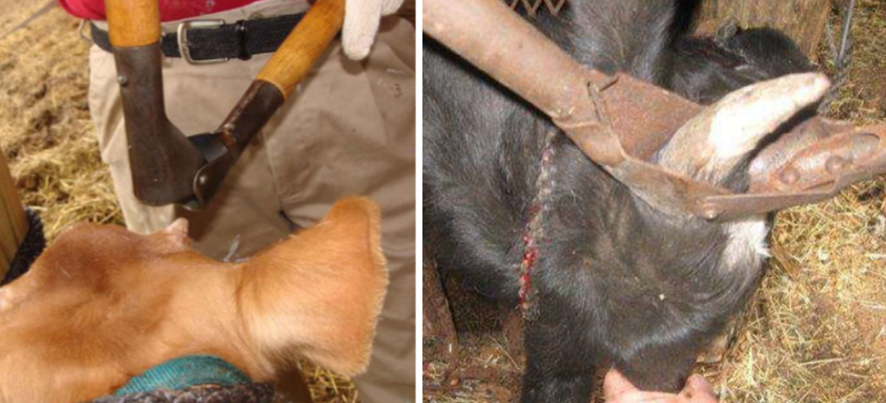 *- Images showing use of a Barnes Type Dehorner for dehorning in calves*

**Advantages:**

* fast - takes a few seconds to perform
* useful after the horn bud attaches to the skull
* Several instrument sizes available

**Disadvantages:**

* not bloodless
* risk of infection because of open wounds
* opens the frontal sinus in older calves
* unreliable when done incorrectly, leads to scurs
* requires expertise - anaesthesia, sedation, analgesia and technique
* requires control of bleeding - pulling arteries or cautery
* poses risk of injury to the animal and handler.