Anatomy of the growing horn

Ref link: http://www.thebeefsite.com/articles/2261/dehorning-of-calves/

### http://www.brahman.com.au/images/information/technical/general/dehorning1.jpg - *YOUNG CALF*

*The horn grows from the skin around its base – at different rates with different breeds. The horn bud is usually free-floating in the skin over the skull base in calves less than about two months old.*

*As the calf gets older, this horn bud attaches to the skull bone and a small horn forms.*

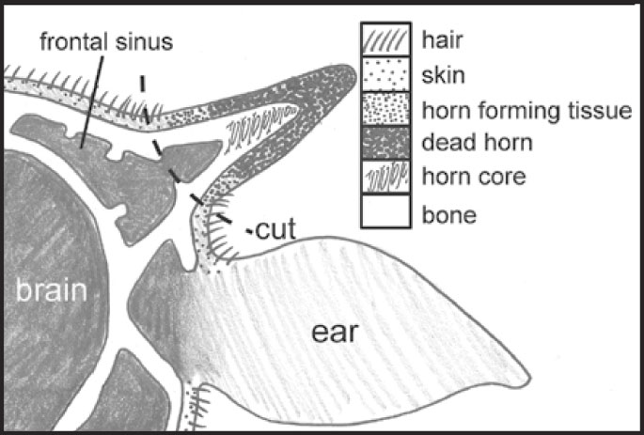 ***- OLDER CALF***

*After the horn bud attaches to the skull, the horn grows out from under the skin. It becomes a bony extension of the skull with the hollow centre of the horn opening into the frontal sinus. The brain lies directly under the frontal sinus covered by a thin layer of bone.*

*Dehorning after the horn attaches increases the risk of entering the frontal sinus and subsequent infection*.

## ***THE KEY TO SUCCESSFUL DEHORNING***

*Applies to all methods. Because the horn grows from the skin around its base, you must remove or destroy a complete ring of hair (1cm wide) around the horn base. Check that the excised ring is wide enough because some horn will grow if the ring is not complete. A 1cm wide ring of hair is enough – any more will make a larger wound, cause avoidable pain, and delay healing.*

DIAGRAM A & B: Locations of where to cut when dehorning.





DIAGRAM C: Location of nerve blocks for dehorning in goats



DIAGRAM D: Location of nerve blocks for dehorning in cattle

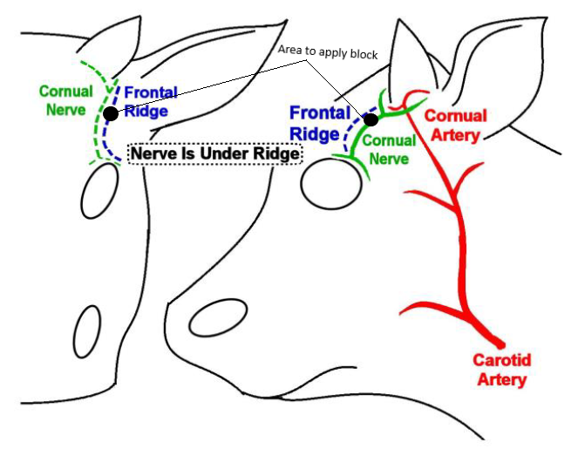

*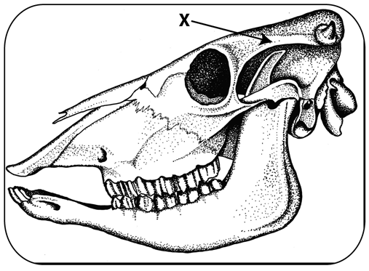-  "X" marks the location on a bovine skull of the midpoint between the horn base and the outside corner of the eye. Anaesthetic is injected beneath the ridge of bone shown with the X and arrow in the figure.*