Caustic Debudding.

What is Caustic Debudding?

Caustic chemicals will prevent the growth of horns when properly applied to the horn buds of calves (eight weeks of age or younger). The caustic chemical (such as potassium, sodium or calcium hydroxide) destroys the horn-producing cells by cauterizing the tissue around the horn bud thus preventing horn growth. The chemicals are can be applied to the bud with a wooden applicator by paste syringe or a moistened stick. To protect oneself, wear gloves when applying the chemicals. To protect the calf, avoid application near its eyes. Do not use caustics in rainy weather.

Technique used for Caustic Debudding

* Administer sedation, analgesia and local anaesthetic.
* Expose the horn bud (about the size of a 5-cent piece) by pushing the hair back.
* Apply the caustic to the horn button. Use a wooden applicator. Apply a thin layer.
* Re-position the hair over the paste and horn bud - i.e., cover the horn bud.
* Although the package insert may instruct operators to clip hair at the horn bud, experienced operators have shown that not clipping hair is preferable, because the hair keeps the caustic in place, reduces the risk of irritation to the cow’s udder and flanks and reduces irritation to other facial skin of the calf.
* Protect the calf and the cow from accidental caustic burns. One method is to place a patch of duct tape over each horn bud. The duct tape usually falls off in a few days. For dairy calves, keep in individual pens.
* In some countries, the technique is only permitted in calves less than eight days of age.

**Advantages:**

* Bloodless
* non-invasive
* less painful than hot-iron disbudding
* less risk of injury to the calf handler

**Disadvantages:**

* Calf cannot be exposed to rain or allowed near other animals for six hours
* cannot be used in calves over eight weeks of age

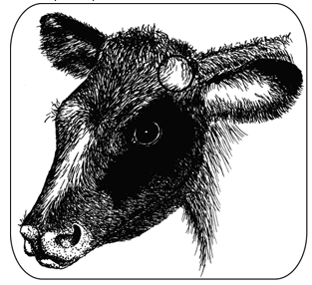 - *The circle at the base of the ear shows the location of the horn bud in a young calf. The horn bud is readily visible after pushing back the hair. Reposition the hair over the paste and bud after applying the dehorning paste.*

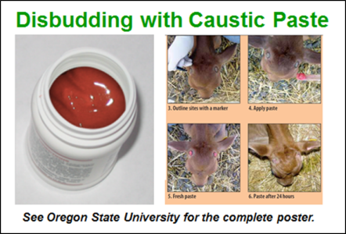 *- effects of caustic paste on horn buds.*