To administer Pen- Strep (Combikel®):

* Dose: 20,000 IU/kg
$$Volume=\frac{Weight ×Dose}{Concentration}$$

* Concentration: 200,000 IU/mL
* Weight of Calf #243: 160kg

$$Volume=\frac{160 kg ×20,000 IU/kg}{200,000 IU/ml}$$

$Volume=16 ml$

8mL was given at each site IM in the rump region of the calf.

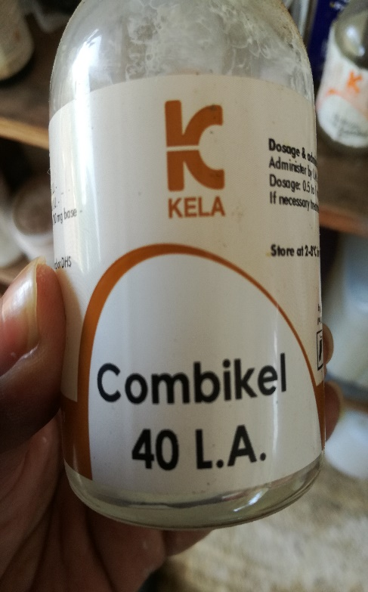 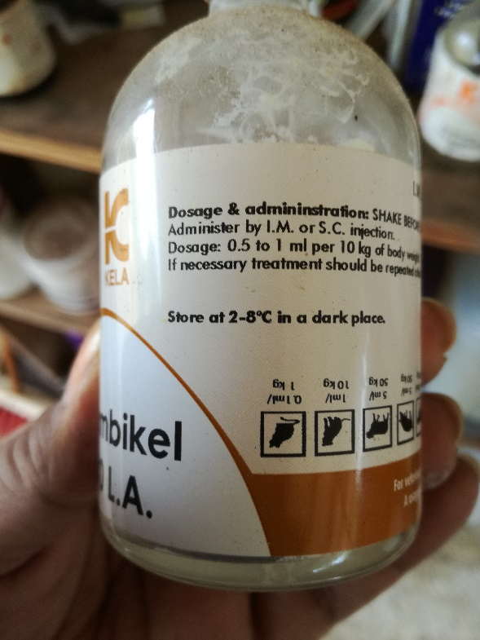 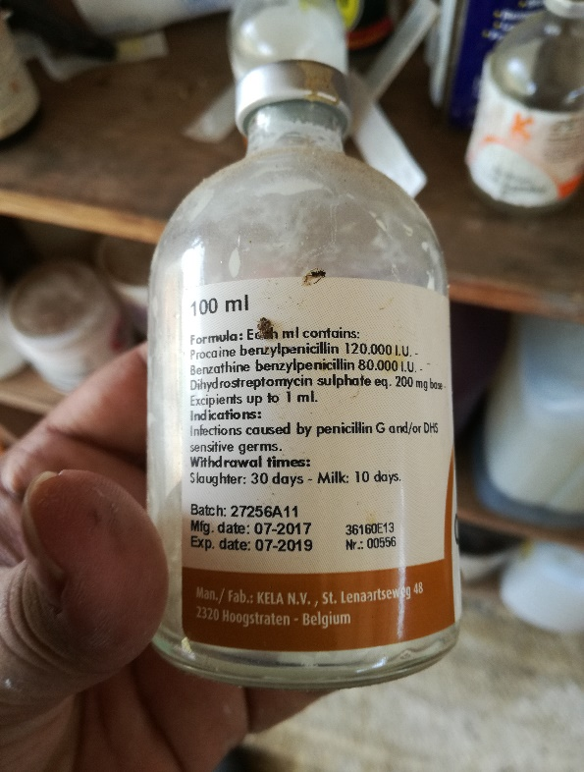

**Penicillin** shows a marked bactericidal action against most commonly occurring Gram-positive cocci, bacilli and anaerobes, and also against some Gram-negative germs (e.g. *Actinobacillus, Haemophilus, Leptospiren,*some *Pasteurella* strains, anaerobes such as *Fusobacterium* and *Bacteroides*).   
  
**Dihydrostreptomycin** is an aminoglycoside antibiotic predominantly active against Gram-negative cocci and bacilli, and against some Gram-positive bacteria (e.g. *Staph. aureus, Mycobacterium*).   
  
The**combination of DHS and penicillin**provides a bactericidal synergistic action with a broad spectrum.

Prevention and treatment of infections caused by penicillin G and/or DHS susceptible microorganisms such as respiratory tract infections (shipping fever, bronchopneumonias, upper respiratory tract infections), uro-genital tract infections (e.g. pyelonephritis by *Corynebacterium*renale, endometritis), infections of skin and wounds, *streptococci* infections in horses (strangles, Str. zooepidemicus infections in foals), erysipelas in pigs, panaritium, necrobacillosis in calves and piglets, anaerobe infections (clostridial infections, tetanus, anthrax), polyarthritis (navel ill), mastitis, septicaemia, bacterial infections secondary to viral ones.    
The drug also can be used in postoperative prevention of infections.

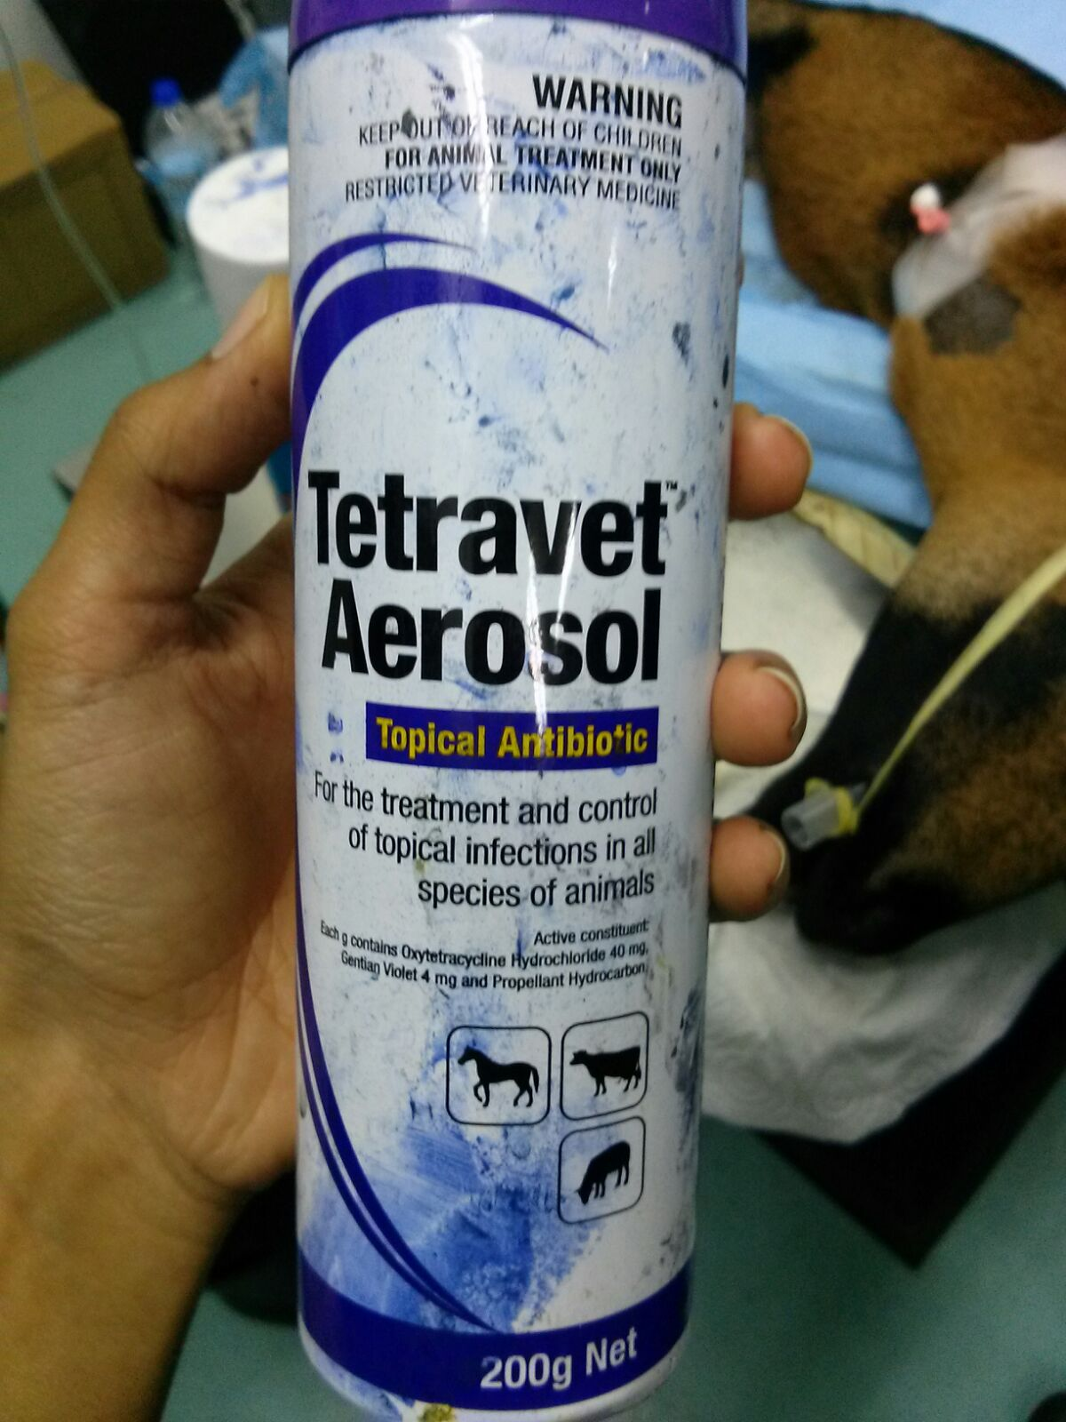

**Active Constituents:**  
Oxytetracycline hydrochloride 25mg/mL and gentian violet 2mg/mL in a purple solution for spray application.   
  
**Indication:**  
Treatment of topical infections caused by, or associated with, organisms sensitive to oxytetracycline hydrochloride and gentian violet in all species except fibre-producing animals. Treatment of cuts and wounds.

Hence, this spray was used after castrations were finished and used daily during follow- up treatments.