What is Castration?

Castration of a bull (male) calf is the process of removal or destruction of the testicles. A steer is a castrated male calf raised for beef.

**Castration Methods:**

There are various methods in which castration may be performed:

* Physical
* Chemical or hormonal techniques.

Physical methods are most common. Testicles may be removed surgically or killed by obstructing the blood supply. Young calves may be castrated with rubber rings, Burdizzo or by surgery. Surgical castration may be more appropriate for calves that are not handled until weaning.

**Elastic Band Castration-**

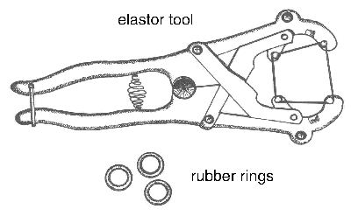

***Figure 1. Elastrator tool used to apply rubber rings.***

Elastic band castration cuts off blood supply to the testicles. A lack of blood supply kills the testicles. The equipment for banding calves less than three weeks of age is called an elastrator. An elastrator is the tool used to apply an elastic band to the neck of the scrotum. The elastic band obstructs blood flow to the testicles and the scrotum. In time, the scrotum and testicles fall from the body. The elastrator band is most reliable for calves less than three weeks of age. EZE and Callicrate are tools used to band older, larger calves with latex bands.

Vaccination to protect against tetanus and blackleg is recommended (especially in sheep and goats- cattle are less susceptible to tetanus compared to sheep and goats). However, infections may be more common when older calves are banded.

Client Communication: Vaccines must be given weeks in advance of banding. Researchers from Saskatchewan provide strong evidence against using elastic band or surgical castration of mature bulls based on pain response, time to heal and post-castration weight loss. Researchers from Alberta found no advantage in average daily gain with late castration with latex bands vs. surgical castration. Faulty application of elastic bands results in retention of a testicle and calves with a bull-like appearance (stags). To successfully use elastic bands, the operator must understand the anatomy and restrain the calf properly. Some European countries have banned elastic band castration because officials consider it inhumane.

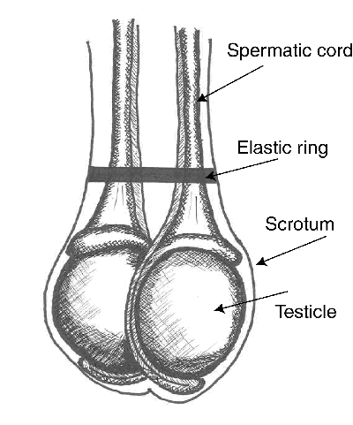

***Figure 2. Elastic band at top of testicles.***

**Burdizzo Clamps for Castration-**

The Burdizzo method crushes the blood vessels, interrupts the blood supply to the testicle and thus kills the testicle. Good restraint is essential because the Burdizzo must be in place about 10 seconds to crush the artery.

The Burdizzo must be in good condition. The jaws must be parallel and close uniformly across their width so pressure will be evenly distributed across their length. Leave the Burdizzo slightly open when not in use.

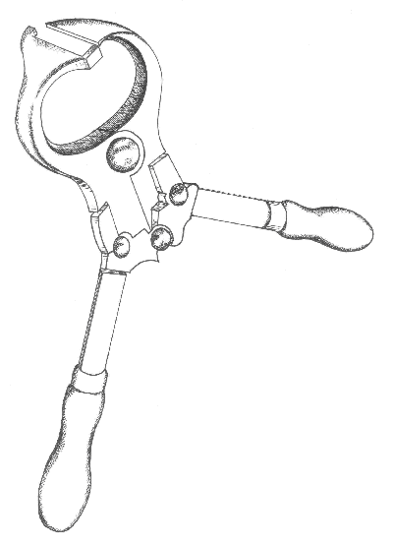

***Figure 3. Burdizzo clamp.***

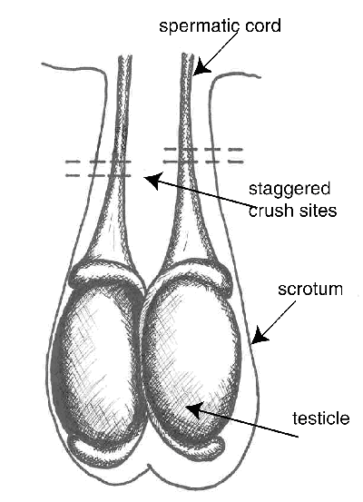

***Figure 4. Burdizzo castration sites.***

**Surgical Castration-**

Client Communication: Surgical castration is the most certain method of castration because the testicles are removed completely. It is best performed before or after fly season and when calves can be turned into a dry area after the surgery. Surgical castration can be performed on any age calf. It is easier to learn on calves with larger testicles. However, larger and older calves experience more stress and usually bleed more than younger calves.

Good restraint is essential to minimize the risk to calves and operators.

Instruments for surgical castration include the Newberry knife, scalpel and emasculator.

Figure 5. Scalpel.

***Figure 5. Scalpel.***

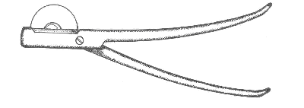

***Figure 6. Emasculator.***

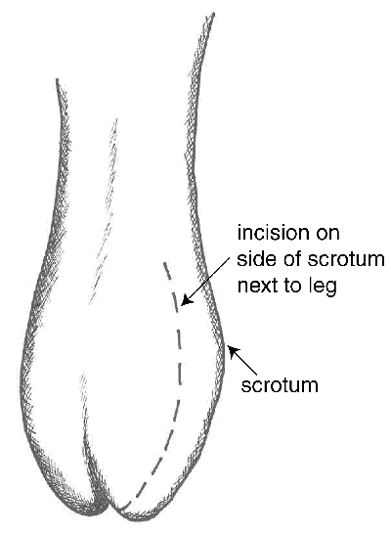

***Figure 7. Incision method A***.

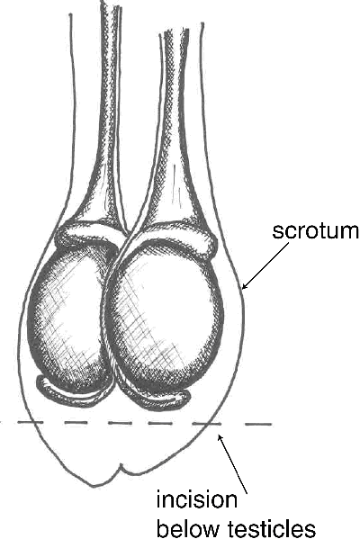

***Figure 8. Incision method B.***

There should not be any tissue hanging from the scrotum once the castration is complete.

If using incision Method B, the castration is complete. If using Method A, once both testicles have been removed, make an incision completely through the bottom half of the median septum to ensure good drainage.