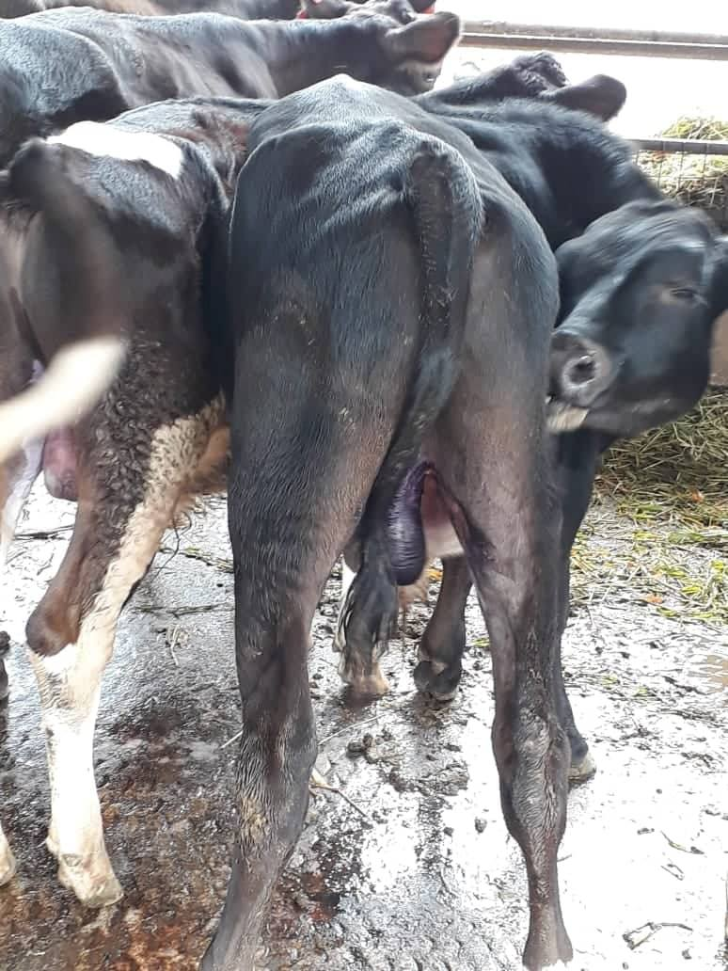The management of a closed castration is not as complicated as the open castration as there is no manager site for infection. The Burdizzo, however, may make nicks in the skin that can be a potential site of infection. So as a precaution tetravet and larvicide/ Ford Dodge aerosol is applied to area. Constant monitoring of the calf just to ensure that there are no signs of inflammation.