UMBILICAL HERNIA REPAIR
The patient, a 8.4 kg female Anglonubian, 2 month old caprine was surgically prepped with pre-anaesthetic induction drugs of Ketamine- Stun (Xylazine at 0.05 mg/kg, Ketmaine5mg/kg) intramuscularly in the neck muscles and Lidocaine at 1 mg/kg IV.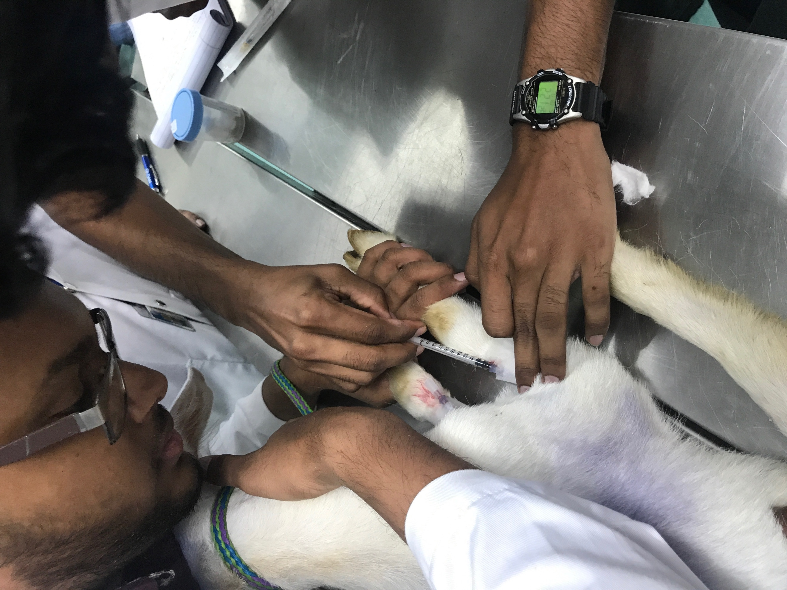
Figure 1 IV induction of 0.42 mls of Lidocaine

Two catheters were placed in the cephalic veins of the right and left forelimbs and an epidural was given.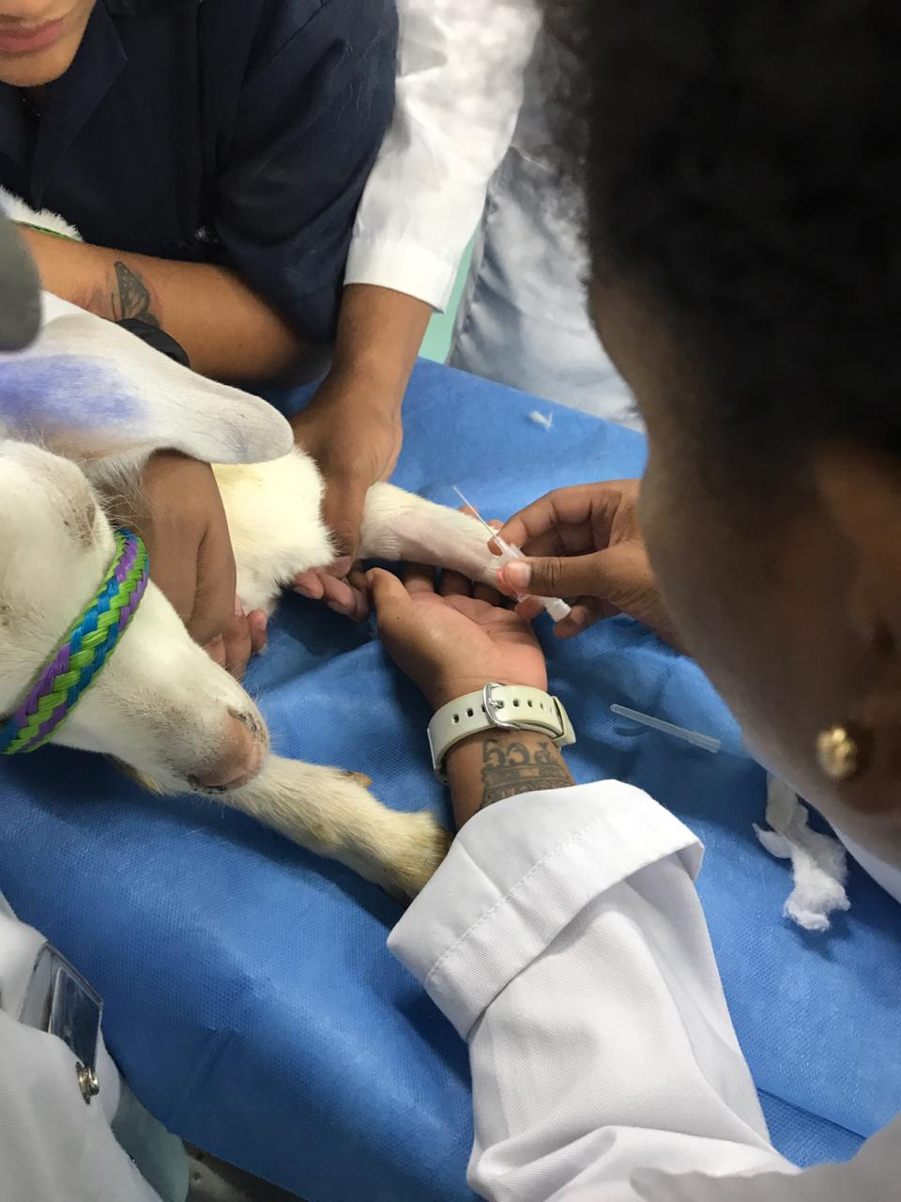
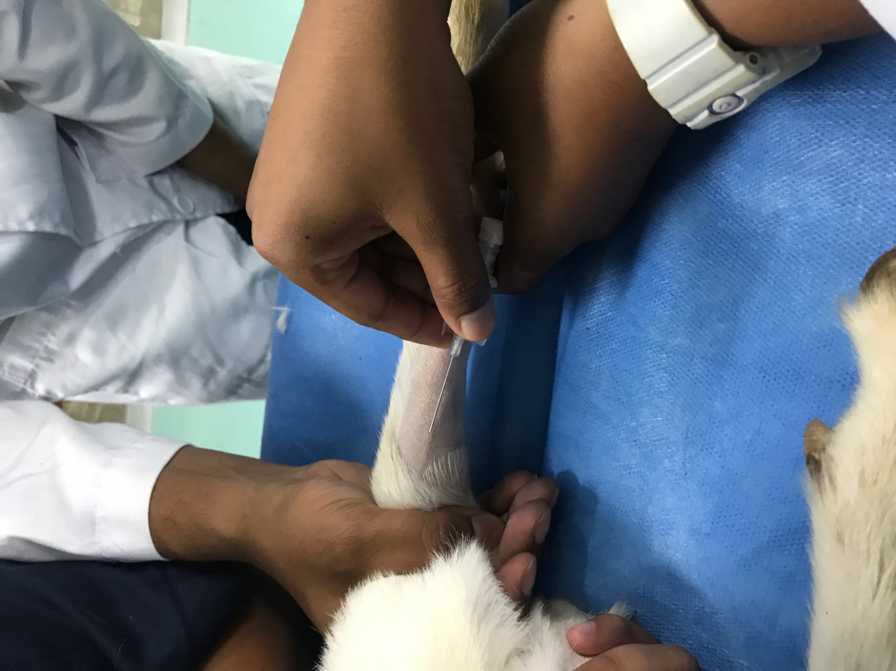
Figure 2 Catheter placement in the cephalic vein

The patient, the surgical site and surgeons were surgically prepped as stated in the ‘Surgeon Preparation’ section of this CMap.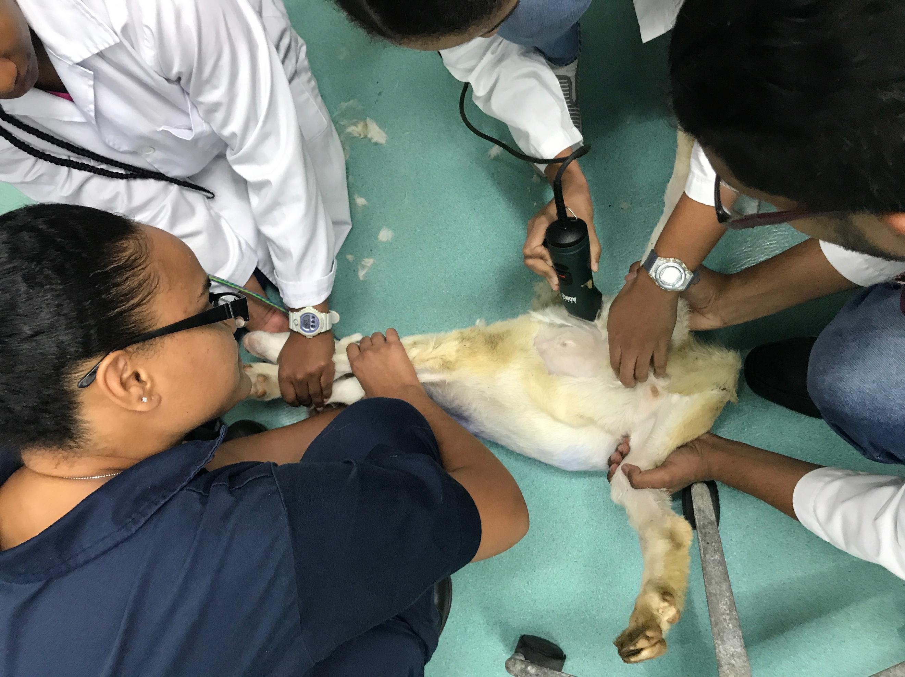
Figure 3 Clipping of the patient's hair
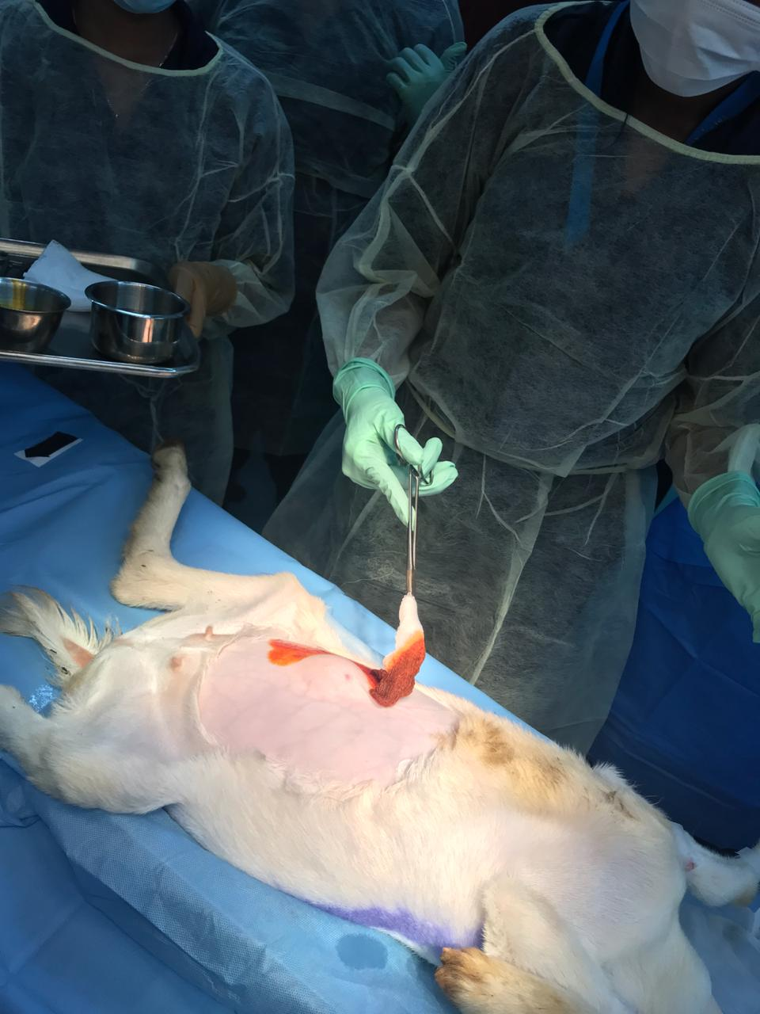
Figure 4 Surgical preparation of the surgical site

The patient was placed in dorsal recumbency, hooked up to the CRI drip bag with its head resting off the operating table, and draped. 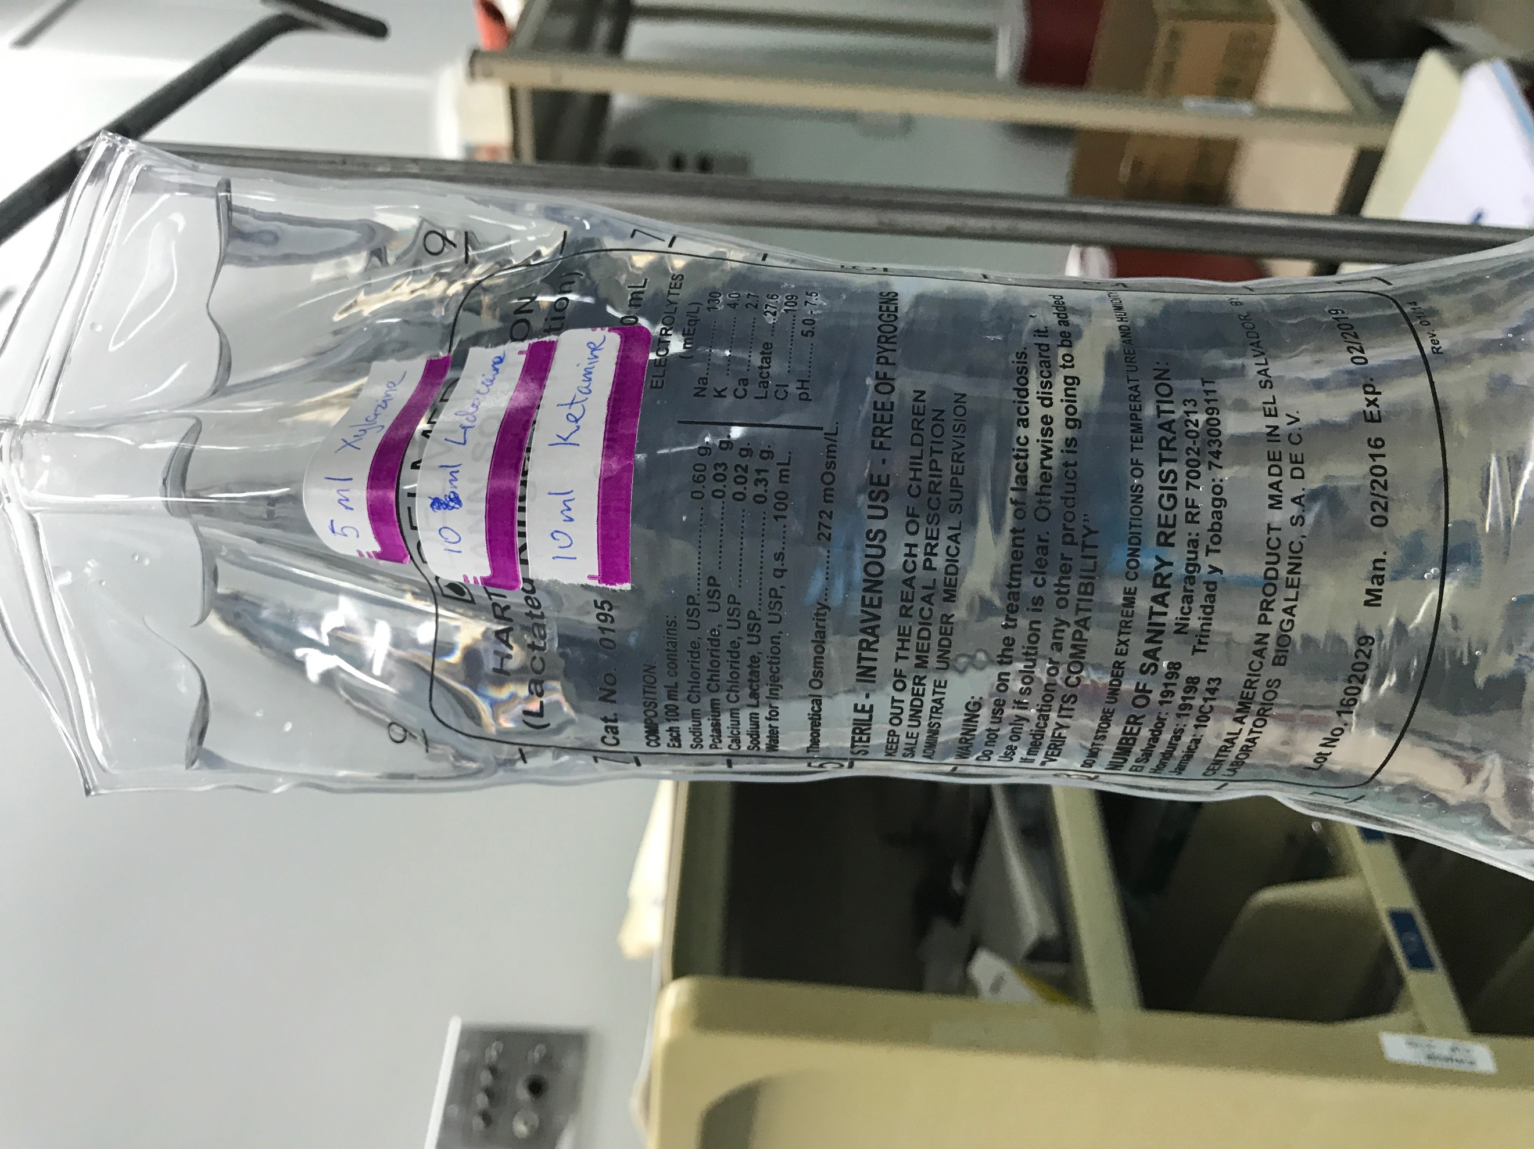
Figure 5 CRI used throughout the surgery for general anesthetic at a rate of 1 drop every 2 seconds.
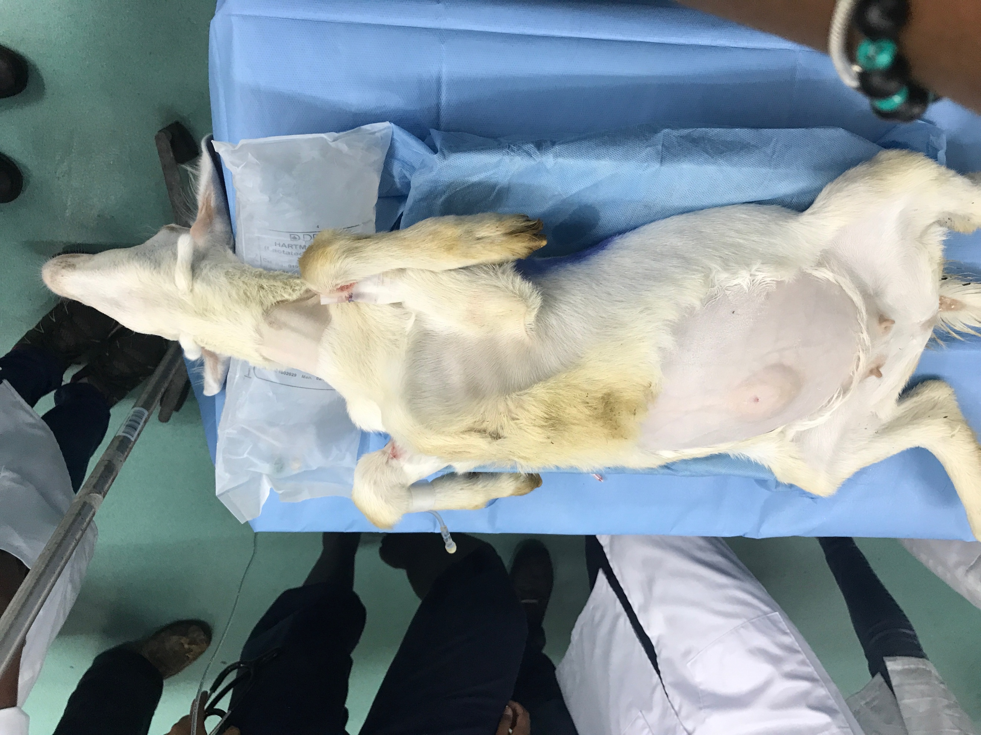

A fusiform incision was made around the hernia site with a sterile scalpel, ensuring to not cut or puncture the hernia sac itself. Blunt dissection was then done to remove the skin flap that was previously incised, and to remove abdominal fascia and tissues to arrive to the hernia ring. The hernia sac was then cut using a Mayo scissors and the surgeons all placed their fingers inside the surgical site to feel for any adhesions and to palpate the hernia ring and its contents. Hemostats and gauze were used for hemostasis, when excessive bleeding was encountered.
The abdominal cavity contents which were inside of the hernia sac (the abomasum and small intestine) were all placed inside of the abdomen, ensuring that they remained there during the closing of the hernia ring. Four pre-placed sutures were used to hold the hernia ring in place, and then closed with a surgeon’s knot. A subcuticular suture was also done and closed with Aberdeen’s knots. The suture material used was Polypropylene and PDS II.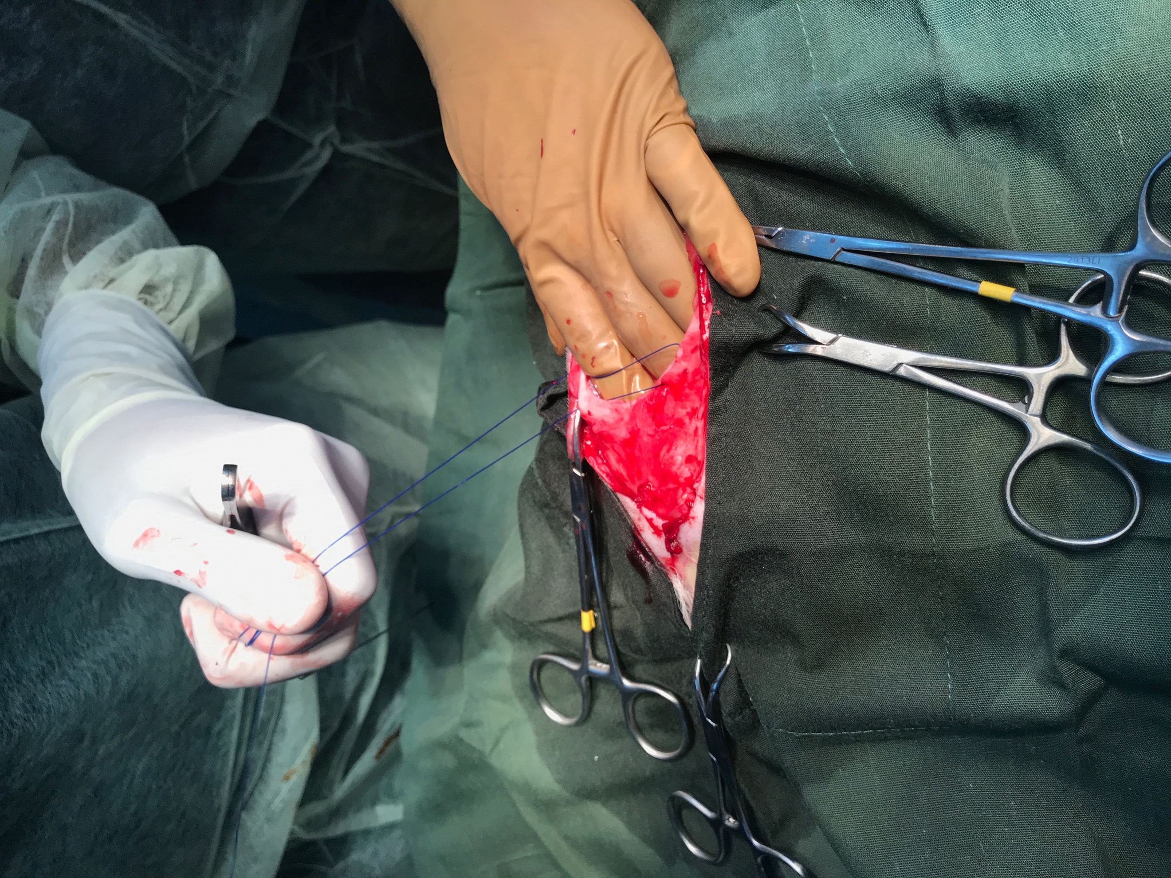
The skin was then closed in a cruciate pattern and tied off using a Surgeon’s knot.

OTHER NOTES
- When excessive movement of the patient occurred during surgery, which indicated the patient was beginning to ward off the CRI drugs, the drip rate was increased, and in cases where even more movement occurred, the patient was given 2mls Ketamine-Stun IV, for further sedation.
- During emergency protocol, epinephrine was given at a dose of 0.02 mg/kg IV, and Tolazaline was calculated at a dose of 0.2 mg/kf for the reversal of Xylazine.

