An umbilical hernia is a protrusion of the abdominal contents through the abdominal wall due to failure of complete fusion between the embryological lateral folds leaving a space in the ventral body wall through which organs may pass. A true hernia is defined as having a ring, sac & contents. Most umbilical hernias are small, reducible and cause few clinical signs. The structures most commonly in the hernial sac (comprising the skin, the subcutaneous connective tissue and the parietal peritoneum) are the omentum, falciform fat and intestine.

Non reducible hernias may contain intestine which could further complicate by becoming strangulated causing acute clinical signs. This is likely when the size of the space (hernial ring) is about Theo some size as the intestine. These hernias may occur with other congenital defects such as cardiac septal anomalies, bladder exstrophy, or cryptorchidism. Unusually, a very large congenital defect in the ventral body wall may occur (an omphalocoele) that leads to the eventration of entire organs and death shortly after birth.

Additionally acquired umbilical hernias may form if excessive traction is applied to the umbilical stump before it has contracted completely or if the stump is ligated too close to the abdominal wall.

Because of the genetic contribution it is advised not to breed animals that have had an umbilical hernia.

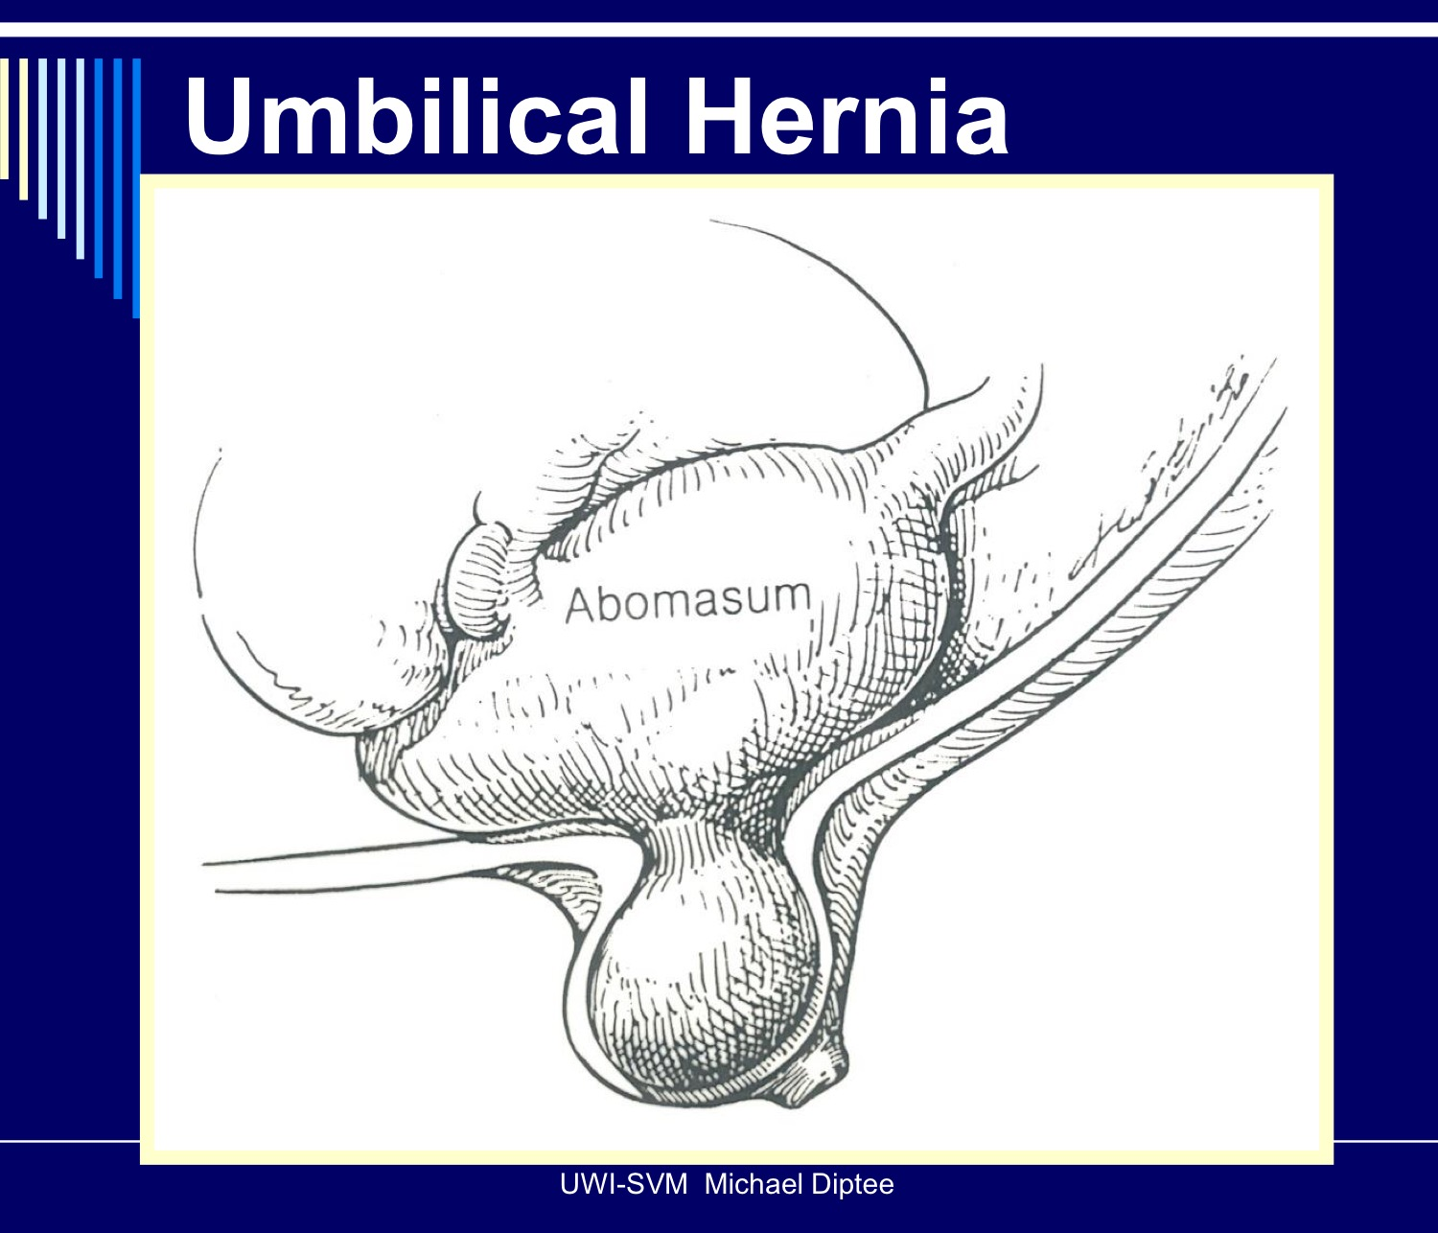

Common hernias in animals are
- Diaphragmatic hernias - congenital or from trauma in small animals
- Inguinal hernia - congenital or due to late testicular descent in young dogs or due to obesity or in stallions post castration
- Perineal hernia - weakening or rupture of muscles forming the pelvic diaphragm and anus
- Peritoneopericardial hernias - failure of fusion of the septum transversum during diaphragmatic development, allowing communication between the abdominal cavity and pericardial sac

In this lab, an umbilical hernia in a 2-month-old kid was seen. The umbilical opening in small ruminants should close after birth in few days. Failure of this opening to close properly results in umbilical hernia (the intestine or other tissues from within the abdominal area projects through the opening). Its cause might be either congenital or acquired factors that hampers this closure, such as omphalitis or abscesses.
Another reason could be the relatively thin nature of abdominal wall of goat in comparison to other ruminants.

