Preparation of the patient

Before surgery can begin, the surgical site of the patient must be prepped. The main purpose of this step is to minimize or eliminate risk of infection through the surgical wound by reducing the presence of bacteria on the skin. It also helps with visualization of the surgery site.

Commonly this procedure consists of a soap scrub for 5 minutes, alcohol and chlorhexidine which is a disinfectant.

Considerations:
- for a site that is close to a mucous membrane alcohol is not used nor is an alcohol based disinfectant (instead a water based one is used).

1. Fur is shaved with clippers to remove all fur from the site.
2. The skin is scrubbed to physically remove debris and organic matter on the skin. This is usually done with chlorhexidene and was used for our patient for this lab. This step can be done twice and the brushes or gauze used should not be re immersed in the container of solution. A first scrub is done oriented away from the surgical site and a second is done while getting a good lather to get good contact over the entire surgical field. Scrubbing is not necessary at this point as this may cause abrasions. 5 min contact time is required.
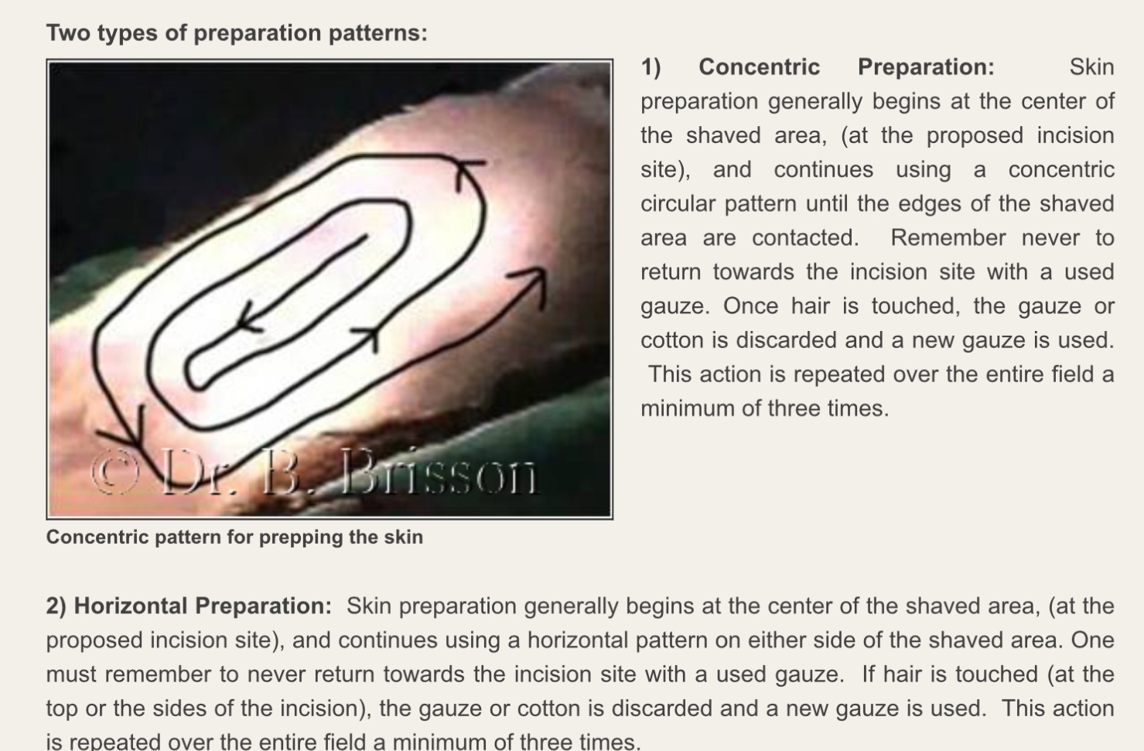
3. Suds are wiped with fresh gauze. Skin preparation at this step can be done in a concentric or horizontal pattern, and a concentric pattern was used for our patient. Prep begins in the center of the site and moves outwards until the boundary of the shaved area is reached. This Is alternated between iodine and alcohol three times. Each gauze should be replaced and never reused.
4. Sterile draping is done to further protect the site. A hole to the size of the surgical wound is cut in the drapes with sterile scissors. In the field a clean garbage bag may be used!

Note that all preparation except shaving is to be done by individuals who had already been aseptically prepared to minimize risk of infection from contaminated clothing, skin, etc. This was also practiced in lab, and sterile gauze was used for all preparation and held with a hemostat.

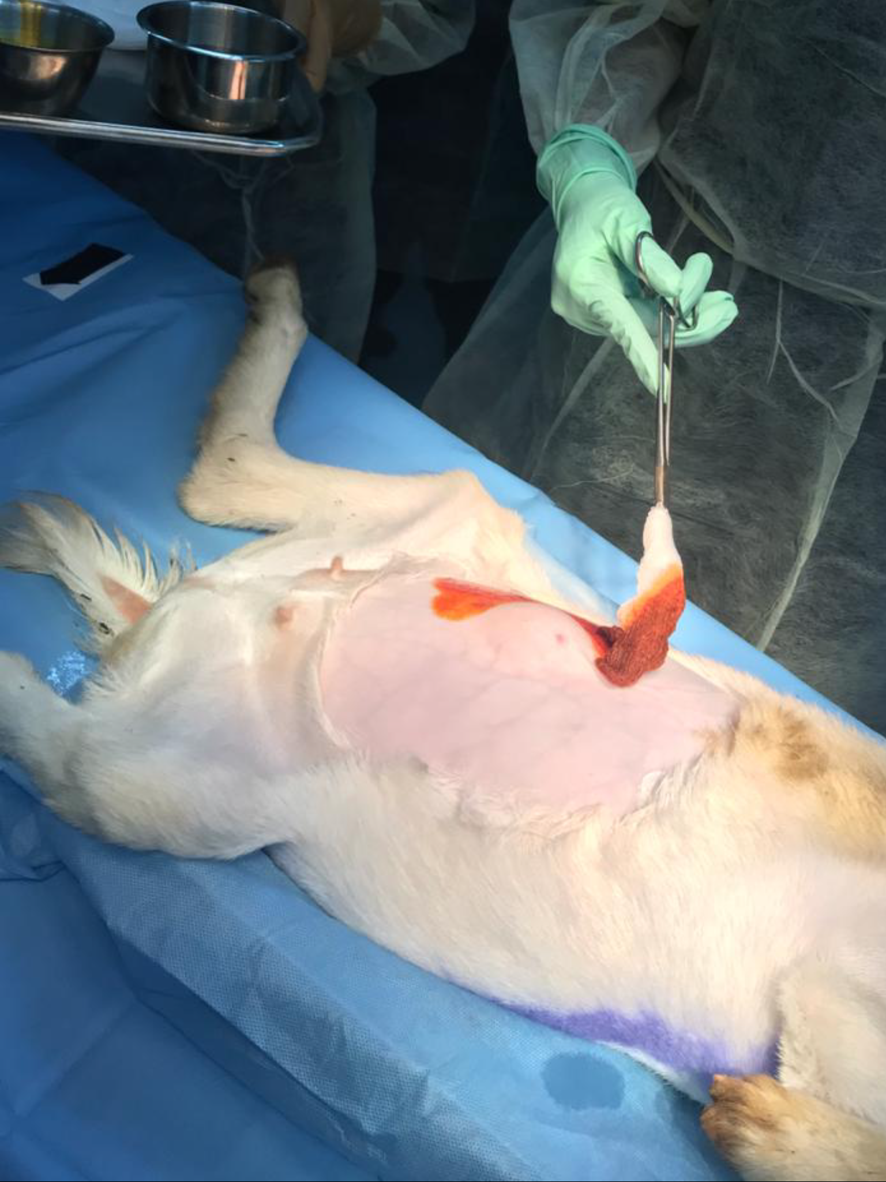
Our patient being prepped with iodine in a concentric pattern.

