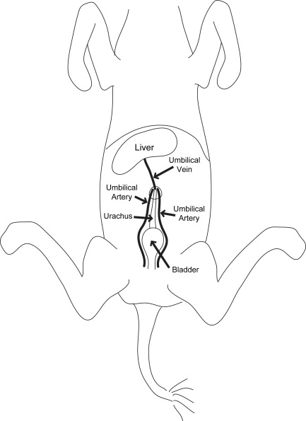

The urachus is a fetal continuation of the bladder taking waste to the allantoic sac.

Paired umbilical arteries – carries oxygen-poor blood from the fetus; later become arteries become the lateral ligaments of the bladder. Umbilical aa. are branches of the internal iliac artery.

Umbilical vein - courses from the umbilicus cranially into the liver. It delivers oxygen-rich blood and nutrients to the fetus through the liver and ductus venosus. It normally becomes the round ligament of the liver (falciform ligament).