Anatomy of the Palmar digital Neurectomy

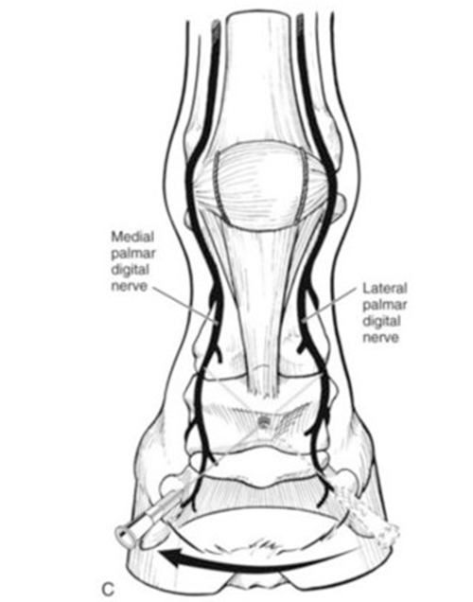

- The lateral and medial palmar digital nerves are continuations of the lateral and medial palmar nerves.

- The palmar digital nerve is identified just palmar to the digital artery approximately 0.5cm below the skin surface and deep to the ligament of the ergot.
- These supply nerves to the navicular area and bifurcates above the fetlock joint to form anterior and palmar digital nerves.

