- Palmar Digital Neurectomy Surgical Techniques

- Surgical Procedures:
Anaesthesia and surgical preparation:

- Neurectomy may be performed under local analgesia with the animal standing or under general anaesthesia.
- If the surgery is performed with the animal standing, it is preferable to inject the local analgesic agent on the palmar nerves at the level of the abaxial surface of the sesamoid bones. The nerves can be palpated in this area, and the infiltration of this area avoids additional trauma and irritation at the surgery site.
- If neurectomy is performed in a field situation, immediately following the use of a diagnostic block of the palmar digital nerve, however this same block may also be used for the surgical procedure
- However, it is recommended that the surgery be done 10 days after the palmar digital nerve block to reduce inflammation in the region
- General anaesthesia is convenient to use and for more involved procedures like epineural clipping it is strongly indicated.
- Area of the surgical site must be clipped, shaved, cleaned and prepared for surgery
- Plastic adhesive drapes are useful to exclude the hoof as a source of contamination

- The Guillotine method:
- An incision 2cm long is made over the dorsal border of the flexor tendons
- At this stage of the dissection, accessory branches of the palmar digital nerve should also be observed. These branches are located near the ligament of the ergot. if one is found, a 2cm portion is removed using the scalpel

- Identification of the nerve:
- Smooth, white, and glistening
- Crimped appearance of the nerve after it has been stretched and released
- Palpating longitudinal fibres when the nerve is stretched over the smooth portion of an instrument
- A small incision into the nerve body revels cut transverse section of the bundles of nerve fibres.

- A 2-3 cm section of the nerve is freed from the surrounding tissues
- The nerve is severed at the distal extremity of the incision
- The nerve is stretched with a haemostat and the proximal end is cut sharply using a scalpel
- This sharp incision is made in such a fashion that the proximal portion of the nerve springs up into the tissue planes and out of sight

- It is believed that the severance of untraumatized nerve and its retraction up into the tissue planes help reduce the problems of painful neuromas

- The skin is closed with interrupted sutures of nonabsorbable suture material

- Black's method: The pull-through

The pull-through technique is an extension of the Guillotine technique:
- The first part of the procedure is performed as previously described.
- The main difference is that, instead of transecting the nerve at the proximal site of the incision as in the guillotine technique, traction is placed on the distal nerve, and a second incision of 1 cm is made over the nerve at the base of the proximal sesamoid bone.
- The digital nerve is then pulled through the proximal incision and a guillotine technique is used to transect the nerve.
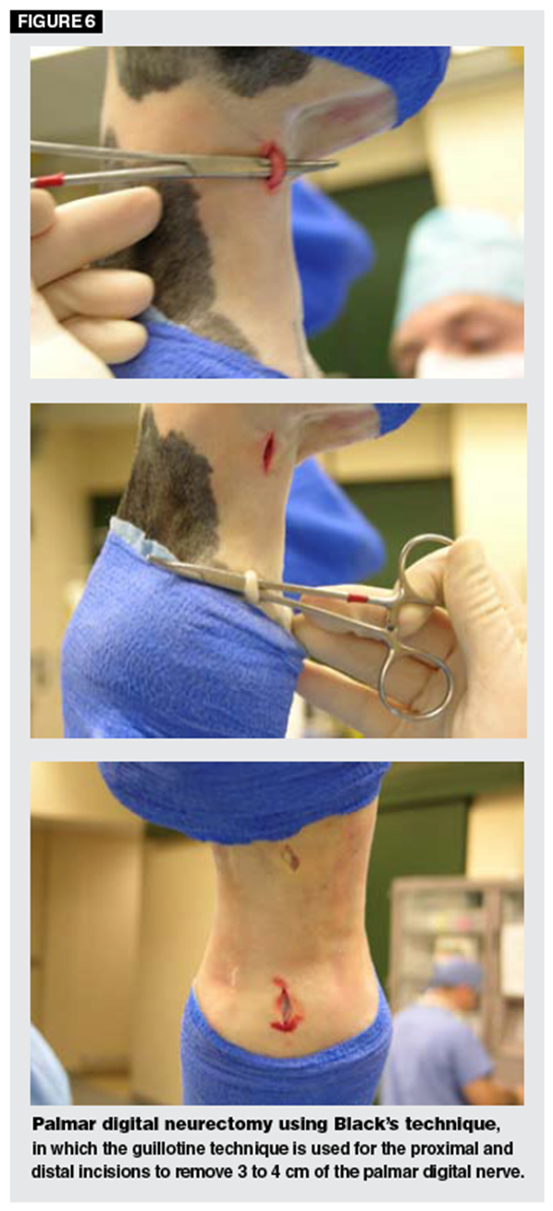

- Epineural Capping
- This is an additional procedure that is intended to reduce the incidence of painful neuroma.
- Surgical dissection and exposure of the nerve are accomplished as in the guillotine method, except the incision is longer.
- A section of the nerve 3-4cm long is exposed and is freed from the fascia and connective tissue.
- The nerve is severed as distally as possible and is raised from the incision.
- The end of the nerve is then held with forceps, and the epineurium is carefully reflected for 2-3cm and tow incisions are made through half the nerve on each side.
- The nerve is then severed distal to these cuts and the epineurium is pulled back over the severed end and ligated with a 2-0 or 3-0 absorbable monofilament.
- The skin is then sutured as described in the guillotine method

