Indications of
Palmar Digital Neurectomy
- Indications
Chronic lameness that improves significantly after palmar digital anaesthesia, but has not improved with alternative treatment options such as Corrective shoeing and Medical therapy
- Includes selected cases of:
- Navicular syndrome
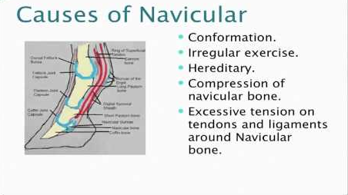

- Navicular bone fractures

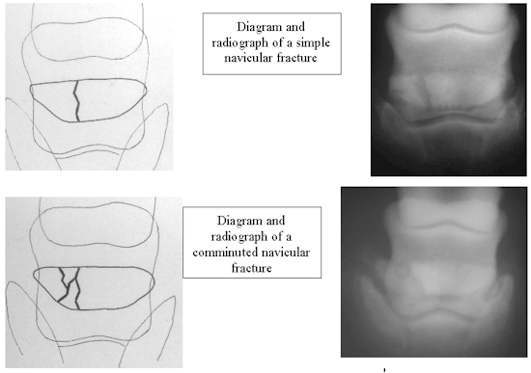
- Selected lateral wing fractures of the third phalanx
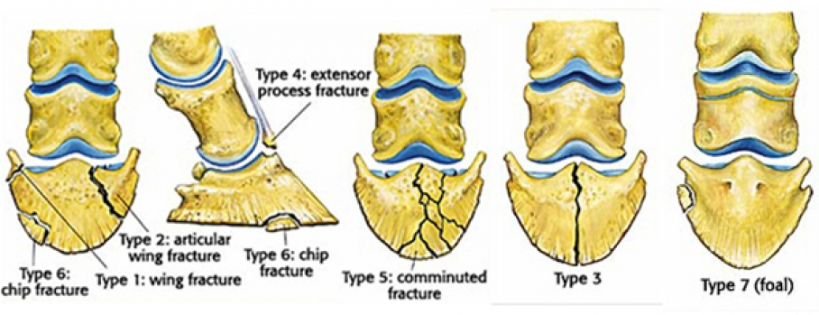

- Calcification of the collateral cartilages of the third phalanx

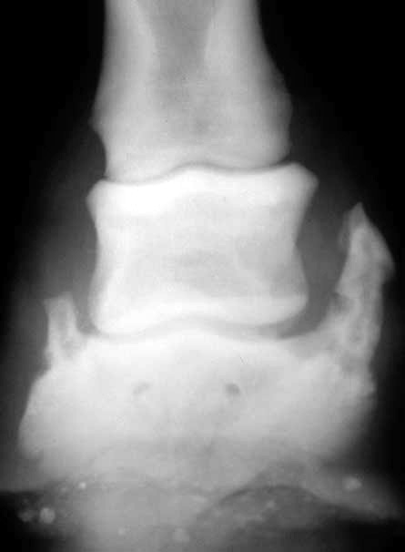

- Idiopathic heel pain
- Palmar/plantar foot injuries
Note – This surgical procedure is not benign, nor a panacea: several potential complications should be explained to the owner prior to surgery.

