Complications of Palmar Digital Neurectomy

- Progression of the underlying problem

- Deep digital flexor tendon rupture

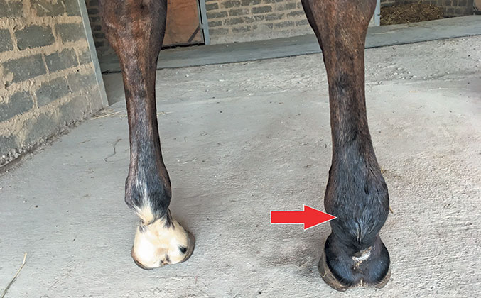

- Navicular bone fractures

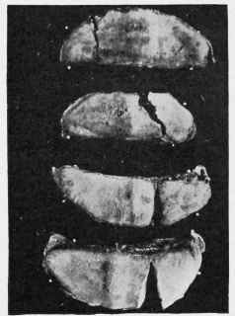

- Foot abscesses
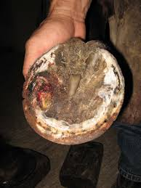
- Reinnervation

- Neuroma formation:
Neuroma is caused when nerves, besides the blood vessels are pinched, severed or crushed by the navicular bone resulting in hypertrophy of the nerves into bundles of tissue that are painful.
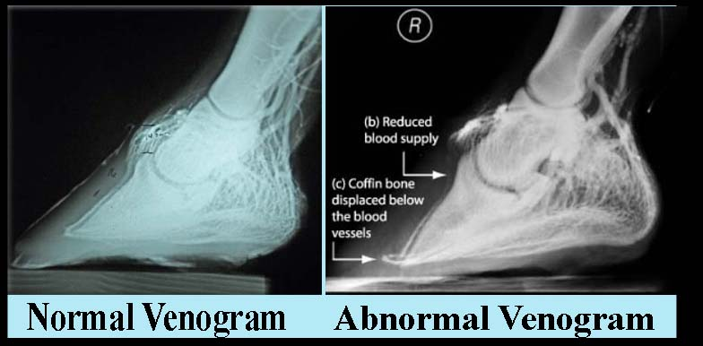

- Ischemia with loss of the hoof wall
