Post-operative management of Palmar digital neurectomy

• A sterile dressing is placed on the incision

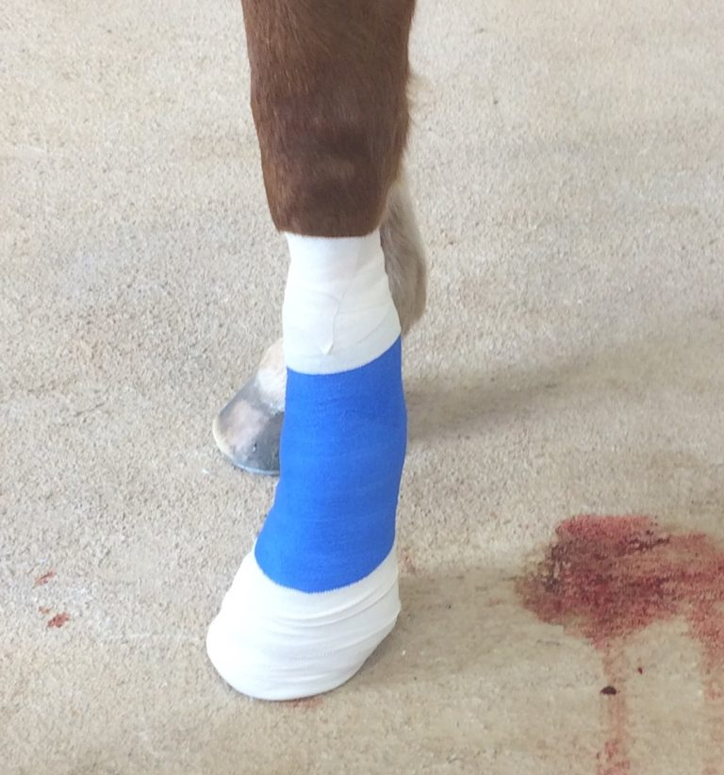

- A pressure bandage is maintained on the leg for at least 21 days

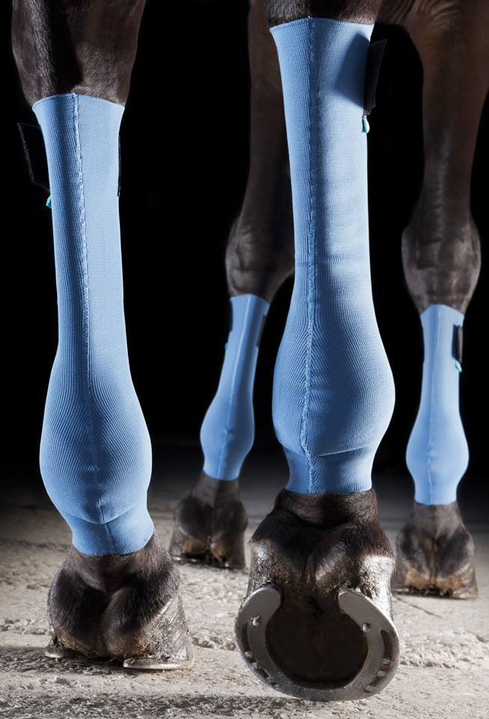

• Medications – Phenylbutazone is administered for 3-5 days to minimize postoperative inflammation

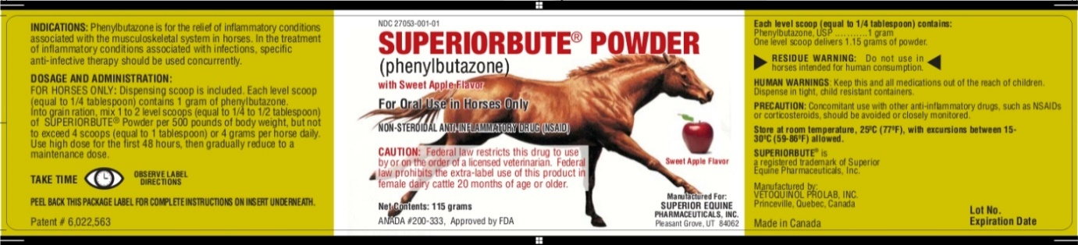
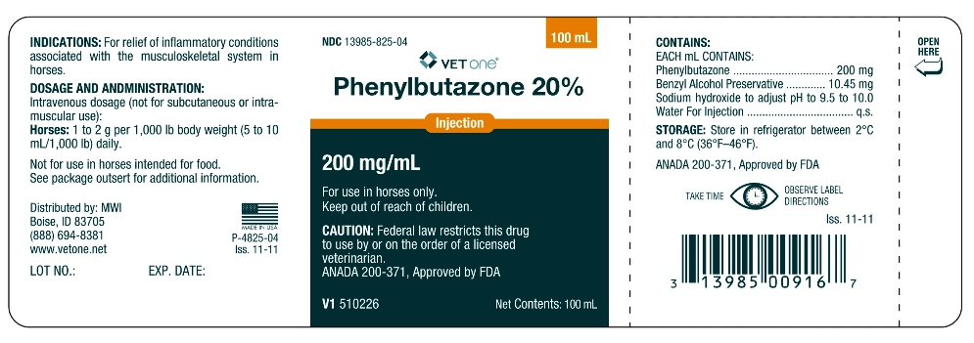
• Exercise – Stall rest is provided for 4 weeks. After 10 days hand walking is allowed. After 4 weeks the horse may resume normal activity

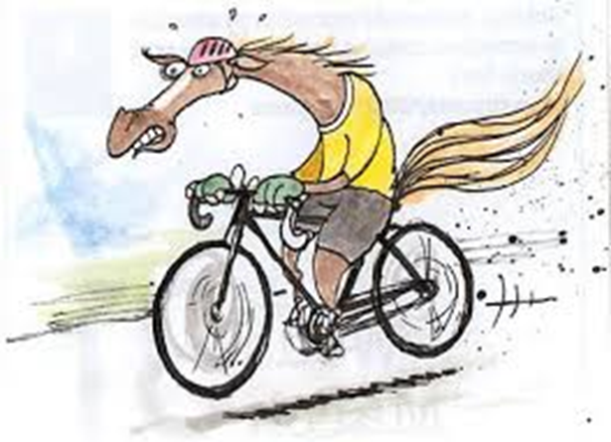

- Sutures are removed 10 days after the operation and horse is rested for 60 days

