What is deep digital flexor tenotomy?

A surgical procedure that transects the deep digital flexor tendon in the mid-cannon bone region.
This major tendon attaches to the back of the coffin bone. Transection removes one of the main forces responsible for rotation of the coffin bone in laminitis. Laminitis is inflammation of the laminae that attach the coffin bone to the hoof capsule, causing decreased blood flow to the laminar attachments. The laminar attachments become so compromised that the coffin bone and hoof capsule separate from each other. If the normal pull of the deep digital flexor tendon exceeds the strength of the remaining laminar attachments, the bone may rotate downward away from the hoof wall.
The surgery helps alleviate a source of pain by decreasing pull on the bone and inflamed laminae.

Pre-op considerations:
- Clients should be made aware that horses that undergo this surgery cannot be used for future racing, and can be used for breeding purposes or for companion animals.

- Tenotomy is indicated if:

- The distal phalanx has rotated more than 12 degrees in the first 30 days of the syndrome
- The extensor process is displaced distally as much as 1 cm during the first week of the disease.
- Cases with massive laminar damage, horses with chronic laminitis in which other forms of foot support and/ or heel elevation have been unsuccessful.
- Pre-operatively, Derotation can be performed using radiographs or the plane of the frog to determine the amount of heel to be removed. In lowering the heels, the distal phalanx should be repositioned as parallel to the ground as possible, thus taking the weight off the anterior portion of the bone. Lowering the heel begins at the apex of the frog and continues in a posterior direction until the frog is nearly parallel to the ground. Trimming in this manner increases the amount of hoof surface at the heels in contact with the ground before tenotomy, thus creating further stability following surgery. The toe is shortened from the dorsal hoof wall back to the white line to further align the hoof capsule to the dorsal surface of the distal phalanx and remove any additional bending forces at the toe.
- Hoof trimming can performed before surgery, and the horse should be placed in wedges until surgery is performed because the force exerted by the deep digital flexor tendon on the newly trimmed hoof will increase the horse's discomfort.
Surgical procedure
- Tenotomy is performed on the standing animal.
- A proximal metacarpal palmar nerve block is performed and a 2 to 3 cm incision is made over the lateral aspect of the deep digital flexor tendon in the middle of the third metacarpal bone. This approach provides good exposure of the tendon, and quick and easy visualization and safety.
- The fascia is separated, and, with the limb flexed, the tendon is isolated and brought to the surface of the wound using small, curved retractors. The tendon is transected completely, and the wound is closed using a skin staples or non-absorbable sutures.
- The severed tendon heals with scar tissue, leaving an enlarged thickening on the leg where the tissue forms. After surgery, the forces exerted by the deep digital flexor tendon are eliminated, and the tension on the apex of the distal phalanx is relieved, thus allowing increased blood flow to the laminae and solar corium. It provides immediate pain relieve and resolution of abscesses or seromas formed as there is increased in the depth of the sole.

Post op considerations:

- Post operatively, proper hoof care is detrimental, and thus, work with a farrier or veterinarian should be done for realignment of the distal phalanx within the hoof capsule (derotation), and support of the heel.
- Strict stall confinement is a necessity. These horses must be confined until the new growth ring extends three-fourths of the way down the hoof wall and this takes about six months. This time is needed for a bond to form between the hoof wall and distal phalanx to adequately support the weight of the horse.
- Horses should not be turned out before this time as this or hand walking results in treatment failure.
- The use of an extended heel shoe or preferably an egg bar shoe is indicated following surgery. This shoe will prevent possible toe lift and will support the posterior aspect of the foot as the horse's weight shifts toward the heels. This will also prevent stretching of the palmar joint capsule, which results when the coffin bone is returned to a more normal angle.
Glued shoes can be used most of the shoes on horses with laminitis as causes no trauma to the foot and the amount of composite used on the ground surface can be varied to provide better alignment of the bone within the hoof and eliminate sole pressure.
- If abscessation has occurred and is draining in the sole, a treatment plate made from ¼ in aluminum or plastic can be attached to toe bottom of the shoe to facilitate treatment of the solar area. This plate can hold medication (such as gauze soaked in povidone iodine) against the solar area and will also protect the sole from bruising.
- Patients with chronic laminitis patient should be confined to the stall for one month following a tenotomy, and brief periods of hand walking can be done. Turning the animal out in a small, flat paddock is can also be performed if recovery has been good.
Monthly follow-up radiographs are indicated to monitor the alignment of the distal phalanx. The distal phalanx should be realigned with the hoof capsule so that it is nearly parallel to the ground. It can determine how much sole should be trimmed to achieve this realignment. The rapid increase in sole depth after tenotomy requires that adequate sole be trimmed.
- Corrective trimming and shoeing should be performed every four weeks, and costs the patient a lot of expenses, and this should be communicated with the client.
- 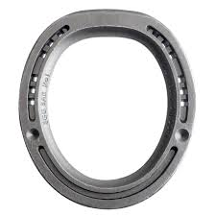
Figure 1: Egg bar shoe

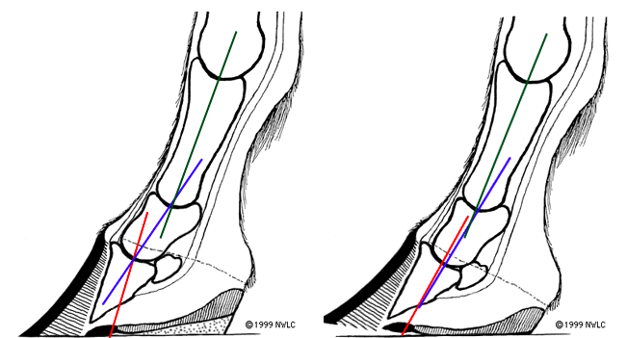
Figure 2 Showing how pastern alignment is effected by excessive heel length. When the heel length is corrected the pastern alignment is also corrected

.
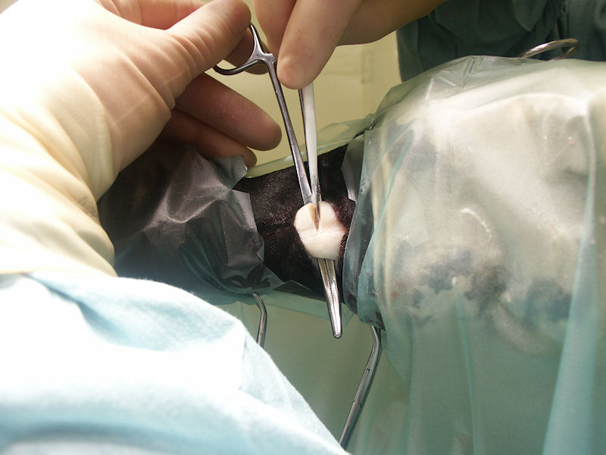
Figure 3 Tenotomy of DDFT

