Surgical Removal of Splint Bone Fracture Fragments
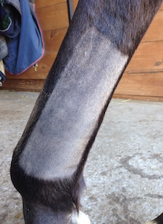 | Most preoperative preparative work is conducted with the horse standing, so that time spent under general anesthesia is minimized. The surgical site is clipped to prevent hair contamination of the incision during the procedure.
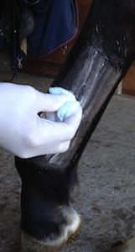 | Contact time between the scrub (bacteriocidal soap) and skin surface is maximized by applying the first layer early. This reduces the chance for postoperative infection.
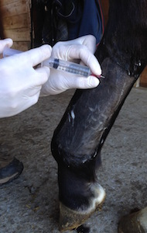 | The skin and subcutaneous tissues along the incision site are locally anesthetized (blocked). This allows the surgery to be performed using less general anesthetics, which is healthier and safer for the horse. Moreover, local anesthesia allows for preoperative "marking" of the underlying bone fragments (see below).
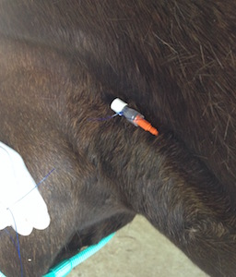 | While the scrub and local anesthetic are working, an intravenous catheter is placed to allow for easy and immediate access to the horse's vascular (systemic) system during surgery. The catheter is always placed on the same side as the limb containing the fracture(s); that way it will be facing upward during the horse's recovery.
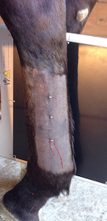 | Skin staples are placed in the skin and spaced along the length of the fractured splint bone.
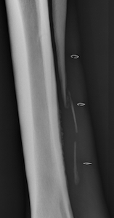 | These staples can be used to ascertain the specific location of each fragment along the length of the limb through follow-up radiographic examination. In this case, the lower two staples lie directly over individual bone fragments.
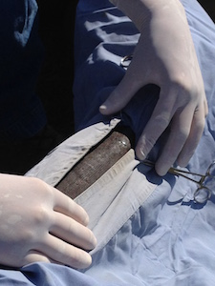 | Once the exact position of each fragment has been determined, the horse is placed under general anesthesia and the limb is further prepped and draped.
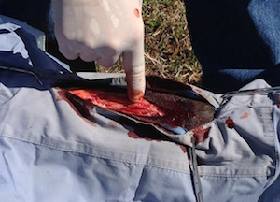 | Following incision, the distal aspect of the splint bone (the button) is identified.
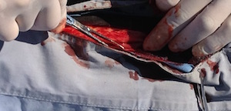 | The button is grasped with forceps, which are used to apply upward traction on the distal bone fragment. This exposes the interosseous ligament, which resides between the fracture fragment and underlying cannon bone.
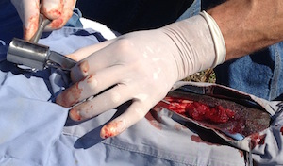 | An osteotome (like a chisel) and mallet (hammer) are used to transect the interosseous ligament, thereby freeing the distal bone fragment from its attachment to the underlying cannon bone.
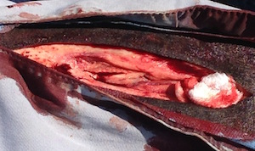 | Once the distal fragment is removed, any middle fragments are identified and resected in similar fashion.
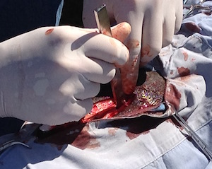 | After all middle and distal bone fragments have been removed, the scalpel and osteotome are used to expose the lower (bottom) end of the proximal (intact) bone fragment. The majority of this fragment will remain with the horse following surgery.
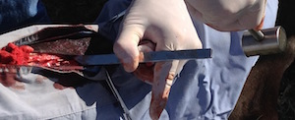 | Once adequately exposed, the lower end of the proximal fragment is resected at an angle (i.e. tapered) to eliminate future interference of sharp bone edges with adjacent soft tissues.
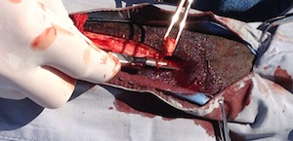 | Once freed, the lower end of the proximal (intact) fragment is removed.
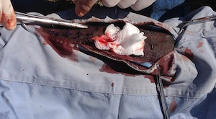 | The incision is inspected and cleansed of persistent hemorrhage, abnormal (infected) soft tissues and any residual debris prior to closure.
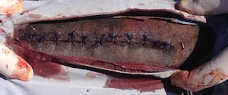 | Closure is performed in two layers; Subcutaneous tissue and skin are apposed separately.
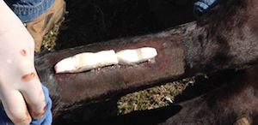 | The incision is covered with a sterile wrap and a heavy, well-padded distal limb bandage is carefully applied prior to the horse's recovery. Click HERE to learn about complications that can occur with bandaging.
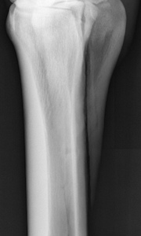 | Postoperative radiographic examination (rarely performed) confirms complete removal of the middle and lower splint bone fragments as well as appropriate tapering of the lower end of the remaining fragment.

Pre- and Post- Operative Views of Splint Bone Fragments
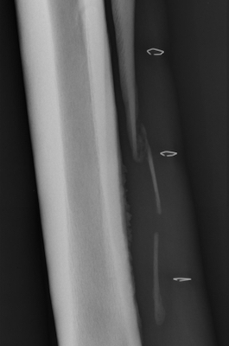 | 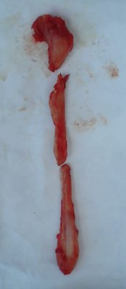
Preoperative Radiographic View | Postoperative Gross View

