Surgical Procedure

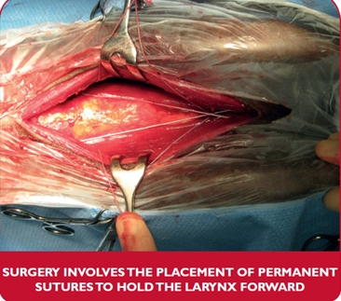
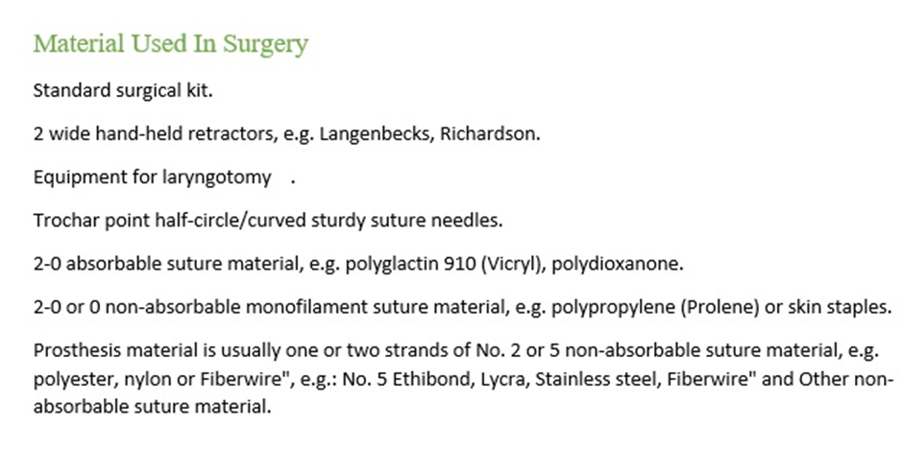
- The horse is placed under general anaesthesia in dorsal recumbency, and endotracheal intubation is performed.
- A 15cm ventral midline incision is made, extending from the rostral aspect of the basihyoid bone to 1cm caudal to the cricoid cartilage. one should be careful not to incise the epiglottis, which is in close association with the thyroid cartilage. The paired sternohyoid muscles are the bluntly separated on the midline and dissection is bluntly extended to the ventral aspect of the larynx.
- If this was not already performed in a prior surgery, the sternothyroid muscle tendon of insertion on the thyroid cartilage lamina is undermined and isolated (but not yet transected) in preparation for transection.
- One size 5 polybend suture (Fiberwire ®) is inserted at the ventral aspect of the right sternothyroid tendon of insertion and exited from the lamina of the thyroid cartilage and through the thyrohyoideus muscles 1cm rostrally and slightly dorsally from its insertion point
- The suture is then placed again through the right lamina of the thyroid cartilage slightly more dorsal (0.5 cm) and exits more dorsally than the previous bite forming a loop in the thyroid lamina.
- The procedure is repeated on the left side.
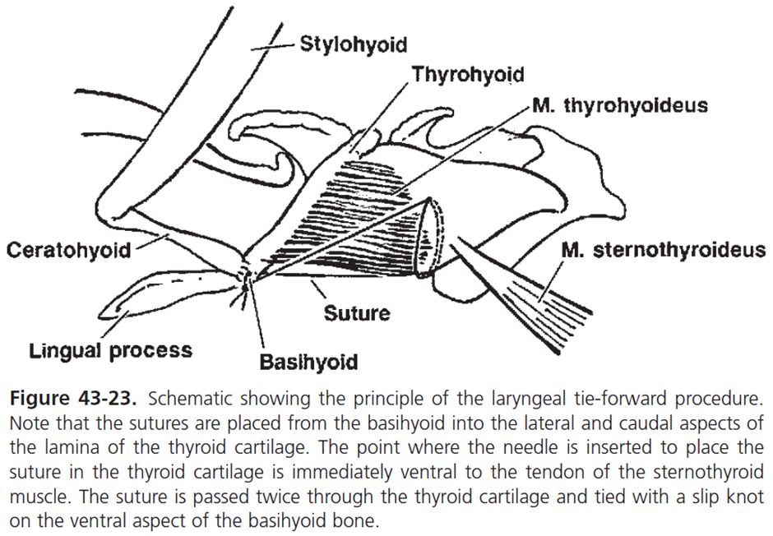
- The Sternothyroid tendon of insertion is transected after the sutures are placed in the thyroid lamina.
- A suture or wire passer is used to pass the most dorsal suture on the right side and most ventral suture on the left side dorsal to the basihyoid to exit on the right side of the lingual process where they are tagged with separate haemostats.
- The most dorsal suture on the left side and most ventral suture on the right side are then similarly passed dorsal to the basihyoid to exit on the left side of the lingual process where they are tagged with separate haemostats.
- To remember the suture, order the phrase “Dude Is Very Cool” can be used; Dorsal suture is placed Ipsilateral, Ventral suture placed Contralateral.
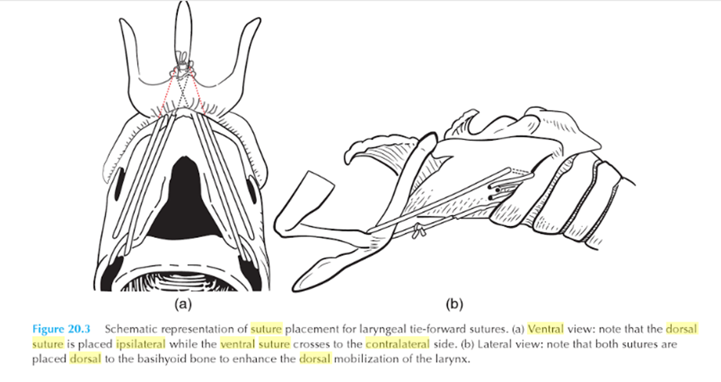
Mobilization of larynx:
- The horse’s nose is lifted so the head and neck are angled at
approximately 90°.
- The sutures are tied separately using a slip knot. The sutures are tied so the rostral aspect of the thyroid cartilage is ~1 cm rostral to the caudal aspect of the basihyoid bone.
- The larynx moves approximately 4 cm rostrally and 2 cm dorsally using this procedure.
- Remember that the dorsal movement is more important. The head is replaced in its normal resting position and the incision closed.

