NERVE BLOCKS | INDICATION | ANATOMY/INJECTION SITE | NOTES
Auriculopalpebral nerve block | To prevent eyelid closure during examination of eyeball | 22G 1.5” needle with 5-10ml of local anaesthetic is inserted in front of the base of the ear at the end of the zygomatic arch and is introduced until its point lies at the dorsal border of the arch  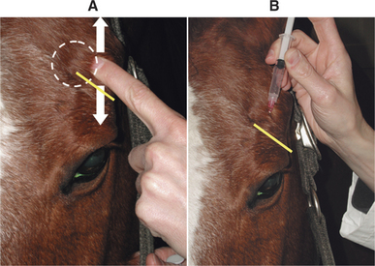 | Does not provide analgesia of the eye or eyelids
Infraorbital nerve block | Desensitizes the nose, muzzle, incisors and rostral maxilla on the side injected. | Done at the exit of infraorbital nerve from infraorbital foramen. The caudal edge of which can be felt after moving the levator labii superioris and levator nasolabialis muscles dorsally, just caudal to the midway point on a line from the rostral end of the facial crest to the nasal incisive notch. The 22G 1.5” needle should be directed rostral to caudal and angled to get down to the nerve at the level of the foramen and 5-10ml of local anaesthetic is administered.  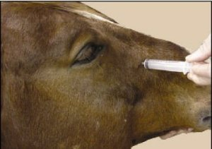
Supraorbital nerve block | Desensitises the middle 2/3rds of the upper eyelid as well as the forehead. | Palpate the two edges of the bone bridge caudal to the eye [supraorbital process of the frontal bone] and follow these to the point where they diverge, which is about level with the dorsal rim of the orbit, the foramen will be felt midway between your finger and thumb. Local anaesthetic can be infiltrated subcutaneously.  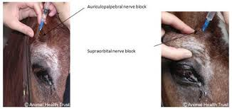
Mental nerve block | Densitises the ipsilateral rostral mandible, the canine and incisor teeth as well as the lower lip. | A 22G 1” needle with 5ml of local anaesthetic is used. The mental nerve can be injected close to its exit from the mental foramen on the lateral side of the mandible rostral to the first cheek tooth. To feel the foramen the depressor labii inferioris muscles needs to be displaced ventrally. The needle is directed in a rostrocaudal direction towards the foramen, where 5ml of local anaesthetic is infused. Infusion should be done gradually with needle insertion to get some anaesthetic around prior to penetration.  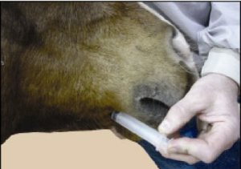
Mandibular nerve block | Desensitizes the lower teeth, the mandible and lower lip on side of injection. | A 7” needle is used and 10-20ml of local anaesthetic is administered. The nerve is injected close to the mandibular foramen on the medial side of the mandible is at the intersection of a line along the occlusal surface of the cheek teeth and a perpendicular line through the lateral canthus of the eye. A needle can be inserted vertically from the caudal aspect of the horizontal ramus of the mandible, being careful not to puncture the facial artery. The distance to the occlusal surface of the teeth can be premeasured on the needle ≈5”. The medial surface of the mandible is slightly concaved so bending the needle before insertion can help get the 20ml of anesthetic closer to the foramen. A shorter approach to the foramen is from caudally on the vertical ramus. Turning the horse’s head to the opposite side moves the caudal aspect of the mandible laterally which makes directing the needle easier.  