Pre-Op Method

Patient Preparation
A day before the surgery, the patient (R 43) , a 28.4 kg, 1 and a half year old, mixed breed ovine was given penicillin-streptomycin IM (dosages and volumes of all drugs are listed in the instruments & drugs section of the cmap), and then its right flank, inclusive of the right paralumbar fossa was shaved along with the skin covering the jugular groove and the dorsum of its metacarpus. These areas were shaved as the flank was the surgical site to be used, and the metacarpus and jugular were sites to be used for catheter placement.
On the day of the surgery, the patient was sedated with ketamine-stun IM, and given tetanus antitoxin subcutaneously. Two catheters were then placed; in the jugular and in the cephalic vein, but due to the jugular vein blowing and access being interrupted, another catheter was placed in the cephalic vein of the left forelimb. Flunixin was given IV for analgesia. An epidural was given in the lumbosacral region where a solution of ketamine and bupivacaine was injected into the epidural space. Lidocaine and Ketamine as in induction doses were given IV and the patient was then immediately placed on CRI drip bag containing 0.5 ml Xylazine, 10 ml Ketamine and 10 ml Lidocaine at a drip rate of 1 drop per second. When the patient seemed to have been going too ‘deep’ under the anaesthetic effects of the CRI, the rate was decreased.
The patient was placed in lateral recumbency and was prepped by scrubbing the surgical site several times (4-5 times) in a concentric manner with alternating usage of iodine & alcohol, and then drapes were placed over the flank and held in place with towel clamps.

Surgeon preparation.
The surgeons first donned on surgical caps, shoe covers and face masks and opened the glove packet and placed It on the operating table. The surgeons then did an initial scrub for 5 minutes, then progressed to do the surgical scrubbing methods, some using the 1) Anatomic timed and some using the 2) Counted brush stroke technique, using Chlorhexidine gluconate and scrub brushes. These two techniques are generally used by surgeons before any surgery, to ensure that bacterial and microbes on the skin are removed as best as possible, to enhance asepsis. After rinsing, hands were dried in paper towels, and the surgeons entered the operating room where closed gloving was performed, and hands were raised to ensure they did not place hands outside of the sterile area. Closed gloving was done, as this method enhances asepsis, as the surgeons’ hands are not exposed to the environment while gloving.

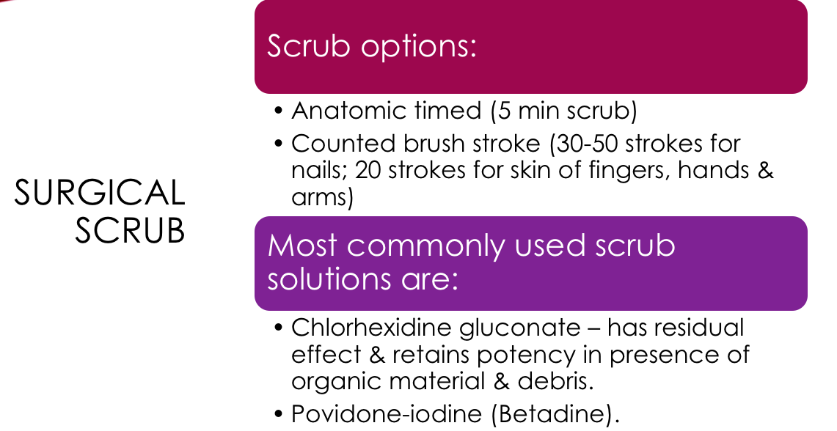
Figure 1 Methods of surgical scrubbing before surgery

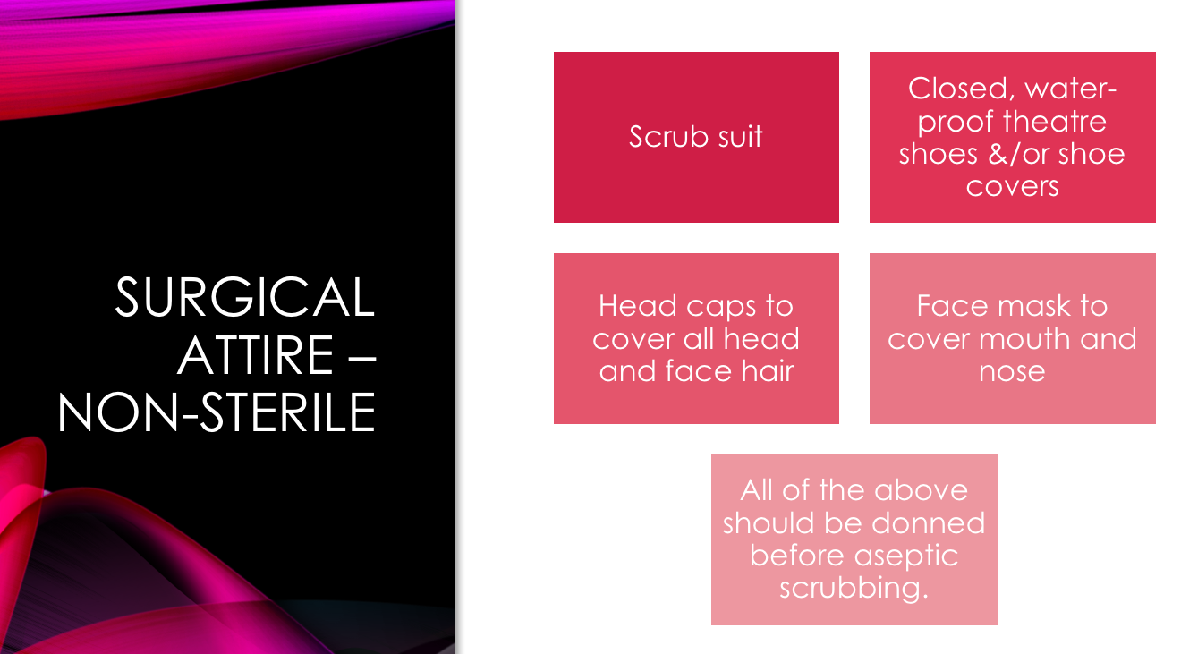
Figure 2 Before scrubbing

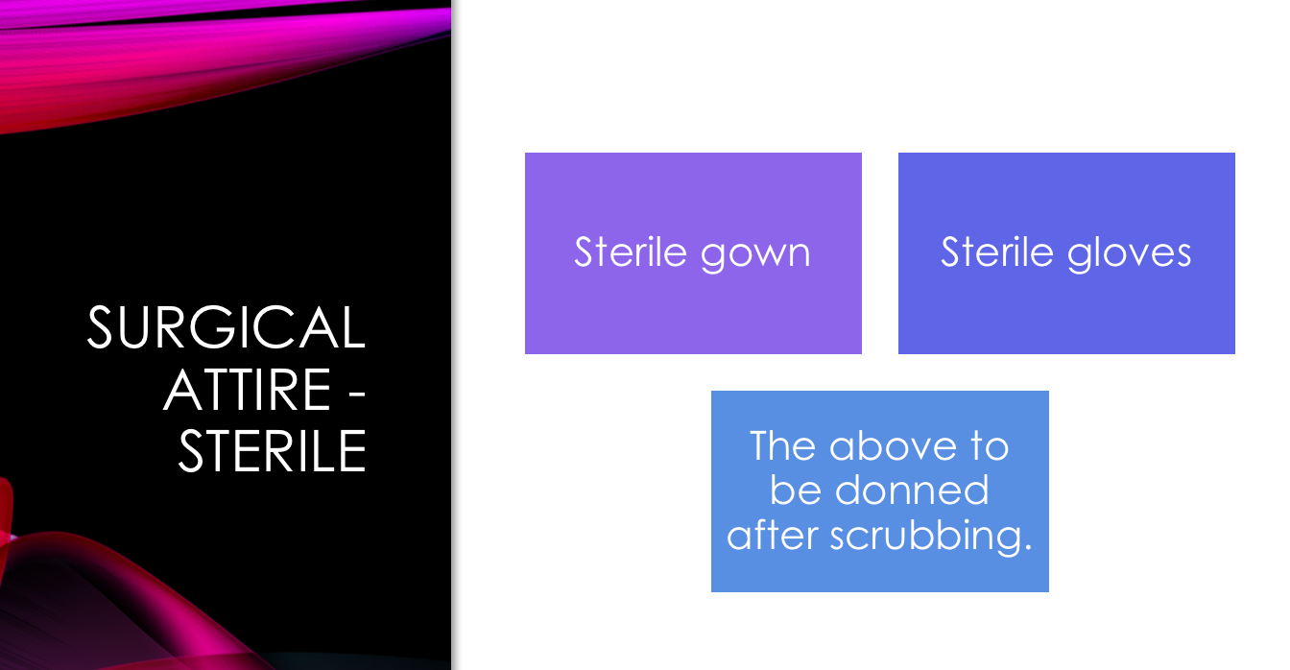
Figure 3 After scrubbing
Intra Op Method:

Complications before surgery:
After being administered CRI, the patient began to show signs of hyperventilation and respiratory distress based on quick, deep, frequentbreaths and increased respistory rate. The mucous membranes changed to a pale colour and the patient developed bloat. To combat this, the patient was placed in sternal recumbency, the CRI drip rate was decreased and a stomach tube was passed to allow release of some of the gas in the rumen, 15 minutes passed and the patient showed no signs of significant improvement, and bloat began to reoccur and thus, the patient was taken off CRI and considered not fit for surgery.
The bloating that occurred, and its adverse respiratory effects may be attributed to the fact that this patient was not fasted before surgery.
Complications of not fasting before surgery is listen in the ‘Complications’ section of this Cmap.

The following procedure is what took place with another surgical candidate and what ideally should have occurred with the patient if the surgery was continued:

After the patient was prepped a 25 cm long longitudinal incision was done midway between the last rib & the tuber coxae using a scalpel. Blunt dissection was done to remove any fascia, fat and excess adhesions in the abdominal wall. The cutaneous trunci muscle was carefully removed using a scissor. Hemostats were used to control hemorrhage. The external and internal abdominal oblique, and transversus abdominus muscles were carefully opened and incised using scissors to ensure no abdominal organs or structures would be accidentally incised. 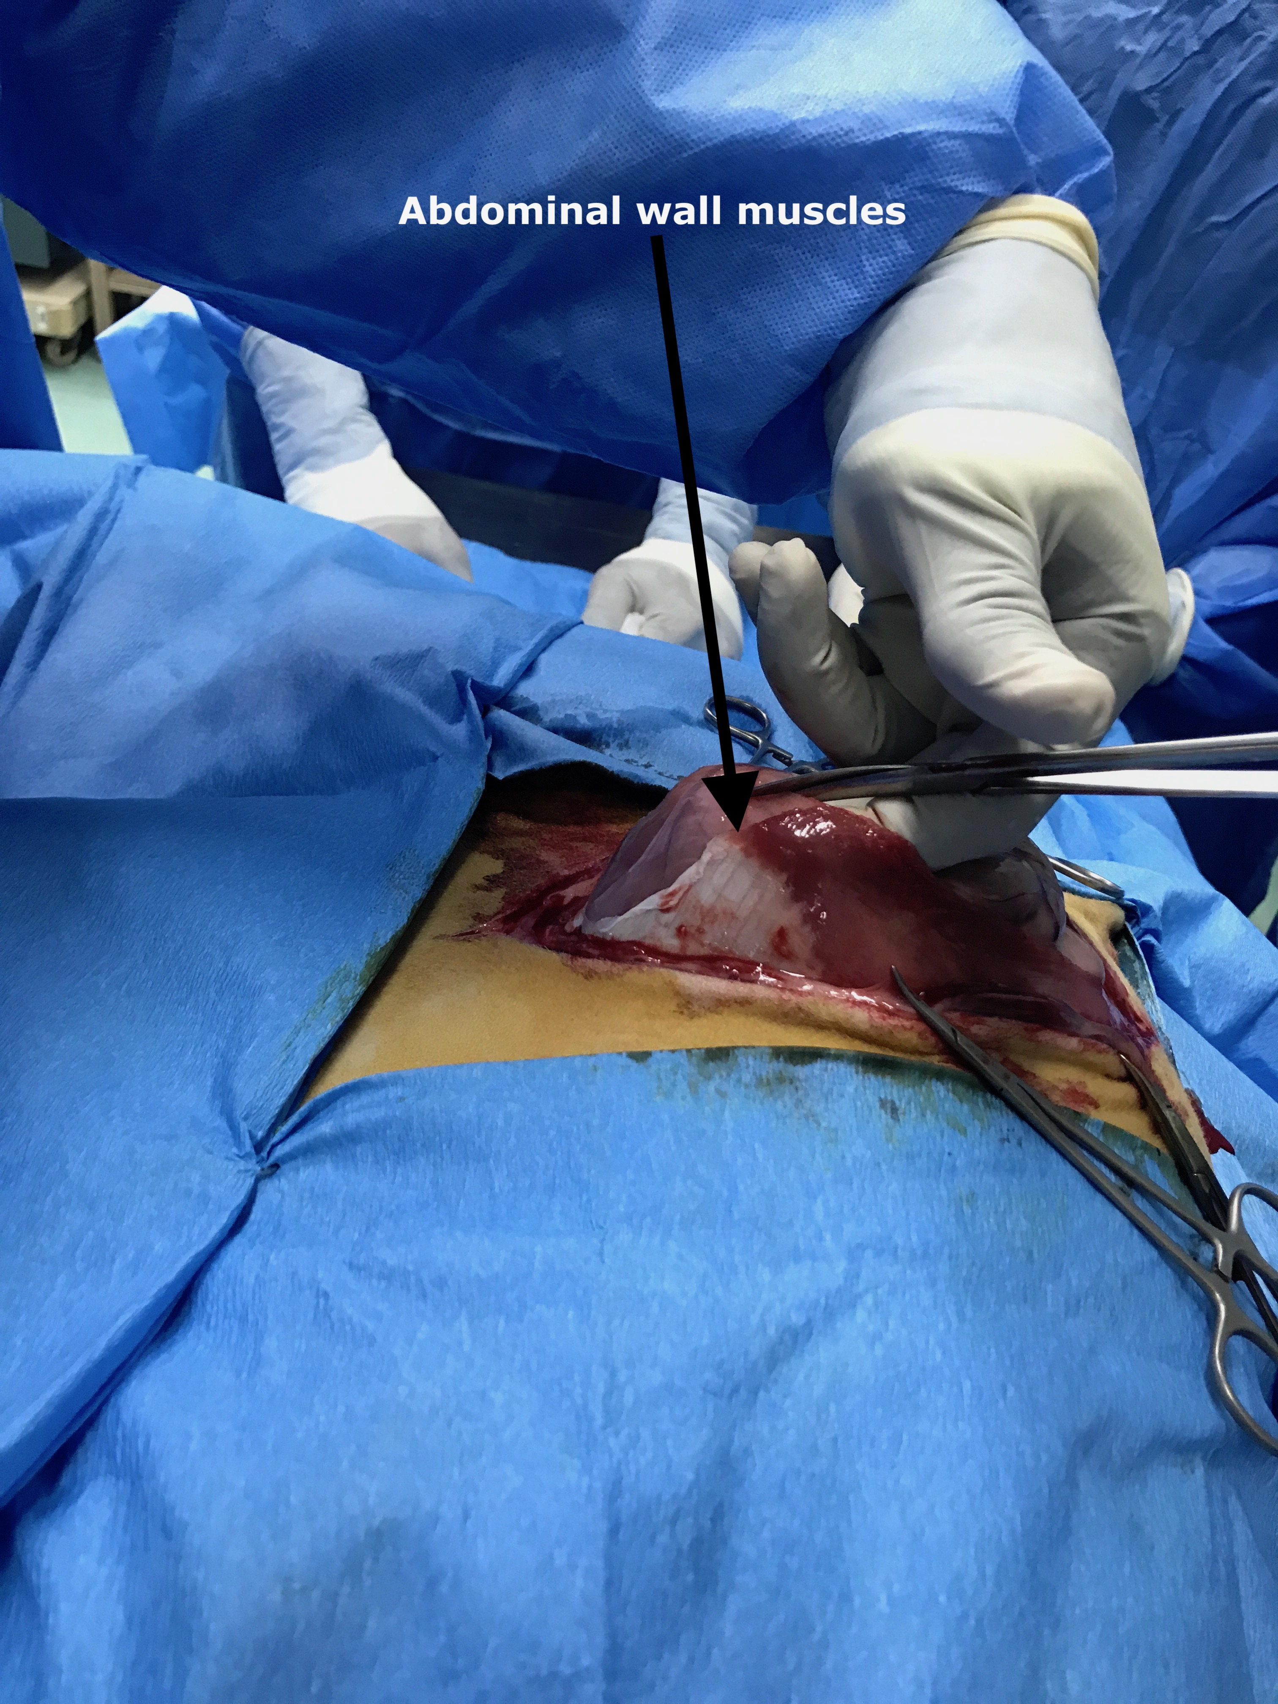
When inside the peritoneum, the surgeons applied saline solution to their gloves for lubrication purposed then began exploration by identifying the greater omentum (sow’s ears) and the lesser omentum. 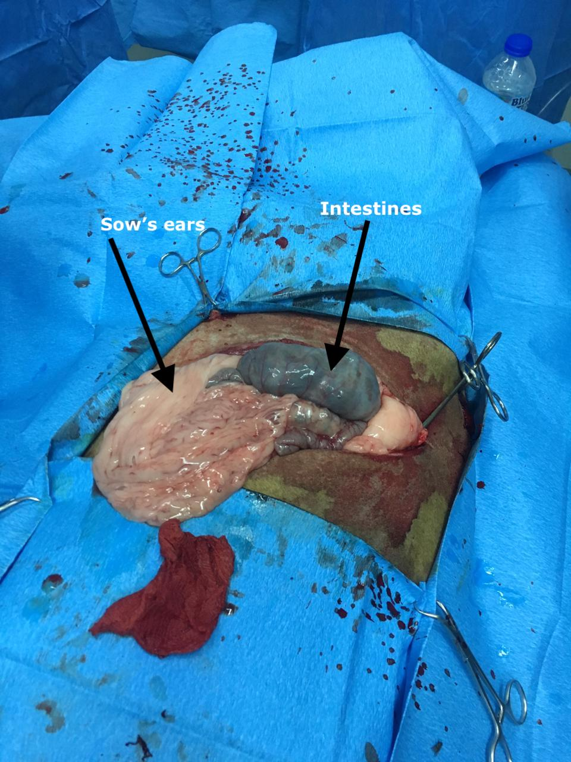
The surgeons exteriorized the intestines and identified the caecum by its blunt end, spiral colon and the small intestines (where the ileum was traced to identify the ileocecal junction. In situ, the right kidney was felt in situ as well as the caudal edge of diaphragm, where the pulse of the patient’s heartbeat was felt and the abomasum and rumen, identified by its ‘doughy’ texture. The ovaries were also identified which contained a corpus luteum, and the texture of this was examined. 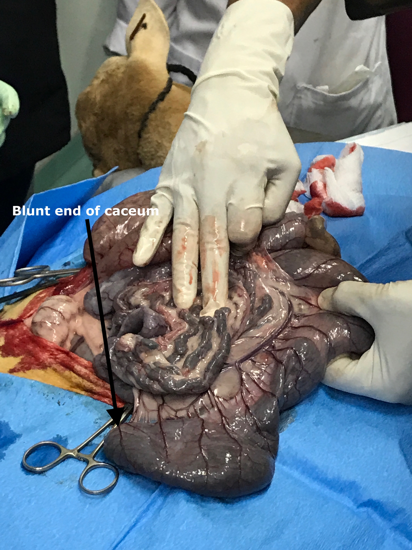
Figure 4 Exploration of the intestines (cecum & spiral colon)
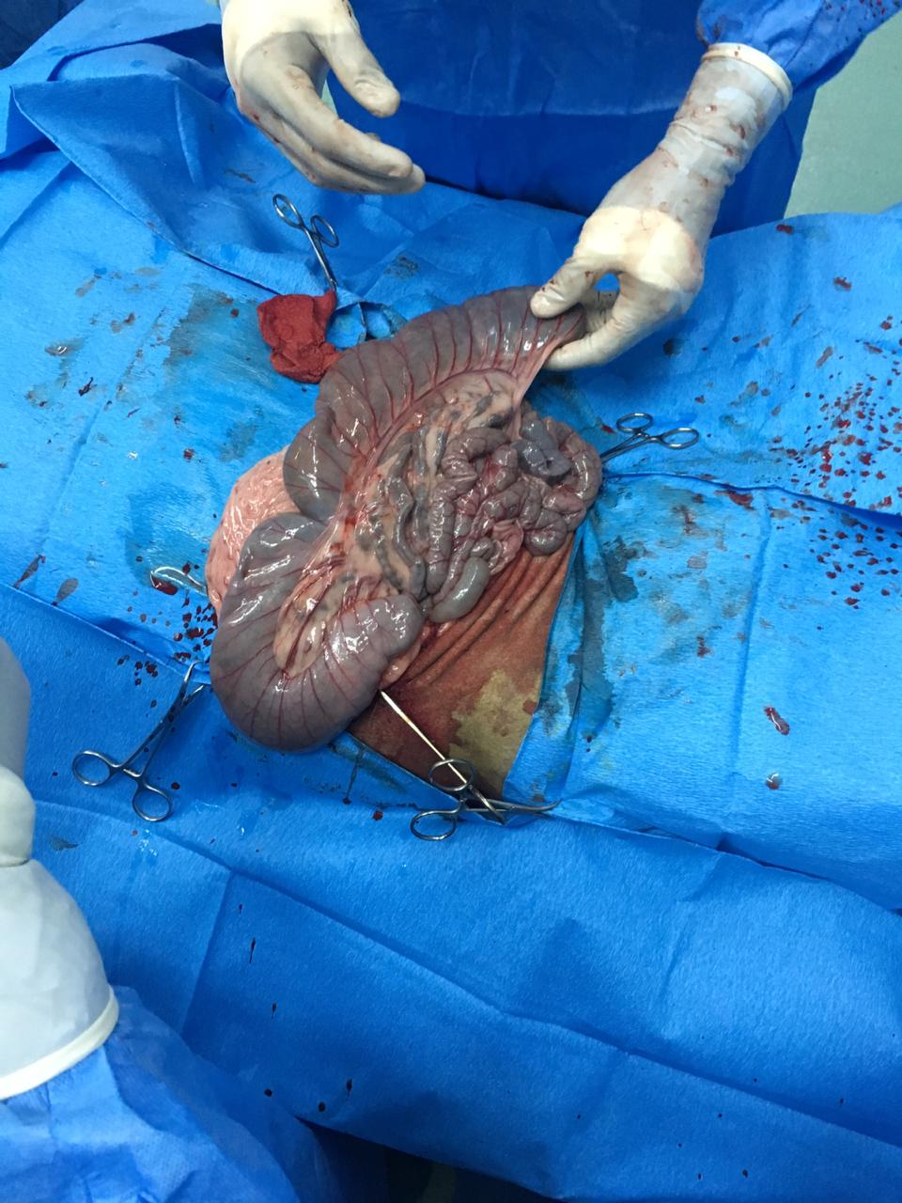
Figure 5 Surgeon holding the cecum, identified by its blunt end)
During entry into peritoneum and during exploration, splash blocks of a solution of lidocaine and saline were given at varying intervals for added local anaesthetic effects. In addition, splashes of Lactated Ringers Solution was intermittently sprayed on the peritoneal contents to ensure that they were kept moist during exploration. After exploration was completed, the internal muscles were closed in a simple interrupted manner using 0 Polysorb and the skin was closed using 2-0 Prolene in a Ford interlocking suture pattern. 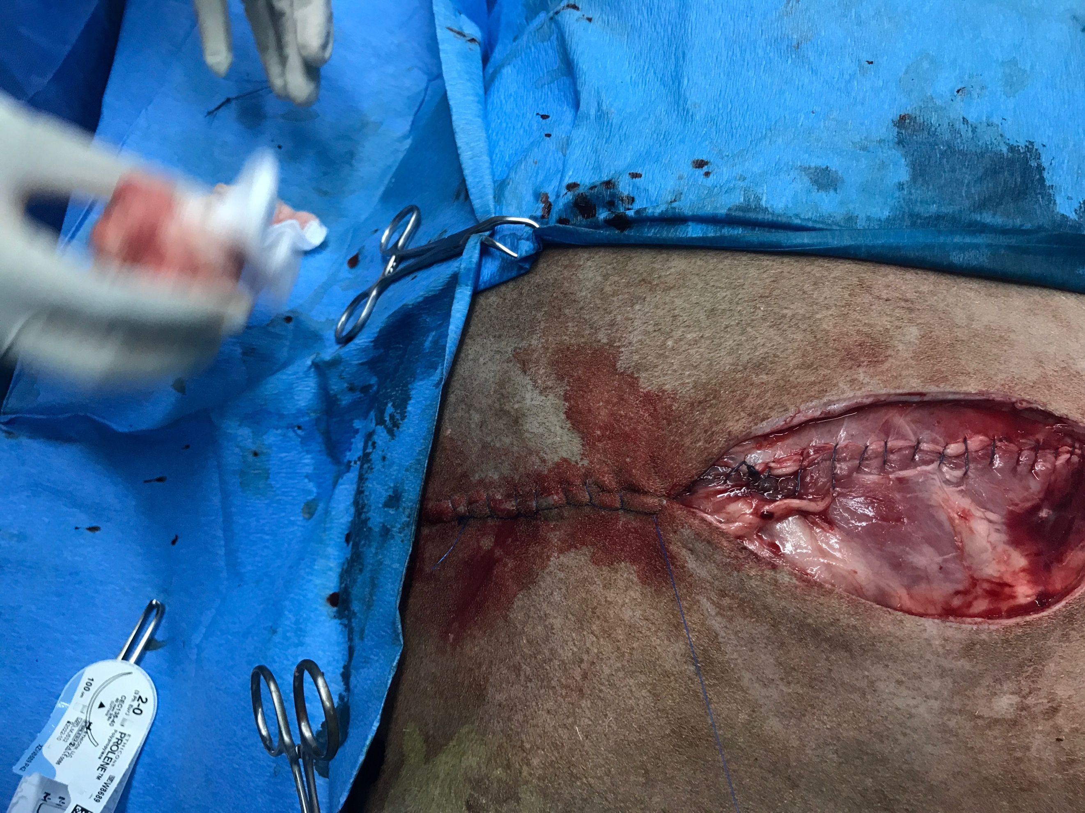
Figure 6 Showing sutures pattern : Simple interrupted for internal muscles and Ford Interlocking for skin closure
After the skin was closed, the skin was cleaned of any blood and debris using chlorhexidine and alcohol, and the surgical site was sprayed with antibiotic and anti myiasis spray. The patient was allowed to rest and recover from anaesthesia for 10 minutes until the animal was bright alert and responsive. The patient was then transported to a clean pen with sufficient bedding and left to fully recover. Post op administration of penicillin-steptomycin were to be given 2 & 7 days after surgery while flunixn was to be given 2 & 3 days after surgery for analgesia. Daily physical exam of the patient was to be done was well as examination of the surgical site for any infection or accidental displacement of the sutures and spraying with anti-myasis spray. 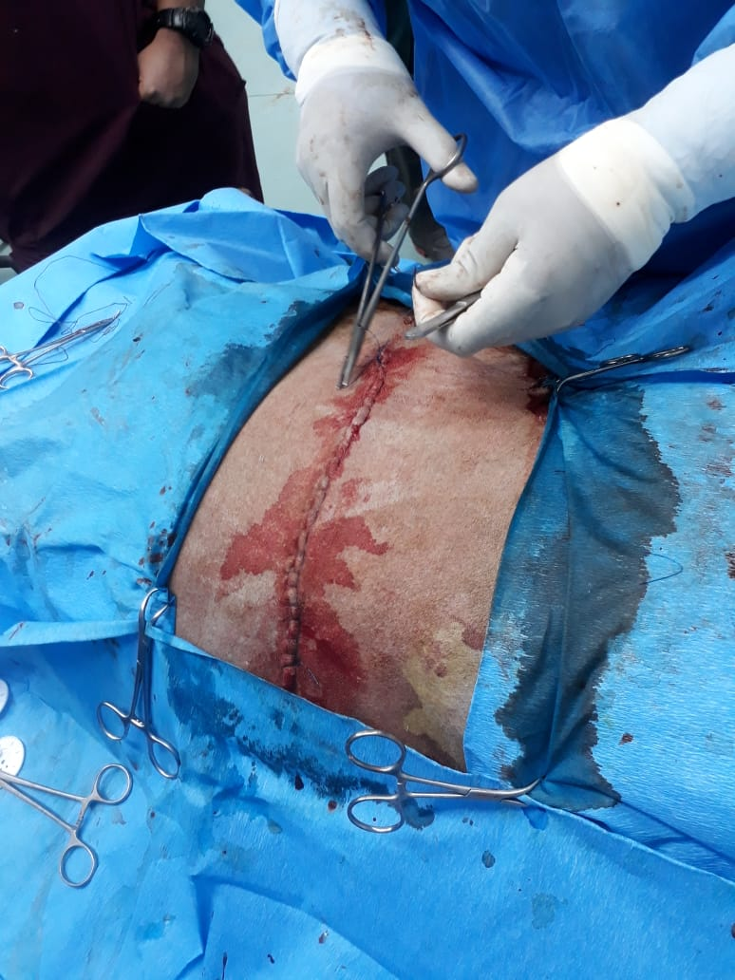
Figure 7 Skin closure

Emergency protocol after pre-surgical complications:
- The CRI rate was decreased to 1 drip every 4 seconds to decrease the dosage of the anaesthetic effects and to reduce the side effects which the patient was experiencing
- A stomach tube was passed to allow release of excess gas in the rumen
- When no signs of improvement were seen, the patient was completely removed from CRI and placed on a saline drip
- The patient was administered Tolazaline IV, at 4 times the induction dose of Xylaine, to reverse its anesthetic effects.
- The patient was left to rest and recover for 15 minutes, after which it was transported on a stretcher back to a clean pen, as walking may have been difficult due to the effects of the epidural. 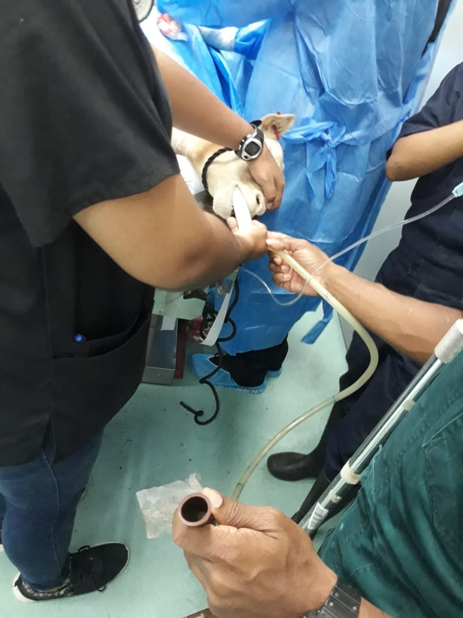
Figure 8 Passing of stomach tube to remove bloat

