Surgical instruments
Instrument | Reason for Use | Picture
Scalpel Handle Number 3 | Used to hold scalpel for more control
Scalpel Blade Number 10 | Used for regular incision and excision of tissues | 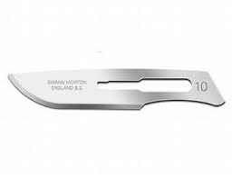
Adson Forceps | Has two fine teeth on the inner portion of the opposing tips that interlock. Used to hold tissue | 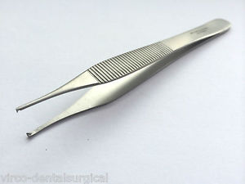
Mayo Scissors | Used for sharp dissection of heavy tissue | 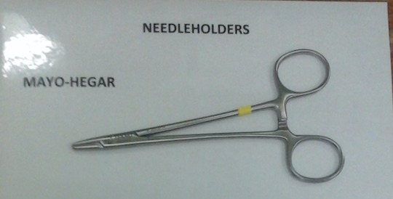
Bandage Scissors | Used to cut bandages and gauze | 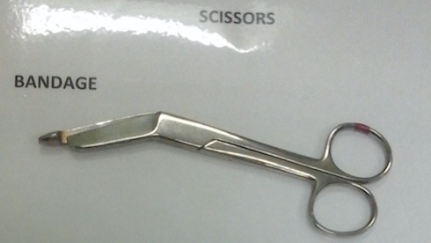
Dressing Scissors | Used to cut suture and materials | 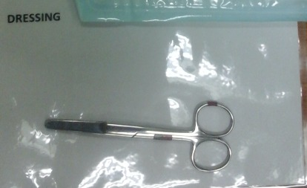
Mayo Hegar Needle Holder | Used to grasp and manipulate curved needles
Backhaus Towel Clamp | Used to fix drapes to the skin of anaesthetised patients | 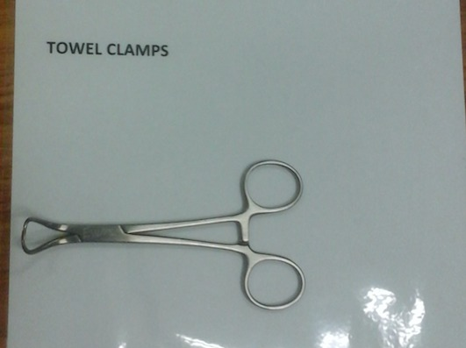
Drape | Used to cover the patient so that the surgical site can be isolated | 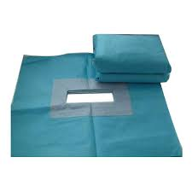
Polysorb 0 Material | Absorbable material used for soft tissue approximation | 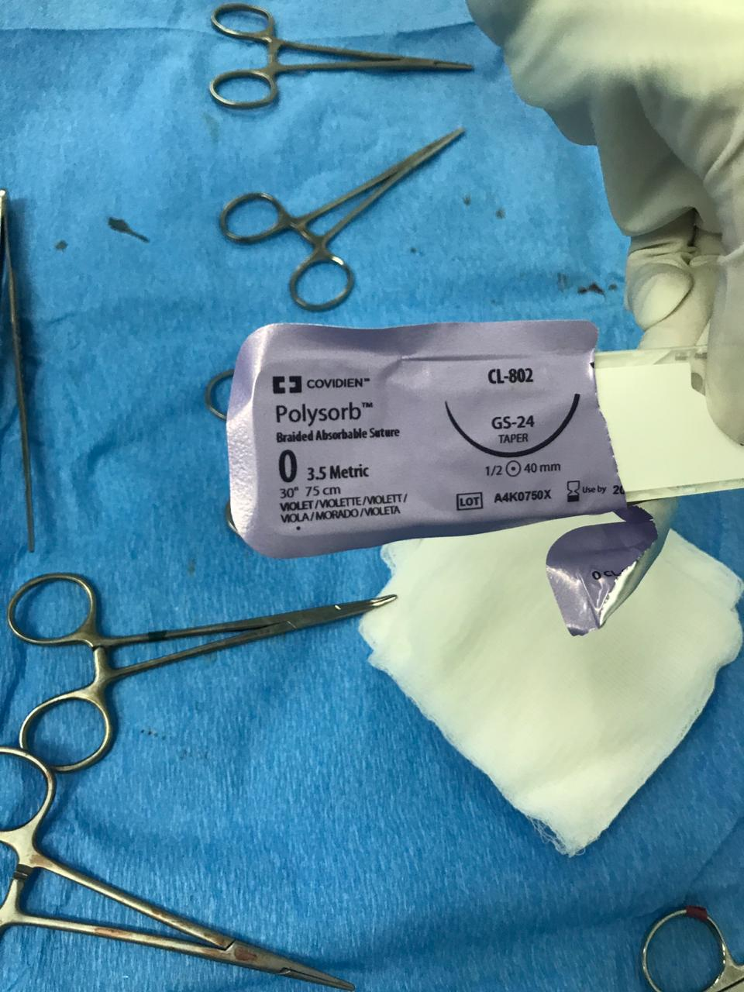
Prolene 2-0 | Non absorbable, Used for skin closure | 