Post-Operative Consideratinons

- Postoperative complications include incisional hernia, seroma, wound fistula and dehiscence.
- The recovery period is almost as important as the anesthetic period is in the small ruminant. Many of the complications associated with anesthesia occur in recovery.
    - The patient should be recovered in sternal recumbency which allows for the return of eructation and gas release. If incubated the endotracheal tube should remain with cuff inflated until the patient can chew, swallow and move its tongue. This provides protection of the airway from regurgitated material still in the animal’s mouth. The cuff should remain partially inflated when the tube is removed. Most sheep and goats seem to enjoy sitting sternally until they can stand easily. The patient can eat and drink 2-3 hours after they are on their feet.
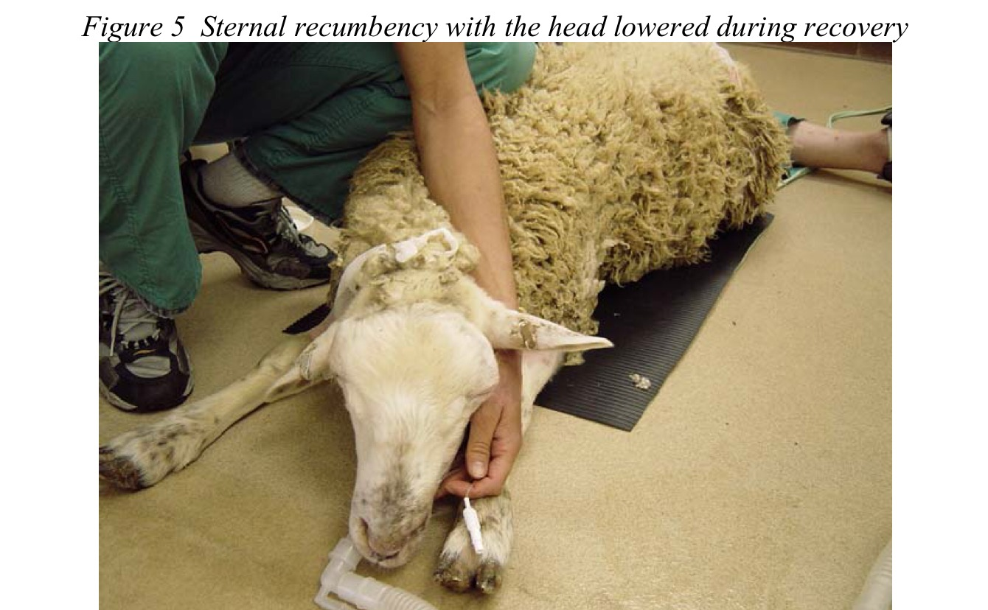
(https://www.acvs.org/files/proceedings/2012/data/papers/170.pdf)

- Ruminants generally remain in sternal recumbency until able to stand
- Position in sternal recumbency with a pad placed under the mandible with the mouth end below the level of the larynx to drain saliva/regurgitants and prevent aspiration
- Regurgitation in ruminants is always a possibility and therefore the ET tube cuff must remain
- in place as inflated
- If animal does not show sign of getting light for > 20 minutes, reversal can be considered using Tolazoline 0.2 – 1.0 mg/kg IV. This sheep was reversed using tolazoline to reduce the present risks of having animal under anaesthesia. The patient was monitored until mucous membrane colour returned to pink and the respiratory rate returned to normal. He was checked once every hour for the next two hours and was BAR.
- Close observation should be continued to avoid the animal returning to sleep and risk of developing aspiration until the animal is on its feet
- Continue to routinely monitor animal behavior and PE as well as TPR, mm, rumen contractions and capillary refill time for 48 hours post op and daily.
- Suture removal in 10 - 14 days
- Post op medication -
- Antibiotics
                - No antibiotics administrated unless issues
- Anti-inflammatories
                - Minimize other treatments
- Note meat and milk withdrawal periods
- Diet
                - Feed as usual

- Assessment of pain in ruminants can be difficult due to their stoic nature. Behavioral changes associated with pain include decreased appetite, sluggishness, indifference to the environment, and avoiding human contact.
- Due to the difficulty of accurately determining pain levels in ruminants, the routine use of analgesic therapy prior to and following painful or surgical procedures is recommended.
- Monitor wound for complications such as rupture, dehiscence, signs of infection, myiasis and dress with antiseptic dressing routinely.

