Client Information

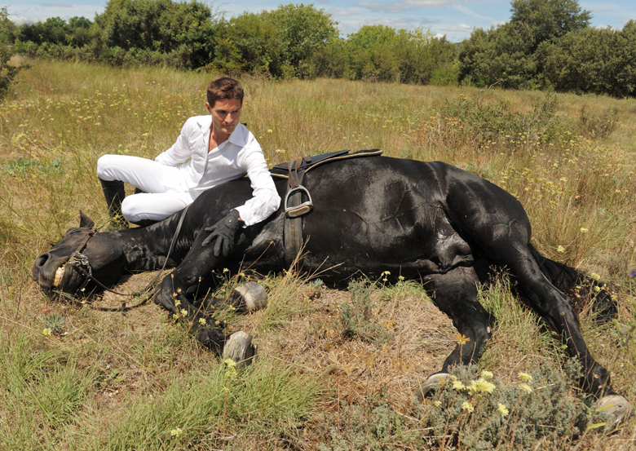

**What to Do**

If the horse is mildly uncomfortable and quiet and not trying to roll, it's probably safe to watch him for a short period. If he's in greater pain or if his discomfort persists after an hour or two then it warrants a call to the veterinarian. If you're in doubt, call and explain your horse's signs. It's better to be proactive.

Meanwhile, take the food away as Impactions are a common cause of colic, and don’t want the horse to eat anything that might add to an obstruction.

* Keep a close eye on him. His signs may take a turn for the worse or seem to improve but then return, so watch for changes. If he's quiet, let him rest in his stall constant walking just exhausts people and horses. But walk him if he tries to roll as rolling could displace the colon, turning a simple gas colic into a more serious case.
* Give a single dose of Banamine (flunixin meglumine) if the veterinarian agrees and you have this prescription medication on hand. Banamine, a nonsteroidal anti-inflammatory drug, that eases belly pain and may help your horse weather a mild colic episode. Some would advise against this out of concern that the drug will mask signs of a potentially surgical colic, but one dose won't do that. A safe dosage rate is 1 milligram per kilogram of body weight, or 500 milligrams for a typical adult horse, every 12 hours.
* Don't repeat the dose, it will be half an hour to an hour before the drug takes effect, so don't give a second dose if your horse isn't better right away. Higher doses and multiple doses may mask serious signs.
* Don't wait to call the veterinarian if the horse doesn't improve in a couple of hours or if his signs worsen or return. Often people find the horse sick in the morning, watch him all day and then decide as night is coming on that it's time to get help. That's not good for anyone, especially the horse. In a surgical case, there's a window of opportunity, a matter of a few hours, before serious damage occurs.
* After assessment from the vet and the horse's pain isn't severe, isn't dehydrated and the exam doesn't turn up anything that suggests surgery, it'll probably be able to get through the episode at home. The veterinarian will give instructions for the horse’s care. The horse will need to be watched closely for a day or so, making sure he's comfortable, that it’s heart rate and gut sounds remain normal, appetite returns, and the horse passes normal manure. It would also be advised that feed be skipped for a day and give him small, frequent feedings of good-quality hay. Controlled hand walks and grazing should be included she adds. If he continues to be OK, gradually return him to his regular diet and routine work.

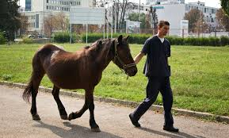

Cut colic risks with smart management:

1. Control intestinal parasites: Strongyles and other parasites can damage your horse's intestines and are a top colic cause. Work with the veterinarian to set up a deworming and parasite-control program.
2. Make sure he drinks water as it keeps food moving through his gut. If your horse doesn't drink enough, he's at risk for an impaction. Give him continual access to clean water. Offering salt, feeding mashes or soaked feed and warming water in cold weather are ways to increase -water consumption.

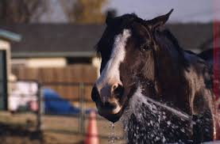

1. Feed forage as the horse’s digestive system is set up to process high-fibre forage like hay and grass. Large amounts of grain may raise the risk of gas and impaction. Meet most of its nutritional needs with forage and divide its concentrates into several small feedings a day.

4) Avoid feed changes, as changes in concentrates, hay or sudden access to pasture can trigger colic. Gas production often increases as the beneficial microbes in the horse's gut adjust. When making a change, do it gradually over a period of days.

1. Turn him out. Light exercise and constant nibbling during turnout will help keep the intestines in good working order.
2. Stick to a routine as abrupt changes in lifestyle are linked to increased colic risk, so be as consistent as possible in work, feeding and turnout schedules. If there's big changes such as a stall rest, a move to a new barn, or travel to a competition one must be alert to the risks.
3. Don't rush meals. When the horse exercises, its circulation sends blood away from the digestive tract to its muscles. The horse also sweats, losing fluid. Follow the one-hour rule by waiting an hour after feeding before riding and wait an hour after riding before feeding.
4. Check his environment by observing for bits of plastic and baling twine or other debris your horse could accidentally ingest. Check for poisonous plants and signs that he's chewing fences or other objects.
5. Cut sand intake If your horse is fed in a sandy paddock by putting his hay in a rack with rubber mats below. If he's turned out in an area with sandy soil, consider feeding a psyllium supplement. Psyllium turns into a gel when wet and may help move sand through the gut.
6. Arrange a dental check-up. If your horse can't chew his feed properly, he's at greater risk for impaction.

