HOOF TRIMMING PROCEDURE
Firstly, prior to conducting any surgery in the hoof, full understanding of the anatomy and conformation (refer to Background and Pre- Operative Preparations) of both fore- and hindlimbs must be ensured.
Hoof assessment can be very valuable to the indicating the cause of lameness in animals and used when selecting male animals for structural soundness for breeding purposes (as shown below).
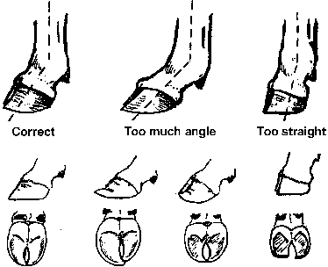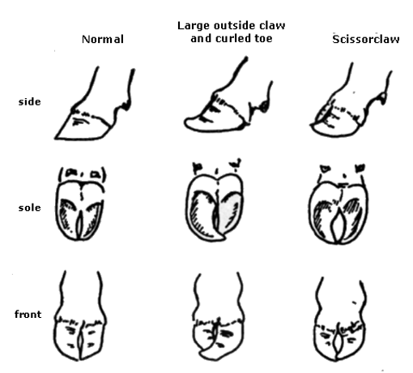
Figures 1, 2: Assessing bull’s hooves for structural soundness
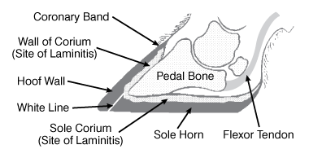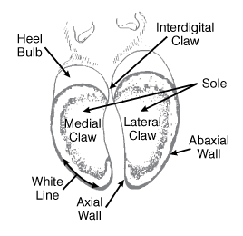
Figures 3, 4: Anatomy of a hoof of a small ruminant
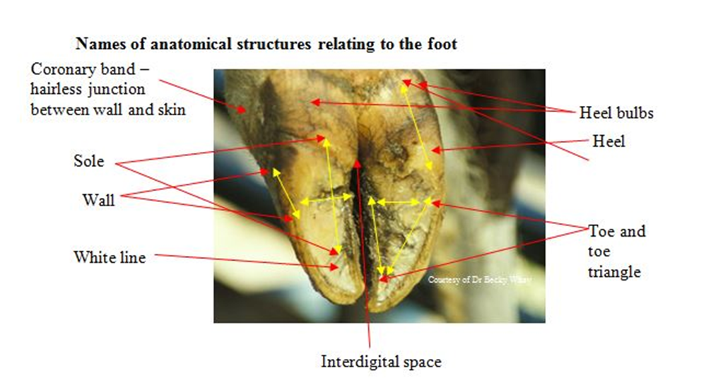
The 'Dutch 5 Step method' of claw trimming is the internationally accepted approach to effective claw trimming which is best implemented following training.

Dutch 5 steps method:
- Functional Trimming
1) Trim toe length to correct length
2) Match untrimmed claw length/level
3) Model (dish) out sole ulcer site
- Corrective (Therapeutic) Trimming
4) Relieve weight off painful claw
5) Remove loose/under-run horn and hard ridges in high risk zones

Practical claw trimming instructions for Holstein-Friesians
1. Correct the toe length - for average Holstein-Friesians measure 8cm from top of where the claw goes hard (8.5-9 cm from top of coronary band). This length may need adjusting according to age, breed, disease and if the wall at the front of the toe is curved.
For hind feet, start with the inner claw (most normal) first in step 1.
For front feet, reverse the claw order throughout this method i.e. outer=inner and inner=outer.
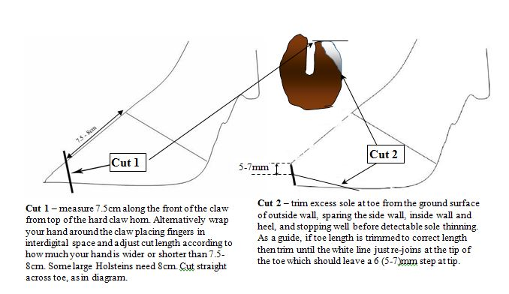
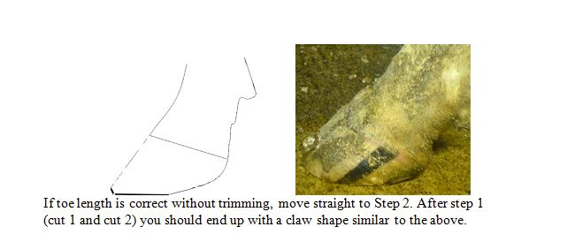
2. Trim the partner claw to match length and balance to first claw (if correct)
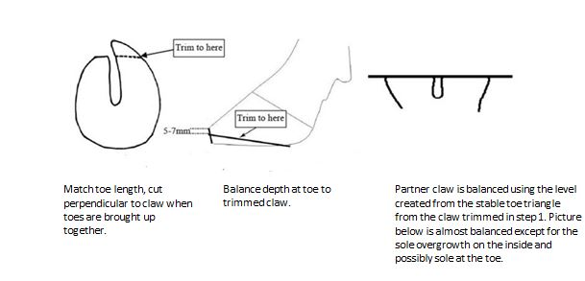
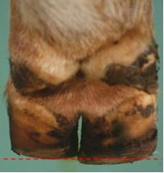
Inner claw Outer claw

The outer hind claw is slightly larger and more likely to be misshaped or affected by bony change around the coronary band. Therefore, errors occur if this claw is measured. Instead, match toe length and levels to the correctly trimmed first claw. Always err on the side of caution, especially in sound and healthy animals. Step 2 correct any obvious imbalances in weight bearing between inner and outer claws.
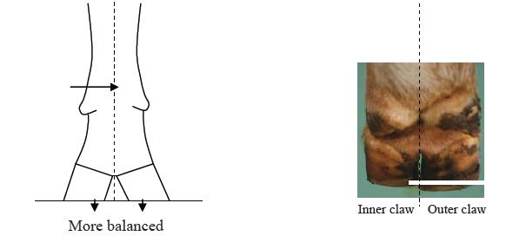
While equal weight bearing is probably ideal, for some animals a naturally shallow heel on the inner hind claw can leave the outer claw over-trimmed and exposed to bruising if completely equal weight bearing is attempted. Therefore, caution is advised when trimming down heels, with frequent checking of sole depth and slight imbalance preferred to thin soles in the heel of the outer hind claw. In sound, healthy animals the heels rarely need much trimming.

3. 'Model' (Dishing out, hollow out) the ulcer site
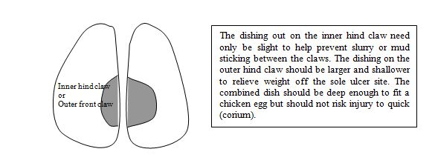
This step transfers weight from centre of the sole onto the harder wall, toe triangle and more cushioned heel.
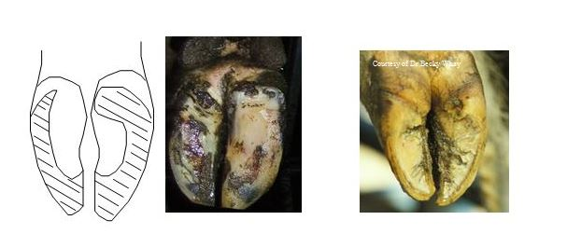
The claw has evolved to absorb concussive forces, bear weight and pump blood through the heel, wall and sole next to the wall. The heel acts like the suspension, absorbing concussive forces as the foot strikes the ground. The wall is the hardest and toughest part of the claw, able to withstand the wear and tear from harsh underfoot surfaces. Carefully dishing out the central sole will aid this function. To be effective, a greater dished area by 2:1 is required for the outer hind claw compared with the inner.
That completes the functional trim. For the functional trim, only excess horn should ever be removed. It also prepares the foot for inspection prior to the corrective trim.

Corrective trim - steps 4 and 5
For the corrective trim, functional shape of the claws must be preserved, and lesions prioritised for corrective trimming. Many healthy cows receiving a routine trim will have no painful lesions or lesions likely to cause lameness. In these cases, claw trimming can move to the final step (5).
In lame cows it is possible to identify painful lesions by:
- Locating a lesion associated with exposed "quick".
- Triggering flinch behaviour when light pressure is applied to the painful claw, either using thumb pressure, pressing on the skin next to the claw or by using blunt "pincers" to apply focal pressure. Similarly, the cow may 'tense' when the claw is gently twisted.
- Heat, swelling, odour or redness affecting one claw or digit (one side of the foot).
By taking a thin 'skim' of horn from the sole surface of the painful claw, tracts of diseased horn may be spotted, and pain confirmed using blunt pincers (or thumbs).
4. Relieve weight off a painful claw - trim down the back 2/3 of painful claw and/or fix a block to the healthy claw
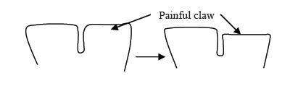
Relieving weight off a painful claw can be achieved in two ways. If there is a good depth of heel horn on the unaffected claw, then the heel horn on the painful claw can be trimmed down (red arrows below). Additionally, a plastic, rubber or wooden block can be applied to the healthy claw for 4-6 weeks. Almost all cows with sole ulcers or white line lesions will benefit from blocks. However, in some cases, bruising or disease may be present on the healthier claw, making it unsuitable for blocking. These cases require a straw yard or nursing paddock to aid recovery. Anti-inflammatory drugs will also help, whether blocked or not.
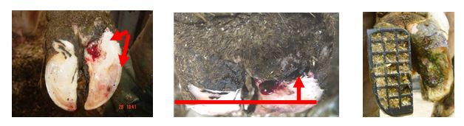

5. Remove loose or under-run horn and hard ridges
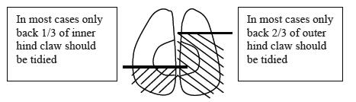

As little serious disease occurs in the front 2/3rds of the inner hind claw, and front 1/3rd in the outer claw, then tracts or under-run horn should be ignored in these regions. Loose horn around the base of the sole ulcer, in the heel or around white line lesions should be removed (red arrows below). However, cutting into the "quick" should be avoided to prevent unnecessary pain, scarring or risk of severe infections spreading to the deeper tissues. The final stage is to ensure there are no sharp ridges that could injure the teats or legs, checked by running the hand over the claw.
