PLACING DRAINAGE
Because you have sepsis, up and down through the tendon sheath, place a drain through to maintain the drain and then suture the incision to close.
Use a Buhner Needle (shown below) to aid with passing the drain material down through the channel of the flexor tendon.
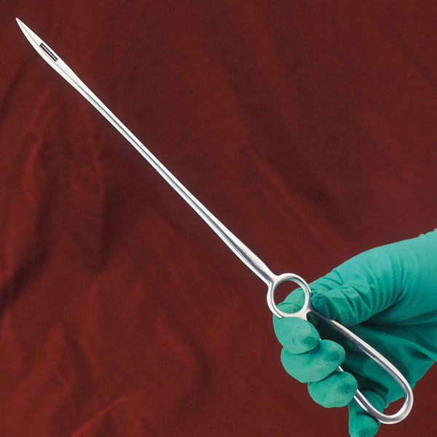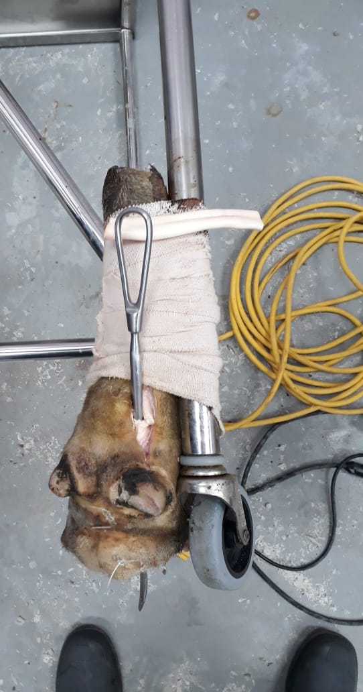
A gum- rubber tubing is usually used as the drainage material.
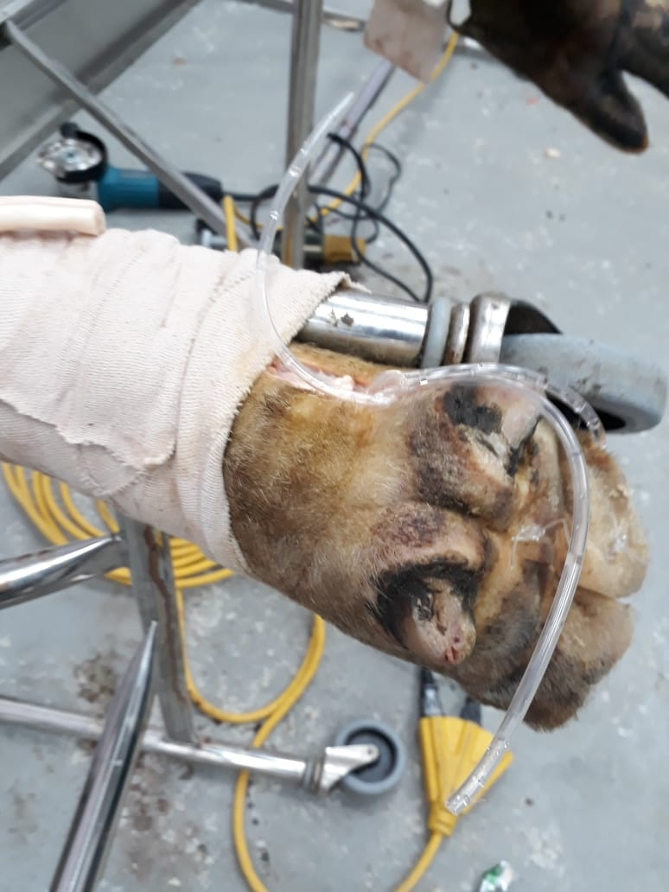
After the Buhner Needle is placed into the incision along the path the drainage is to be placed, thread the tubing through the eye of the Buhner Needle and pull the needle straight through which would simultaneously pull the drainage material along the path needed.
Finally tie the drainage in a knot on the outside of the limb. Suture the incision and bandage the amputated claw/ digit.

