**Anatomy of the Bovine hindlimb:**

* In ruminants, the lateral and medial digits of each limb are connected through the tough skin and interdigital ligaments until the level of the coronary band, where the distal phalanges of each digit are encased within the hoof.

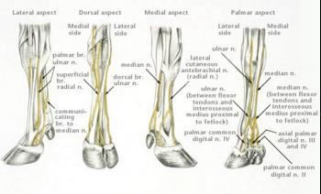

* The Distal (Interdigital) collateral ligament spans the interdigital space at the level of the distal sesamoid bones and travels over the tendons of the deep digital flexor muscle to the abaxial surfaces of the middle phalanges.
* The proximal interdigital ligament connects the axial surfaces of the proximal phalanges.
* The distal interphalangeal joint (DIP) of each digit is formed by the articulation of two distal sesamoid bones, the distal phalanx, and the middle phalanx.
* There are two bursas associated with the DIP joint. The dorsal bursa lies deep to the tendon of the common digital extensor muscle, and the palmar (plantar) bursa lies deep to the tendons of the deep digital flexor and the distal sesamoid bones and associated ligaments.
* The lateral digit bears more weight than the medial digit in the hind limb while the medial digit bears more weight in the forelimb.

