Drugs | Indications | Calculations | Withdrawal Times | Contraindications
2% Xylazine  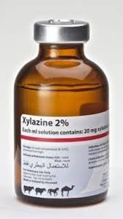 | Dose-dependent sedation and analgesia. Premedication for surgery. | $$Volume=\frac{550Kg ×0.05 mg/Kg}{20 mg/mL}$$  $$Volume=1.38 mLs$$ | Milk – 0 hours  Meat – 0 days | Hypersensitivity
10% Ketamine  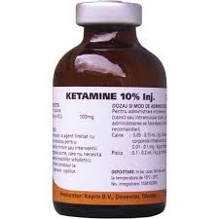 | For induction of anaesthesia in combination with α2-agonists, benzodiazepines or neuroleptics. | $$Volume=\frac{550 Kg ×0.5 mg/Kg}{100 mg/mL}$$  $$Volume=2.75 mLs$$ | Milk – 0 hours  Meat – 0 days | Patients suffering from renal or hepatic insufficiency.
Combikel  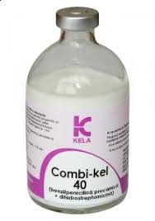 | Prevention and treatment of infections caused by penicillin G and/or DHS susceptible microorganisms. The drug also can be used in postoperative prevention of infections. | $$Volume=\frac{550 Kg ×20,000 IU/Kg}{200,000 IU/mL}$$  $$Volume=55 mLs$$ | Milk – 4 days  Meat – 30days | Hypersensitivity and renal insufficiency in patients  Do not use intravenously
5% Flunixin  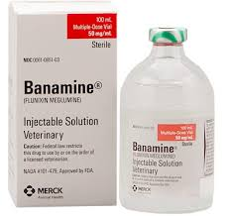 | Control of pyrexia associated with bovine respiratory disease and endotoxemia. Flunixin Meglumine Injection is also indicated for the control of inflammation in endotoxemia. | $$Volume=\frac{550 Kg ×1.1 mg/Kg}{50 mg/mL}$$  $$Volume=12.1 mLs$$ | Milk – 72 hours  Meat – 4 days | Hypersensitivity. Patients suffering from renal or hepatic insufficiency, cardiovascular impairment, gastro-intestinal ulceration and/or platelet disorders. It is also contraindicated in dehydrated animals.
2% Lidocaine  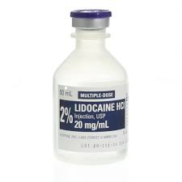 | For local anaesthesia | 5 cc 10 cc per site. | Milk – 24 hours  Meat – 24 hours | Patients with a known history of hypersensitivity to local anesthetics of the amide type
2% Lidocaine Toxic Dose |  | NB: ½ Toxic Dose was used  $$Volume=\frac{550 Kg ×5 mg/Kg}{20 mg/mL}$$  $Volume=137.5mL$s  $$∴Do NOT exceed 137.5 mLs of Lidocaine$$
10% Ivermectin | Effective treatment and control of the following harmful species of gastrointestinal roundworms, lungworms, lice, mange mites and prevention of myasis | $$Volume=\frac{550 Kg ×0.2 mg/Kg}{100 mg/mL}$$  $$Volume=11 mLs$$ | Milk – n/a  Meat – 35 days | This product is not for intravenous or intramuscular use.

Emergency Drugs
Drugs | Indications | Calculations | Withdrawal Times | Contraindications
Tolazoline  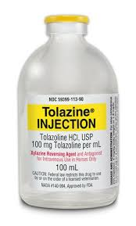 | Xylazine reversing agent and antagonist. | $$Volume=\frac{550 Kg ×0.1 mg/Kg}{100 mg/mL}$$  $Volume=0.55 mL$s | Milk – 48 hours  Meat – 8 days | Avoid giving overdoses of this drug, especially to animals with cardiac or circulatory compromise
Atropine  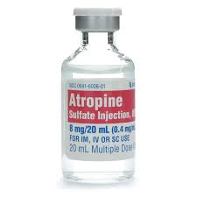 | - Used to reduce salivary and bronchial secretions prior to anaesthesia before surgery.  - Used in the prevention of abnormal heart rhythms and low blood pressure caused by acetylcholine associated events.  - Atropine Injection BP can also be used in the management of acute myocardial infarction.  - Used in the management of cholinergic poisoning by organophosphates or anticholinesterases with muscarinic effects. | $$Volume=\frac{550 Kg ×0.04 mg/Kg}{0.54 mg/mL}$$  $Volume=40.74 mL$s | Milk – 3 days  Meat – 14 days | Patients hypersensitivity to anticholinergic drugs, GI obstructive disease, paralytic ileus, severe ulcerative colitis, obstructive uropathy, and myasthenia gravis.
Epinephrine | Emergency treatment of allergic reactions (Type I), including anaphylaxis. Bronchospasm. Urticaria. Angioedema. Serum sickness. | $$Volume=\frac{550 Kg ×0.02 mg/Kg}{1 mg/mL}$$  $Volume=11 mL$s | Milk – 0 hours  Meat – 0 days | Allergy or hypersensitivity to adrenaline. Pregnant or patients in labor. Patients with ventricular premature beats or other types of heart irregularities

NB: The emergency drugs listed were not used during this procedure.

