Anaesthesia and surgical preparation

- The animals usually placed in lateral recumbency by means of ropes and chemical restraint

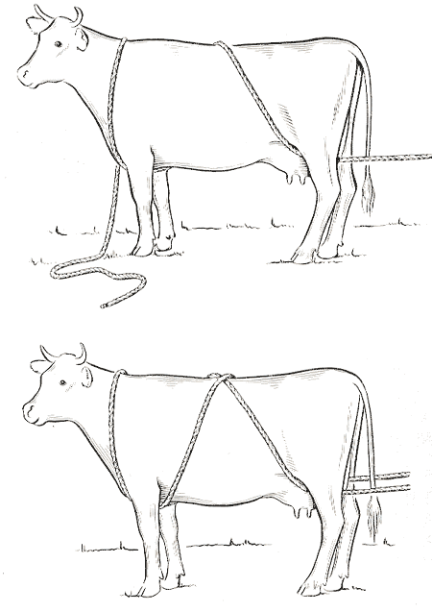
Burley method of casting

- Or it is secured to a surgical table, with the affected claw uppermost.
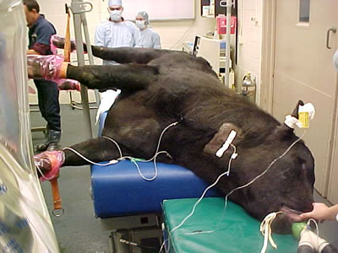

The procedure may be performed with the animal standing, but this is not generally recommended.

- The limb is clipped from the mid -metacarpal region or mid metatarsal region distal, and the area is prepared surgically prior to administering local anaesthesia. The claw and interdigital space are cleared of all faecal material and debris; a scrub brush and hoof knife are useful for this initial preparation.

- Intravenous local analgesia is the preferred method of local desensitization, but regional nerve blocks or a ring block may also be used.

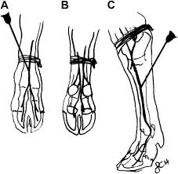

- Following administration of the local anaesthetic, the surgical site is given a final surgical scrub.

- If the intravenous analgesic technique is not used, a tourniquet (rubber tubing) is applied at this stage

- The limb is draped so the foot is exposed, and a sterile glove may be applied over the claw, so I can be handled by the surgeon during surgery

