Anaesthesia of Ruminants
For anaesthesia of the distal limb, the technique of intravenous administration of local anaesthetic drugs is considered superior to specific nerve blocks or ring blocks. The technique involves intravenous injection of local anaesthetic solution distal to a tourniquet.
- The animal is restrained, and the tourniquet (e.g., rubber tubing/Penrose drain) is applied distal to the carpus or hock (Figure 2.5). A protective pad may be placed under the tourniquet.
- Following tourniquet placement, a superficial vein is identified, typically either the dorsal common digital vein III in the metacarpus/the cranial branch of the lateral saphenous vein in the metatarsus.
- An intravenous injection of 10–20 ml of 2% lidocaine or mepivacaine is administered to adult cattle after the area has been clipped and prepared.
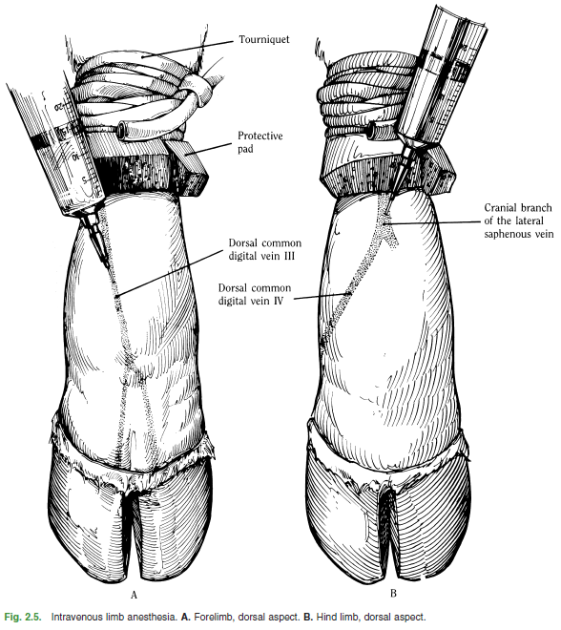
- It is important to avoid the use of lidocaine with epinephrine because the combination may cause regional vasoconstriction and systemic release of epinephrine upon release of the tourniquet may result in adverse effects Following injection, the needle is with-drawn, and the injection site is wrapped to prevent hematoma formation. Alternatively, a small gauge catheter may be secured and left in place until the procedure is completed.

- Anaesthesia of the distal limb is complete in 5 minutes and persists 1–2 hours if the tourniquet remains in place.

- At the end of the operation, the tourniquet is released slowly over a period of 10 seconds, and the limb will regain normal sensation and motor function in about 5 minutes. Toxicity related to the entrance of the local anaesthetic into the circulation at these doses has not been observed.

