Client Communication

- The client should be informed of the expected time of recovery. This would be essential for record keeping to track the patient’s rate of healing and potential for re-introduction into the herd.

- The client must be notified of drugs used before, during and after the procedure and their corresponding withdrawal times and potential side-effects. This is important for both beef and dairy farmers as both have the ability to contain residues that can be potentially poses severe public health consequences that can affect the farm’s reputability and economic success.

- A safe, comfortable enclosure must be established for the patient. To further ensure a relatively steady rate of healing, the immediate environment of the patient must have little to no potential for stress that can slow down healing.

- The surgical wound is to be inspected at least twice a day and sprayed daily with an appropriate anti-myiasis spray (e.g. Bactri-Vet Silver).

- It would be ideal for the patient animal to be isolated from other animals for the duration of recovery. This would prevent the patient from suffering any undue trauma or contamination of the healing surgical wound.

- The pen must be cleaned very often (e.g. early morning and late afternoon) to prevent any contamination of the surgical wound and thus, subsequent infection.

- The relevant veterinarian is to be contacted in the event of any adverse changes e.g. fever, pain, recumbancy.

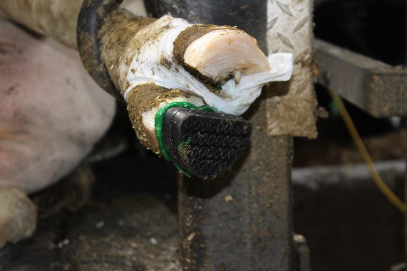
- In cases involving the use of hoof blocks with hooves that were trimmed and found to have pathologies, the routine checks should involve the assessment of the block’s integrity and attachment to the digit, as well as the contralateral digit for growth, healing and any new abnormal developments.

