Equipment and functions

To restrain the cow:
Cattle crush/ stanchion:  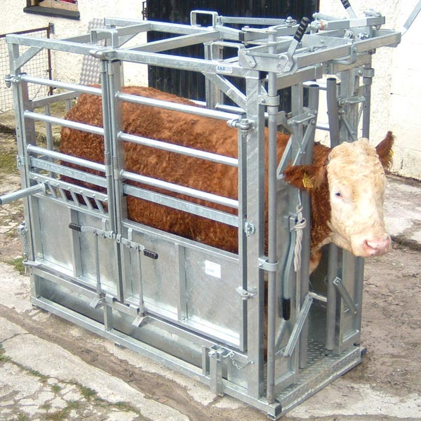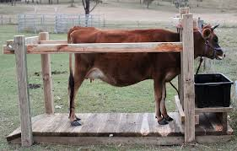 | Allows safe access to the  cow’s front and rear legs
Good quality rope or webbing straps  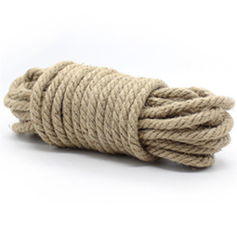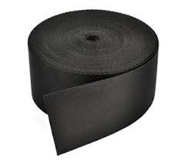 | For restraining legs  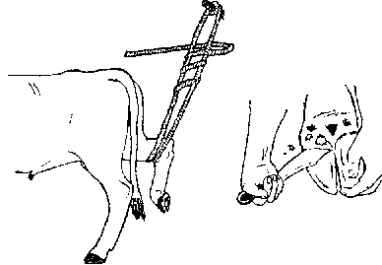
Back bar or rope and/or wide webbing support belt(s)  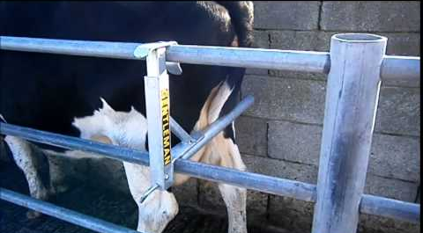 | To prevent the cow form stepping backward

To trim the hooves:
Name | Use
Hoof knifes  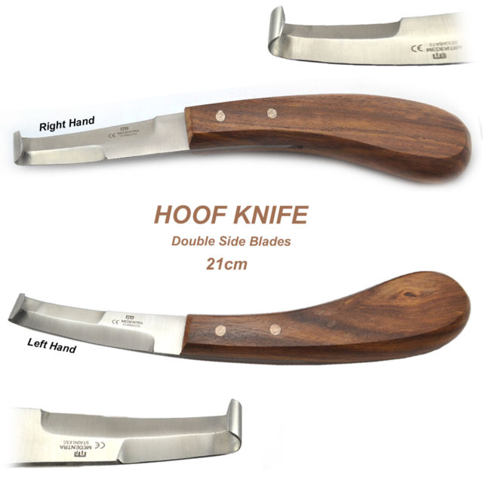 | Trimming away loose and dried out sole  a strong, slightly curved knife with its tip turned laterally on itself to form a tunnel. The flat part of the blade is used to trim the bottom of the hoof wall and the curved part to make grooves or cut holes.
Hoof tester  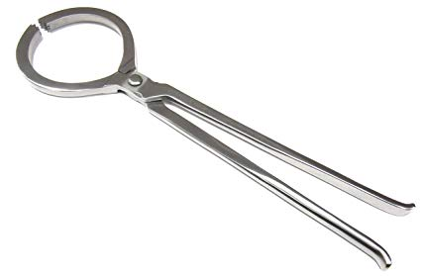 | They help detect abscesses, stone bruises and many other problems.
Hoof trimmer  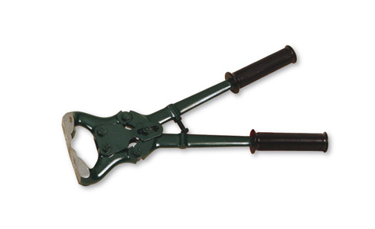 | To clip the overgrown toes
Rasps  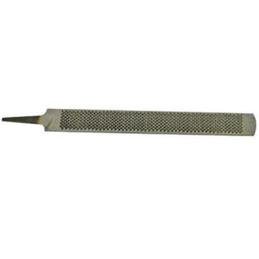 | To remove excess wall
Hoof Grinder and grinding disks  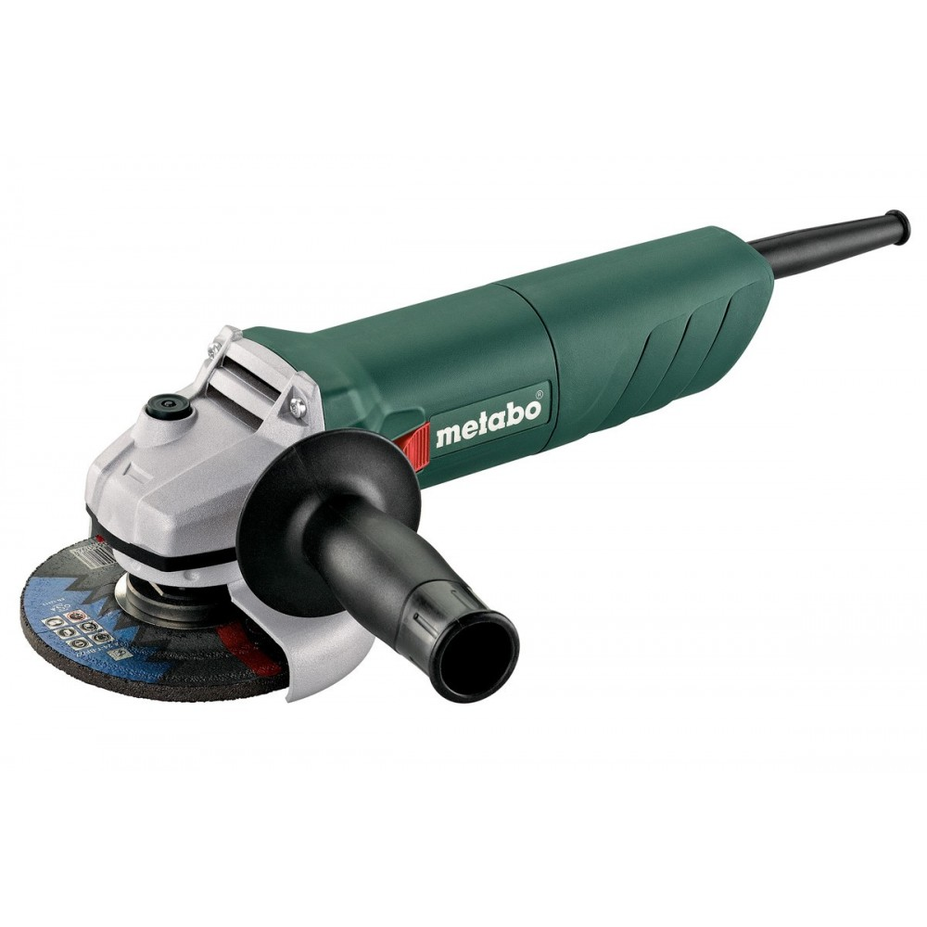  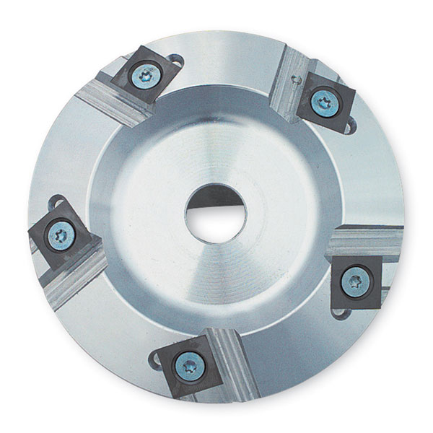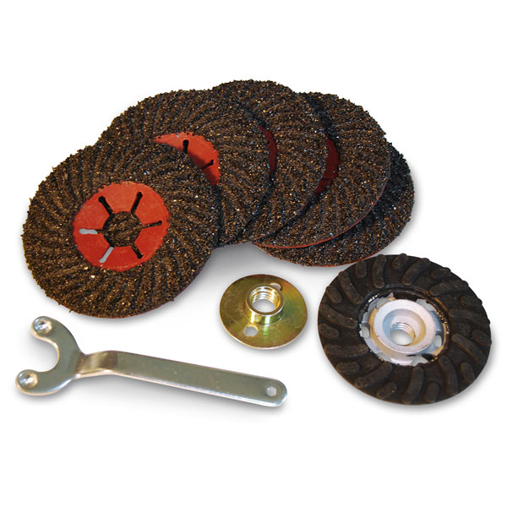 | for grinding the bottom of the hoof as well as between the toes.
Merlin hoof trimming tool  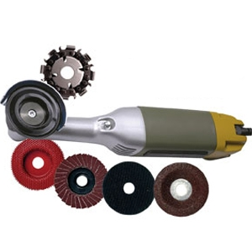 | For quickly removing excess hoof wall material or over-growth, cleaning pith from the sole area and dress the flare from the hoof wall. The Merlin can be used for both corrective and routine or maintenance trimming.
Cow slip or wooden blocks and suitable adhesive  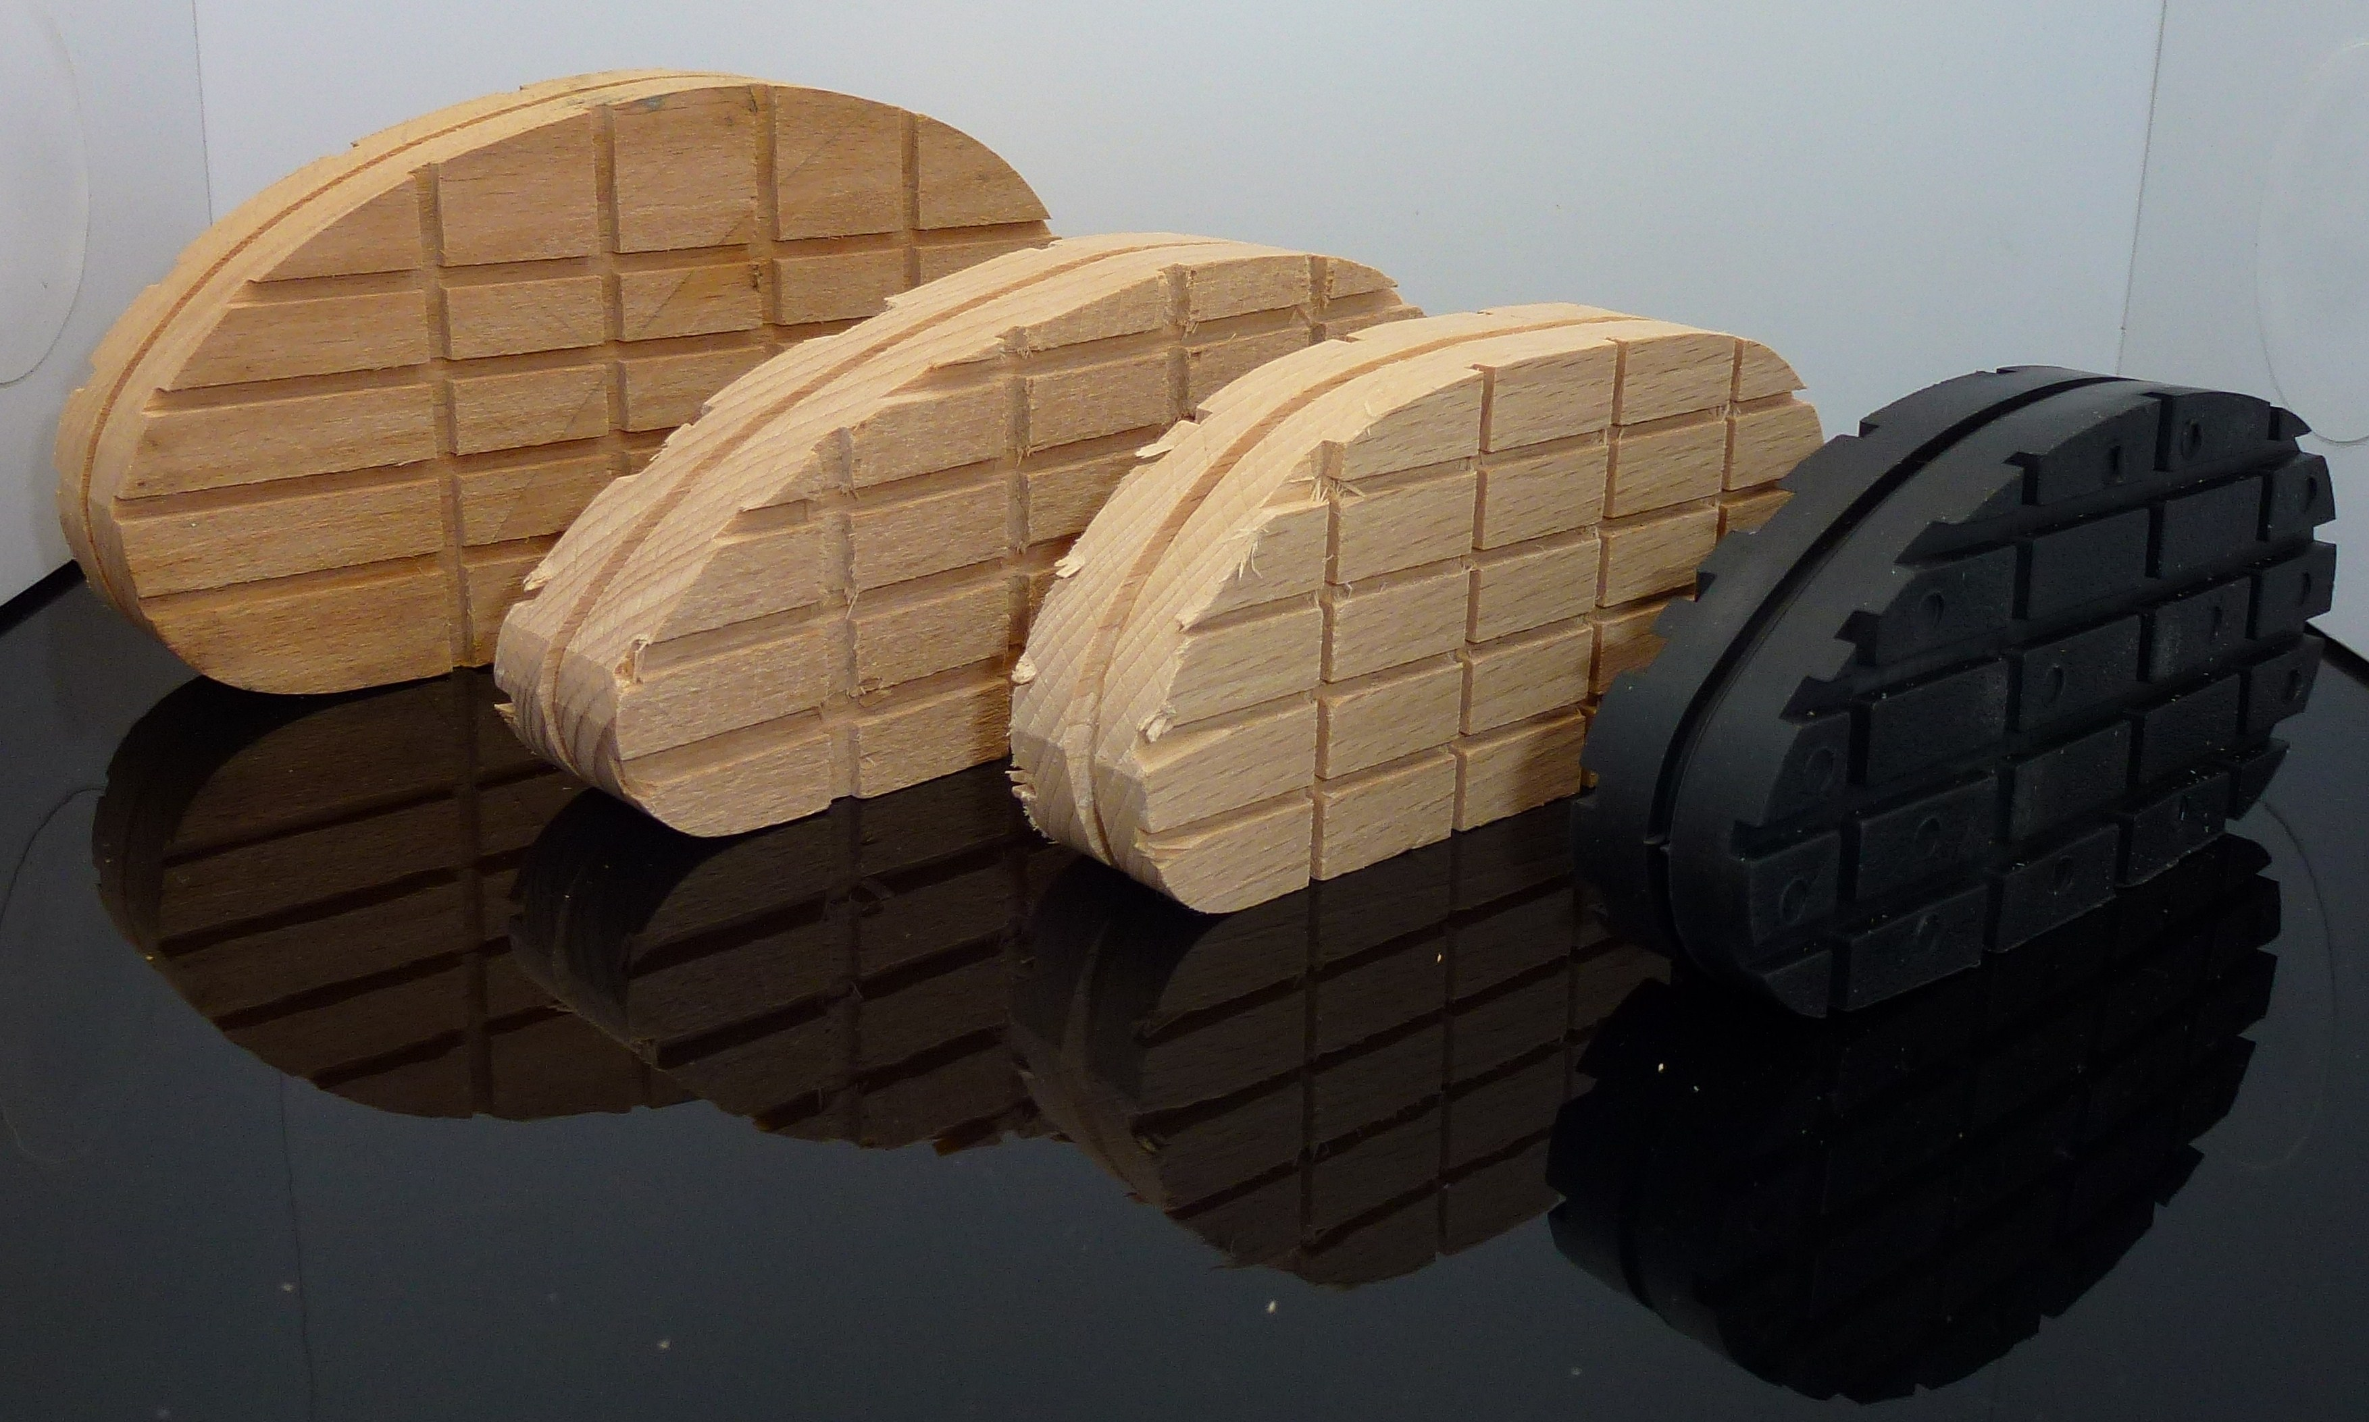  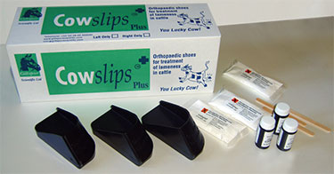 | This is applied to the unaffected hoof for the treatment of lameness due to sole ulcers or white line disease in dairy cows. This improves healing by removing the pressure from the affected hoof and significantly reduces the pain felt by the cow
Antiseptic spray.  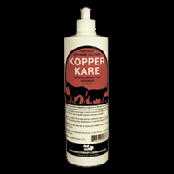 | A fungicide-antiseptic-astringent solution indicated for use in the treatment of foot rot on cattle
Antibiotic | Antibiotics are given to animals that are in danger of becoming sick in order to prevent the illness or infection from happening in the first place
Fine round chain-saw file  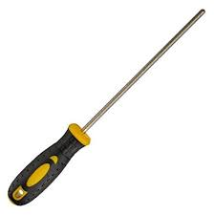 | To sharpen the hoof knives

Safety gear:
Safety Gloves  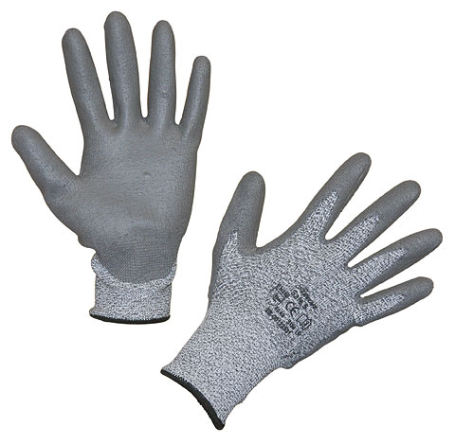 | Protects hands from cuts and dirt
Hoof trimming apron  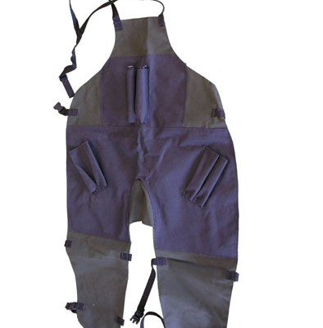 | To protect the person during hoof trimming
Safety boots  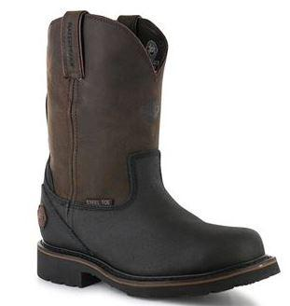 | To protects the foot from falling objects or compression, usually combined with
Dust mask  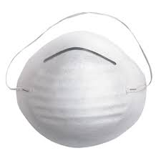 | To protect from dust
Safety glasses  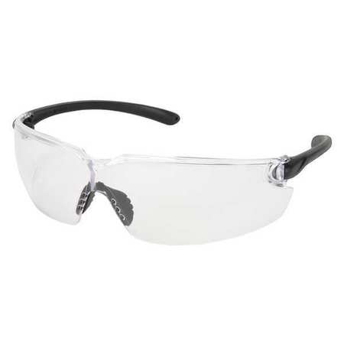 | To protect eyes from dust
Coveralls  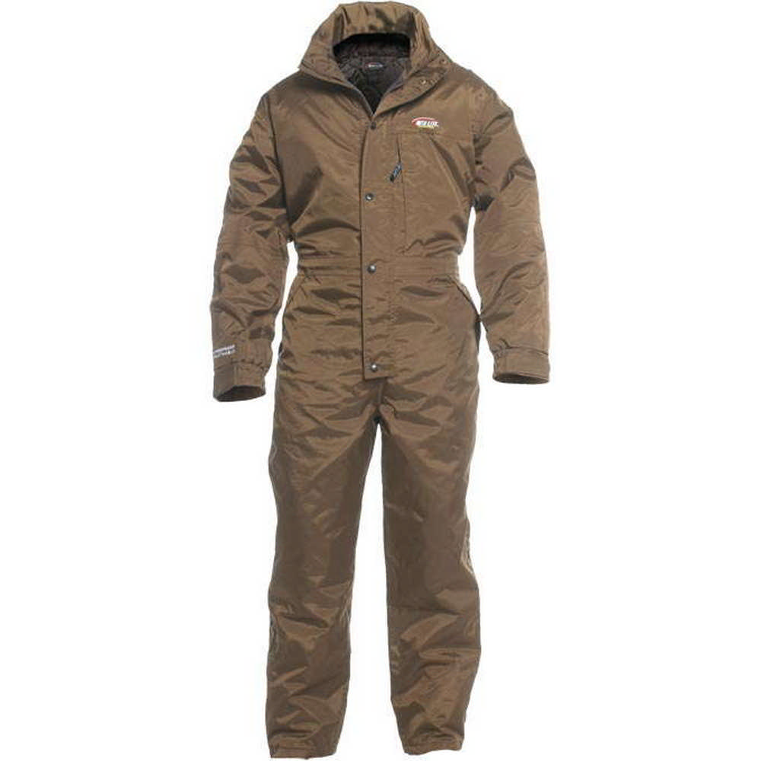 | To protect the person clothes from dust

If surgery is required:
Scalpel blade and handle  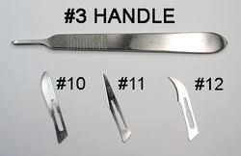 | For making incisions and cutting tissue
Nylon suture material  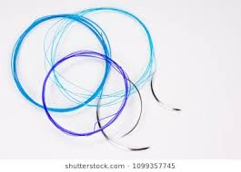 | For closing wounds and incisions
Buhner needle  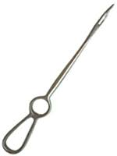 | Aids in creating a Junction between two incision sites
Tubing (drip line)  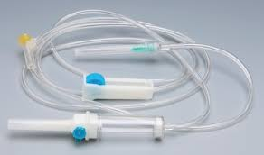 | Supports the drainage between the connecting incision sites ensuring a clear passage for fluids and debris to be passively removed

