RELEVANT ANATOMY

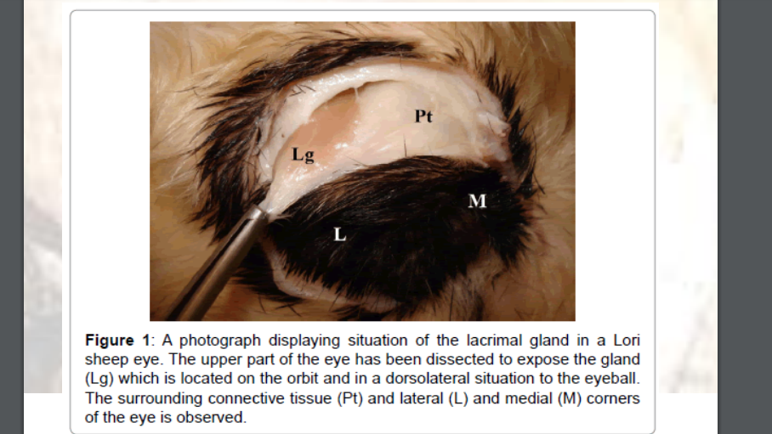
ACCESSORY STRUCTURES OF THE EYE

- The upper & Lower Eyelids- The eyelids have three basic layers: the outer skin, a fibromuscular layer, & the palpebral conjunctiva.
- Conjunctival sac- The palpebral conjunctiva together with the bulbar conjunctiva.
  - Palpebral Conjunctiva- lines the inner surface of the eyelid
  - Bulbar Conjunctiva- the reflection of the palpebral conjunctiva onto the eyeball.
- Third Eyelid or ‘nictitating membrane’- the fold of the conjunctiva, reinforced by cartilage, located between the eyelid’s medial angle and the eyeball. Retraction of the eyeball causes the third eyelid to move across and protect the eyeball. The gland of the third eyelid is a lacrimal gland.
- The dorsal and ventral distal extremities of the sac are called the fornices.
- Lateral & Medial commissures or canthi- the point where the eyelids meet. The lateral and medial angles are the areas near the canthi.

Muscles responsible for moving the Eye
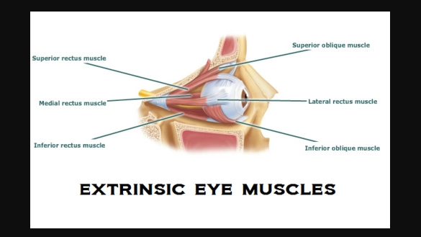
The Muscles of the eye is divided into intrinsic and extrinsic muscles.
Intrinsic muscles consist of the pupillary sphincter, pupillary dilator and ciliary muscles which deal with the size of the pupil and lens shape (accommodation).
Extrinsic muscles move the eyeball and are located behind it. They are the four rectus muscles (dorsal, ventral, medial, and lateral), two oblique muscles (dorsal and ventral) and the retractor bulbi muscles.

