**Subconjunctival Injections**

**Advantages:**

* Markedly increased penetration of water-soluble drugs.
* Short term high concentrations of drugs in cornea and anterior segment.
* Supplement to topical therapy.

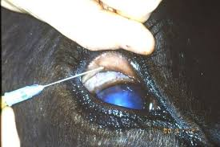

**Disadvantages:**

* Local irritation, residues, necrosis and granuloma formation can occur at the site of injection.
* Once injected the drug(s) cannot be removed.
* Temporary pain at site of injection.
* Injection is quite difficult with potential of injury to eye.