Drug | Conc. | Dose | Calculations | Route of  admin. | Withdrawal time | Contraindications
2% Xylazine  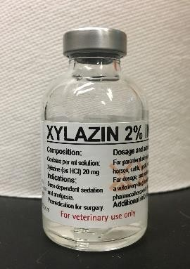 | 20 mg/ml | 0.05mg/kg | 𝑉𝑜𝑙𝑢𝑚𝑒  0.05 ∗ 8.4  =  20  = 0.021𝑚𝑙 | IM | 14 days meat  48 hrs milk | -Do not use in animals receiving epinephrine or having active ventricular arrhythmias  -Do not use in the last trimester of cattle pregnancy  -Do not give to ruminants that are debilitated, dehydrated or have a urinary obstruction
10% Ketamine  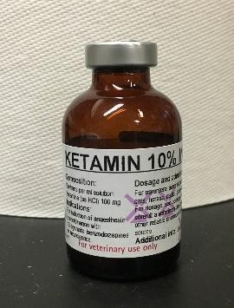 | 100mg/ml | 5mg/kg | 𝑉𝑜𝑙𝑢𝑚𝑒  5 ∗ 8.4  =  100  = 0.42𝑚𝑙 | IM | 3 days meat and milk | -Not for use in animals with prior hypersensitivity reactions, hypertension, severe cardiac, hepatic or regional impairment, head trauma, seizure disorders, glaucoma or head injuries

Drug | Conc. | Dose | Calculations | Route Of  Admin. | Withdrawal time | Contraindications
2% Lidocaine (local anesthetic)  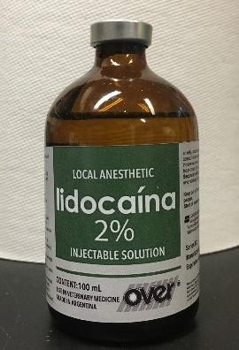 | 20 mg/ml | 1ml per 10kgs | 1  toxic dose  2  5∗8.4  = = 2.1𝑚𝑙  20  Volume administered  = (1/10) * 8.4  = 0.84 ml | Epidural | 1 day meat and milk | Not for use in animals with prior hypersensitivity reactions
Flunixin meglumine (post-op analgesic)  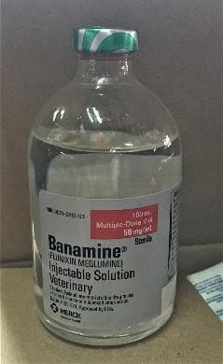 | 50 mg/ml | 1.1mg/kg | 𝑉𝑜𝑙𝑢𝑚𝑒  1.1 ∗ 8.4  =  50  = 0.18 𝑚𝑙 | IV | 4 days  meat, 36 hours milk | Do not use in animals who have shown prior hypersensitivity reactions

Drug | Conc. | Dose | Calculations | Route Of  Admin. | Withdrawal time | Contraindications
Penicillin-streptomycin (antibiotics)  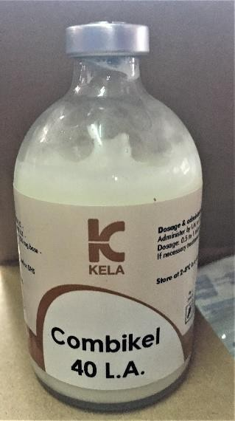 | 200,000  IU/ml | 20,000  IU/kg | 𝑉𝑜𝑙𝑢𝑚𝑒  20,000 ∗ 8.4  =  200,000  = 0.84𝑚𝑙 | IM | 30 days  meat, 10 days milk | -Do not use in animals hypersensitive to it, nor those with renal insufficiency
Epinephrine (for anaphylactic reactions) | 1mg/ml | 0.02mg/kg | 𝑉𝑜𝑙𝑢𝑚𝑒  0.02 ∗ 8.4  =  1  = 0.17𝑚𝑙 | IV | - | Not for use in animals with narrow angle glaucoma, hypersensitivity to epinephrine, shock due to non-anaphylactoid causes, general anesthesia with halogenated hydrocarbons, during labour, dilated  cardiomyopathy or coronary insufficiency
Tolazoline (Xylazine reversal) | 100  mg/ml | 4 times xylazine dose  =0.2mg/kg | 𝑉𝑜𝑙𝑢𝑚𝑒  0.2 ∗ 8.4  =  100  = 0.02 𝑚𝑙 | IV | - | -Do not use in animals hypersensitive to it
Atropine (for bradycardia < 30 bpm) | 0.54  mg/ml | 0.04 mg/kg | 𝑉𝑜𝑙𝑢𝑚𝑒  0.04 ∗ 8.4  =  0.54  = 0.62𝑚𝑙 | IV | 14 days  meat, 3 days milk | -Do not use in animals with narrow angle glaucoma, tachycardia, ileus, urinary obstruction

Drug | Conc. | Dose | Calculations | Route Of  Admin. | Withdrawal time | Contraindications
Tetanus anti-toxin  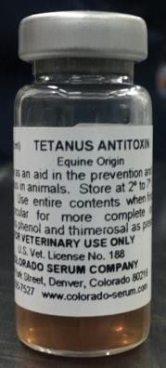 | 1500IU in  5 ml | 1ml | - | IM | - | Do not use in patients who previously displayed hypersensitivity reactions

*Ketamine and Xylazine were used in conjunction to induce general anesthesia

*Lidocaine was used to perform a Peterson block on the kid, so that the region of the incision would be desensitized. If half the toxic dose will be crossed based on volumes necessary, dilute the lidocaine with sterile saline solution to an appropriate concentration before injecting.

*Banamine and Combikel were administered for post-op purposes. Combikel would help reduce bacterial contamination, and Banamine has an analgesic effect that would act up to 24 hours, long after the lidocaine effects have worn off.

*All drugs in red indicate emergency drugs, and they should all be administered IV.

*Tetanus anti-toxin was administered because small ruminants are particularly susceptible to tetanus.

