PROCEDURE FOR HOOF TRIMMING

- Assess hoof condition for structural integrity, cracks, ulcers, fissures and plan your strategy

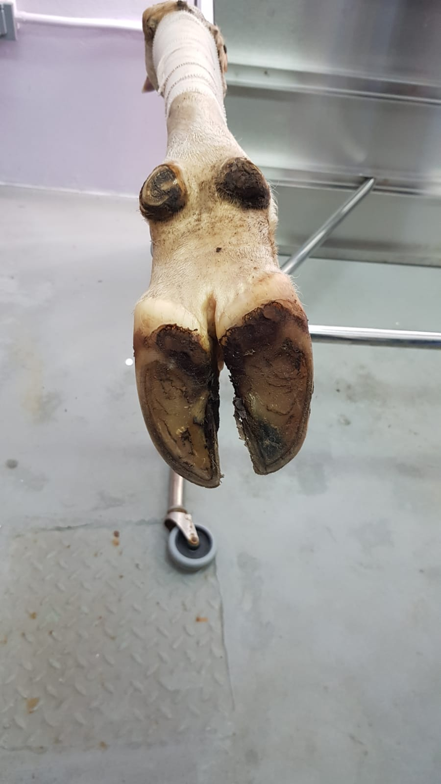

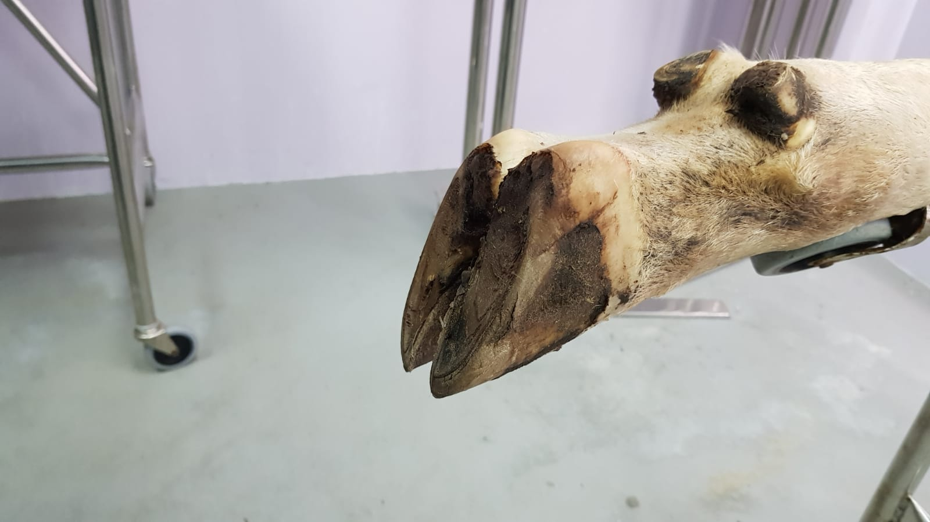

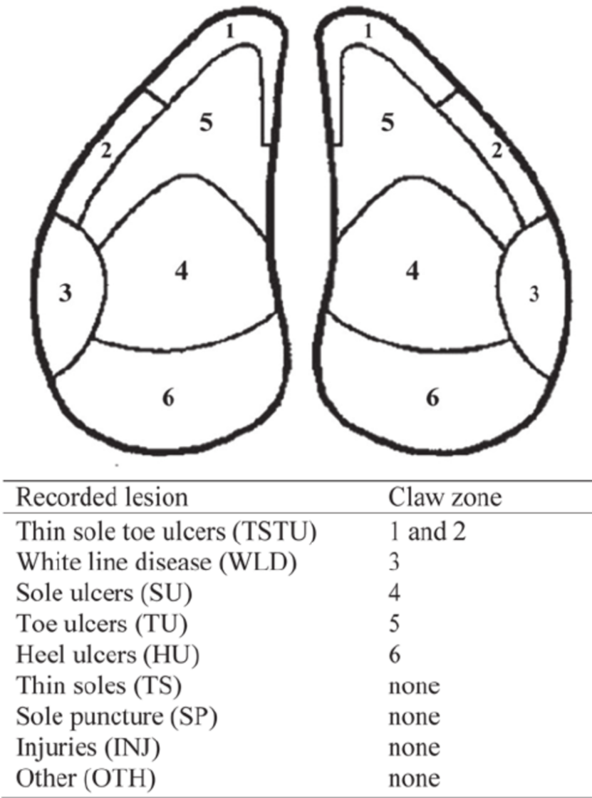Record all lesions using chart

- Measure hoof dimensions for proper hoof length and make markings on hoof

- Normal hoof angle – forelimb – 50 degrees
- Normal hoof angle – hindlimb – 55 degrees
- Toe length from coronary band to sole – 60mm – 80mm
- Heel height – 30mm-40mm
- Tip of toe when trimmed – 5mm – 7mm
- Length from tip of toe to palmar/plantar aspect of coronary band – 100mm – 130mm
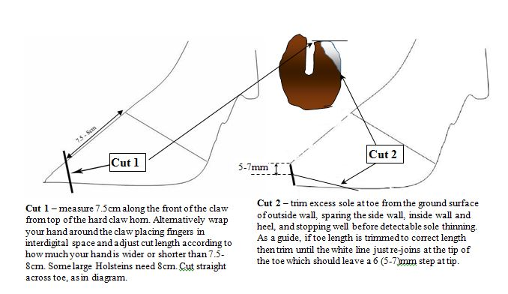

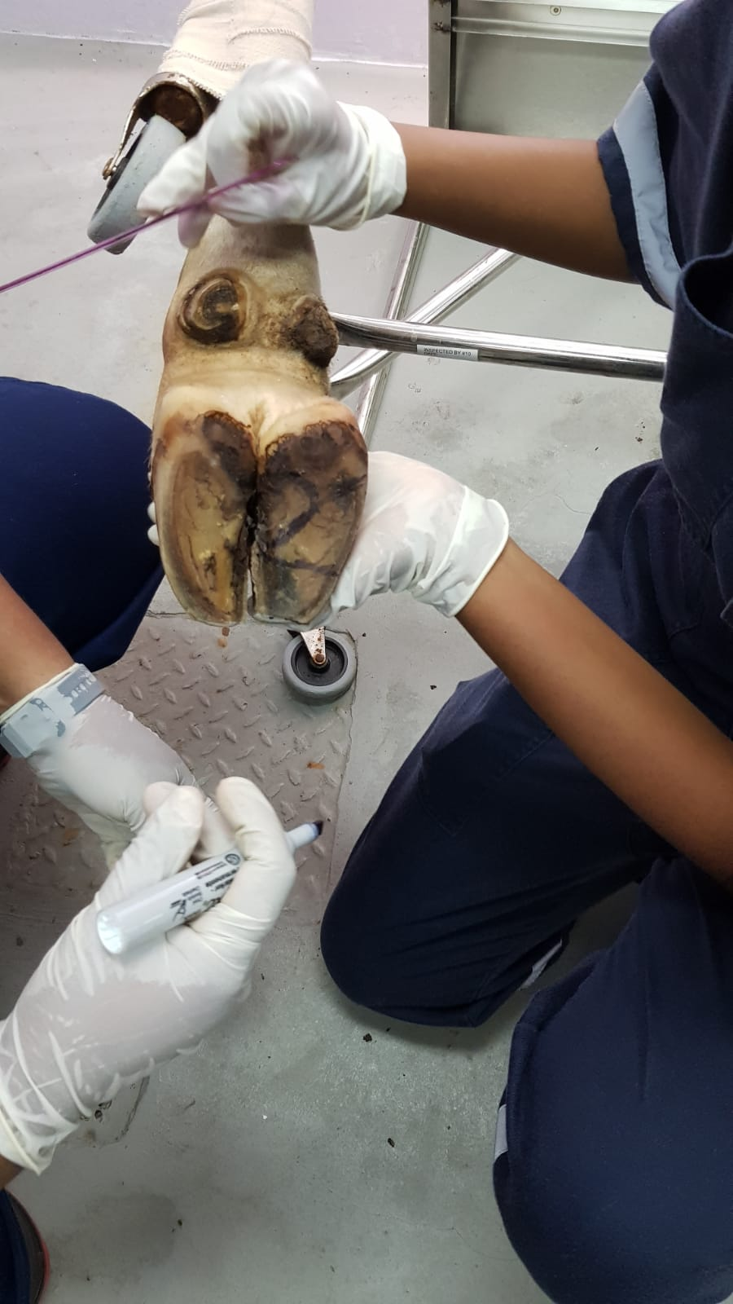

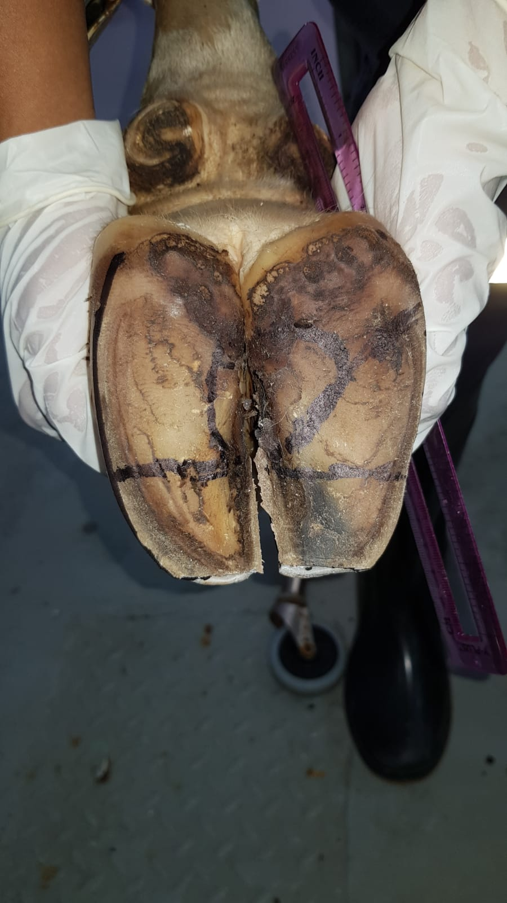
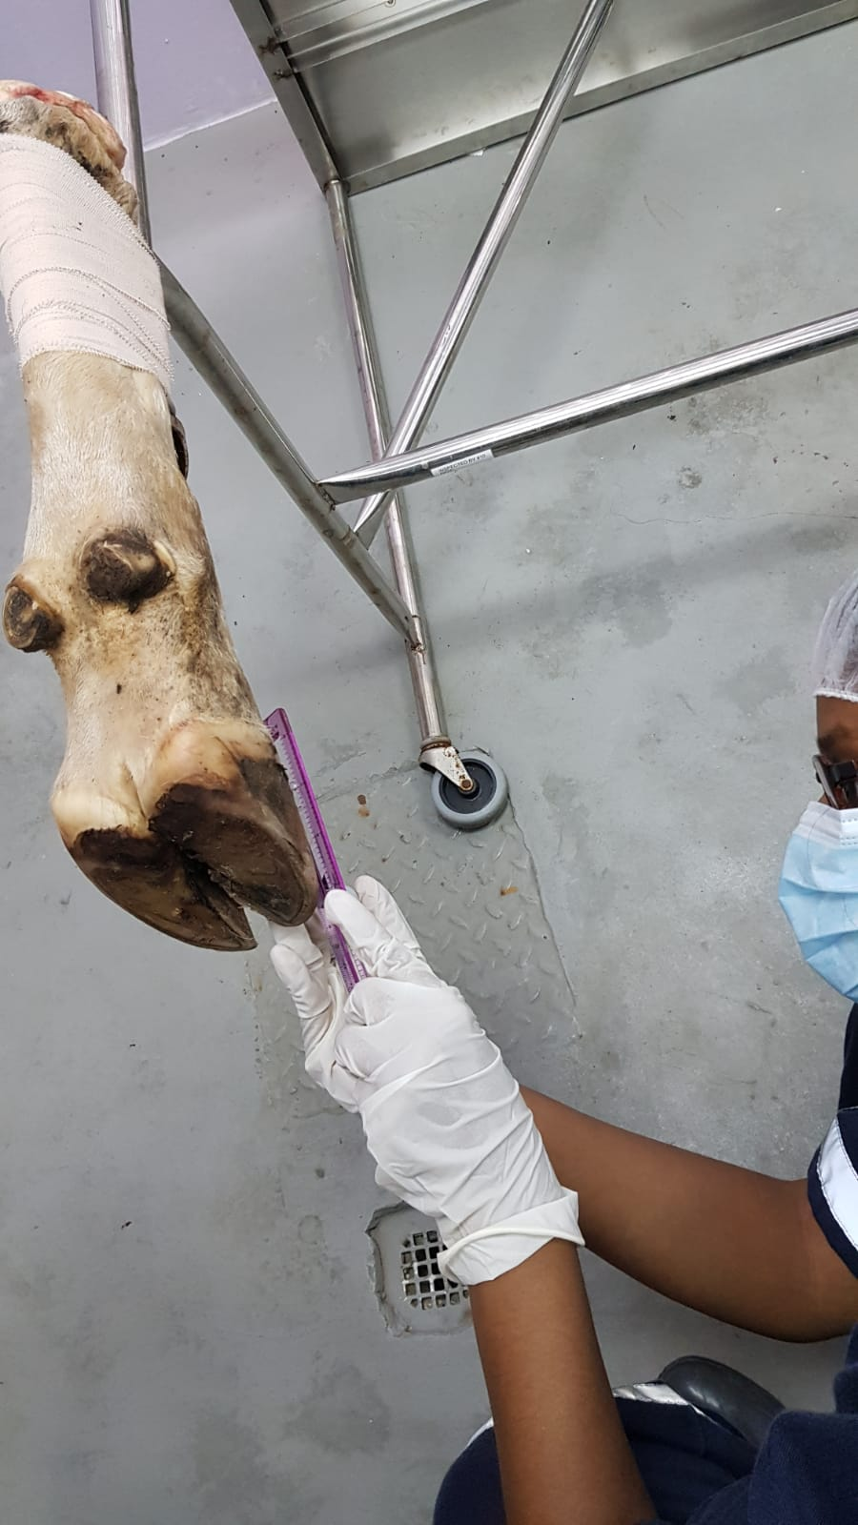

- Use the Dutch method
- Correct toe overgrowth to correct foot angle
- Correct the heel last, leave sole thickness
- Allow the walls to bear the most weight, taking weight of ulcer sites
- Remove weight from painful claws
- Remove dead or diseased horn

- Start with cutting the toe first.
- The handle of the hoof trimmer must be parallel to the sole when the cut is made.
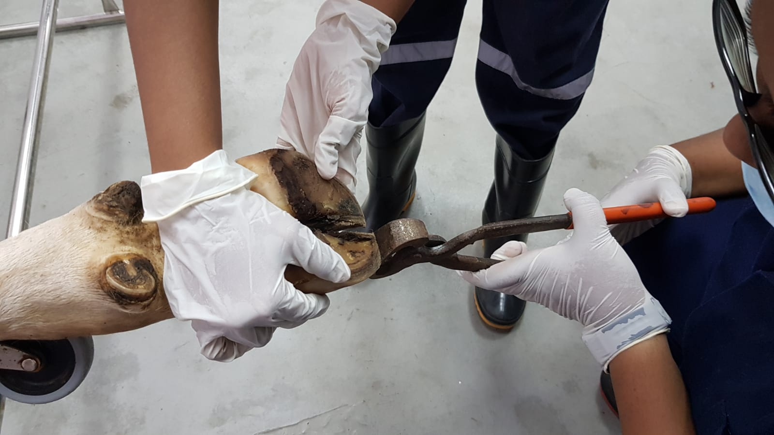

- Proceed to trim the toe triangle, going towards the lateral aspect of the hoof and then to the heel. Always measure with handle of hoof trimmer or ruler to ensure the sole is flat.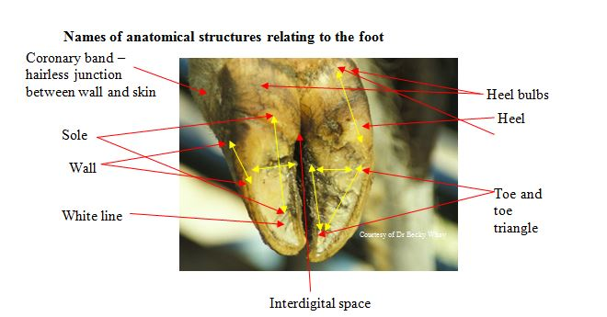

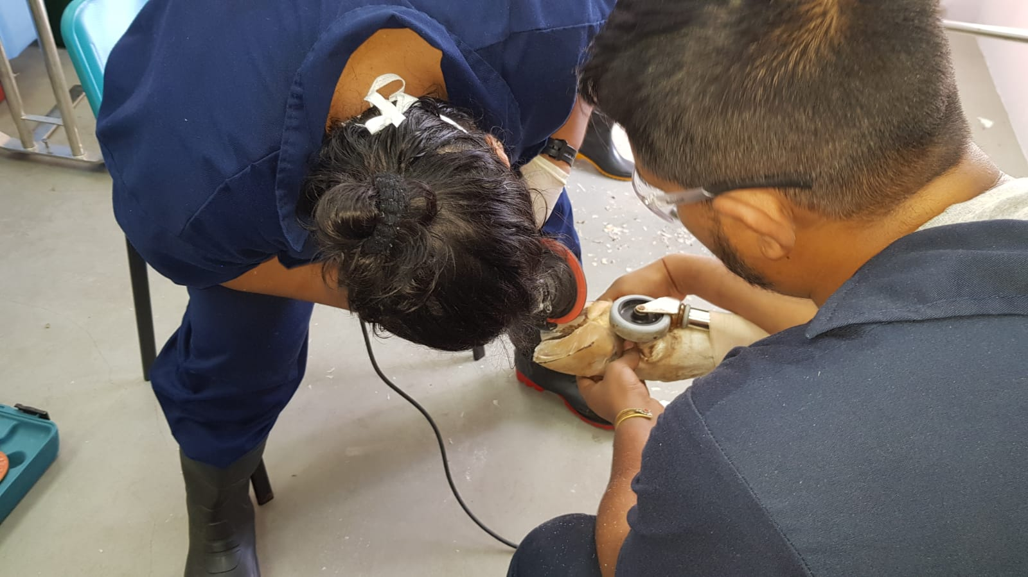
Above – trimming claws with grinder.
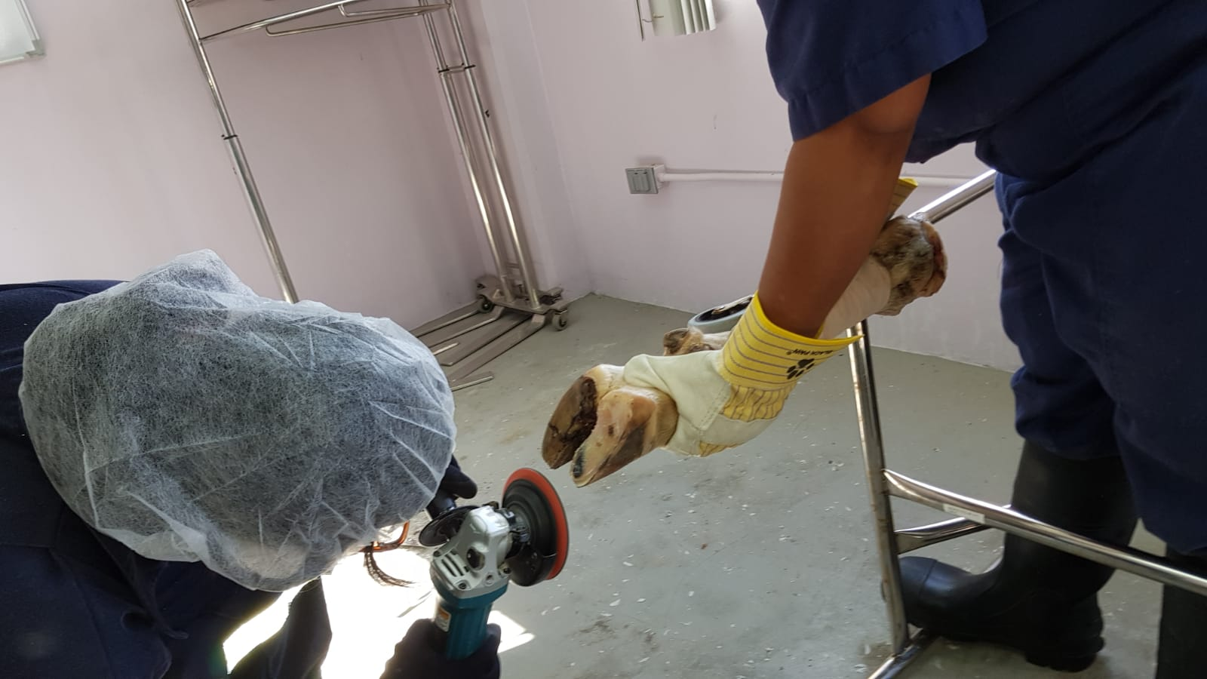
Above – trimming claws with grinder

- Dish the inner aspect of the claws – can be done with hoof knife or Merlin grinder

