Classification of Teat Lacerations
Characteristics | Classification | Prognosis
Duration | Acute | Good prognosis
 | Chronic | Swelling of the teat can be too  severe to permit adequate  reconstruction of the tissue
Localization and  conformation of the  laceration | Simple | Good prognosis
 | Complex – inverted Y or U | Good prognosis – slightly  difficult to repair
 | Longitudinal | Good Prognosis
 | Transverse | Blood supply of the teat is  longitudinal so this laceration  results in more damage to the  blood supply resulting in more  oedema, avascular necrosis  and dehiscence post-op, as  compared to a longitudinal  laceration.  Difficult to repair
 | Proximal | Difficult to repair – the  mucosa is difficult to suture  and the teat swell more postop.
 | Distal | Poor prognosis (especially if  involving the streak canal).  Reconstruction of the streak  canal is difficult and can cause  partial or complete milk flow  obstruction.  Compromises the defense  mechanisms of the quarter  against mastitis so higher risk  of clinical or subclinical  mastitis.  Lead to avascular necrosis of  the distal end of the teat.
Thickness of Lesion | Partial thickness  (skin to submucosa) | Good prognosis – may not  need surgical intervention
 | Incomplete lacerations  (integrity of the teat cistern is  intact) | Surgical intervention may not  be necessary – secondary  healing by medical  management of the wound may be sufficient.  During healing contraction  may change the conformation  of the teat creating problems during milking.
 | Full thickness  (skin to mucosa with milk  leaking out of the incision) | Defense mechanisms of the teat against mastitis are bypassed increasing the risk of clinical mastitis.  Prompt surgical reconstruction of the injured  tissue is needed to protect the  quarter against environmental  pathogens
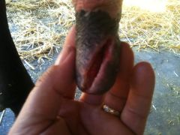
Figure 1 Oblique Partial Thickness Laceration on Distal End of Teat

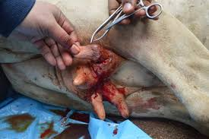
Figure 2 Transverse Laceration on Proximal Aspect of Teat

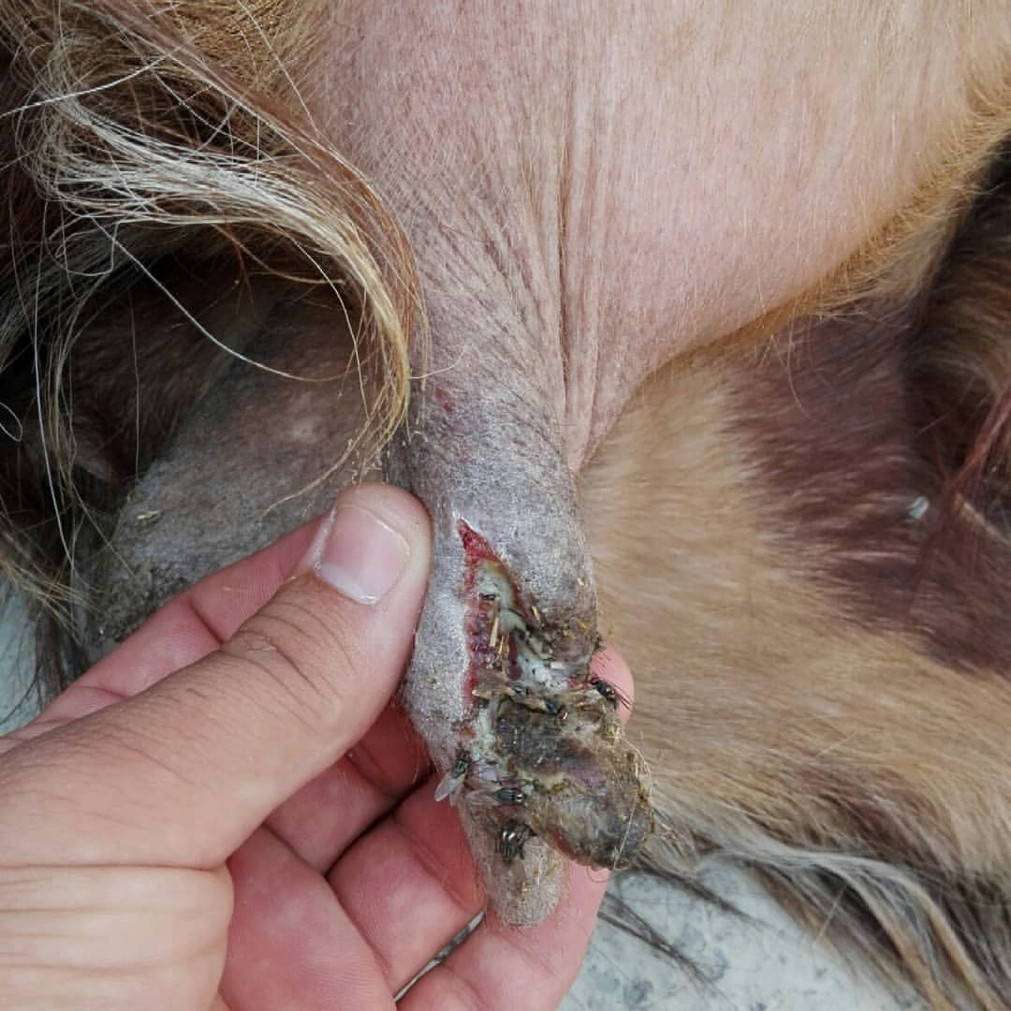
Figure 3 Chronic Severely Infected Laceration of the Distal End

