Procedure for dehorning the animal
Pre-surgical procedure
Fast animal – no food 36-24 hours before surgery, no water 12 hours before surgery.
Properly restrain and sedate the animal using appropriate drugs. Local or regional block may also be employed, it can be implemented at this stage.
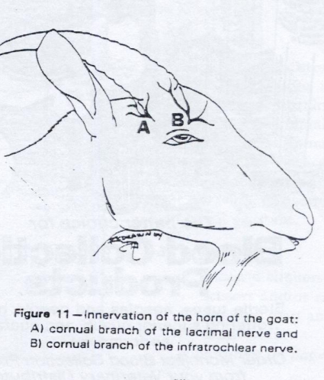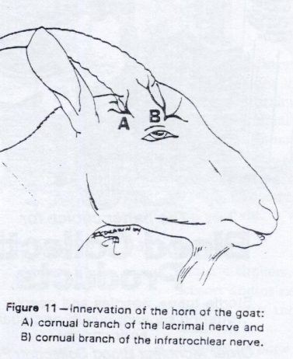

Surgical Procedure:
Clip hairs around the site for surgery and prepare area aseptically
Make elliptical incisions around the base of the horn
Undermine the skin around the horn, so that the horn can be removed using Gigli wire or a saw
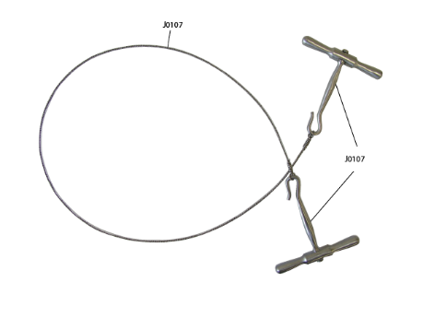
Pull and ligate the cornual artery
Remove excess bone from around the frontal ridge rostrally
Wash any excess blood, clots and excess bone fragments away from site using sterile saline
Close the incisions with a cruciate suture pattern 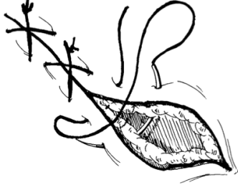

Post-Surgical Procedure
Keep head wrapped for a few days after the procedure.
Ensure animal is administered tetanus anti toxin
Ensure animal’s pain is treated properly with the use of appropriate drugs

