Antibiotics
Can be topical and applied daily for course of pre-op or parenteral & only administered once.
NAME &  (ACTIVE INGREDIENTS) | CATEGORY | CONCENTRATION | DOSE RATE | CALCULATIONS  FOR  ANIMALS | INDICATIONS | CONTRAINDICATIONS | WITHDRAWAL TIMES FOR FOOD ANIMALS
TetraVet Aerosol Spray  (Oxytetracycline hydrochloride & Gentian violet) | Antibiotic | Oxytetracycline hydrochloride 25mg/mL and Gentian violet 2mg/mL | For Topical Use only.  Once or twice daily for 3-5 days. | - 2 Week old goat @ 5kg  Volume Dose= Sprayed twice daily for 5 days  - 6 Month old calf @ 60 kg  Volume Dose= Sprayed twice daily for 5 days  - 2 Year old ram @ 72 kg  Volume Dose= Sprayed twice daily for 5 days | 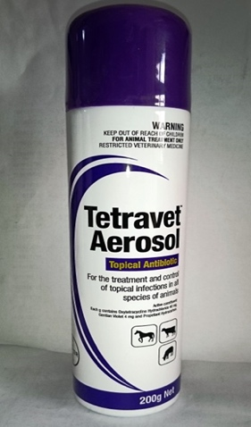  Prevention and treatment of topical infections caused by, or associated with, organisms sensitive to oxytetracycline hydrochloride and gentian violet in all species except fibre-producing animals.  Treatment of cuts and wounds. | N/A. | N/A
NAME &  (ACTIVE INGREDIENTS) | CATEGORY | CONCENTRATION | DOSE RATE | CALCULATIONS  FOR  ANIMALS | INDICATIONS | CONTRAINDICATIONS | WITHDRAWAL TIMES FOR FOOD ANIMALS
Penstrep 400  (Procaine penicillin & Dihydrostreptomycin) | Antibiotic | 200,000 IU/ml | Cattle:  1 ml per 20 kg body weight for 3 days.  Calves, goats, sheep and swine:  1 ml per 10 kg body weight for 3 days.  Note: Shake well before use and do not administer more than 20 ml in cattle, more than 10 ml in swine and more than 5 ml in calves, sheep and goats per injection site. | - 2 Week old goat @ 5kg  Volume Dose= 0.5 mls  - 6 Month old calf @ 60 kg  Volume Dose= 3 mls  - 2 Year old ram @ 72 kg  Volume Dose= 7.2 mls | 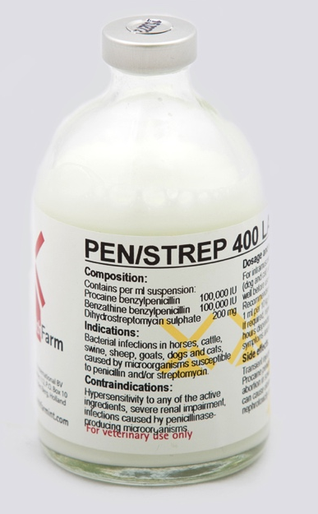  https://www.google.com/url?sa=t&rct=j&q=&esrc=s&source=web&cd=&cad=rja&uact=8&ved=2ahUKEwirwZjIkYXsAhXQmOAKHf1zA0QQFjAAegQIAxAB&url=https%3A%2F%2Fwww.tandfonline.com%2Fdoi%2Fpdf%2F10.1080%2F09712119.1999.9706246&usg=AOvVaw0pz8SyOeN-D6CVHRNUon_X  RoA: I.M. | Should not be used in:  - Animal with hypersensitivity to penicillins, procaine and/or aminoglycosides.  - Administration to animals with a seriously impaired renal function.  - Concurrent administration of tetracyclines, chloramphenicol, macrolides and lincosamides. | Meat: 21 days.  Milk: 3 days.
NAME &  (ACTIVE INGREDIENTS) | CATEGORY | CONCENTRATION | DOSE RATE | CALCULATIONS  FOR  ANIMALS | INDICATIONS | CONTRAINDICATIONS | WITHDRAWAL TIMES FOR FOOD ANIMALS
Amoxycillin 150 LA  (Amoxycillin) | Antibiotic (Beta-lactam) | 150 mg/ml | 1 ml per 15 kg bodyweight.  This dosage may be repeated after 48 hours if necessary.  No more than 20 ml should be injected into a single site. | - 2 Week old goat @ 5kg  Volume Dose= 0.3 mls  - 6 Month old calf @ 60 kg  Volume Dose= 4 mls  - 2 Year old ram @ 72 kg  Volume Dose= 4.8 mls | 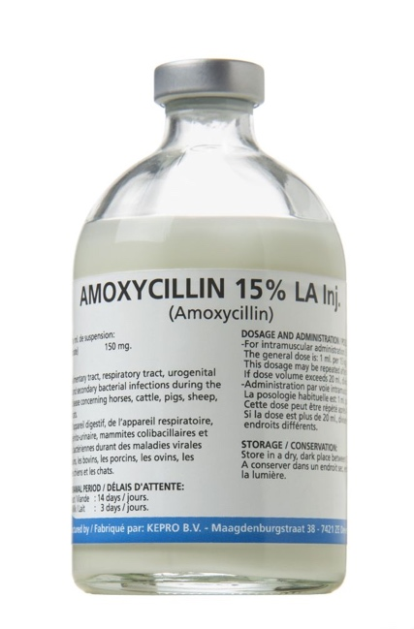  Used as an antibiotic in the treatment of infection caused by organisms sensitive to amoxycillin for the following species:  - Cattle  - Sheep  - Pigs  - Dogs  - Cats  RoA:  Sheep, Cattle & Pigs: I.M  Dogs & Cats: I.M & S.C. | Should not be used in patients with:  - Known hypersensitivity to drug and other beta-lactam antibiotics.  - Pregnant/Lactating animals. | Meat: 14 days  Milk: 3 days
Antiparasitics & Antimyiasis

NAME &  (ACTIVE INGREDIENTS) | CATEGORY | CONCENTRATION | DOSE RATE | CALCULATIONS  FOR  ANIMALS | INDICATIONS | CONTRAINDICATIONS | WITHDRAWAL TIMES FOR FOOD ANIMALS
Matabicheras Fort Dodge  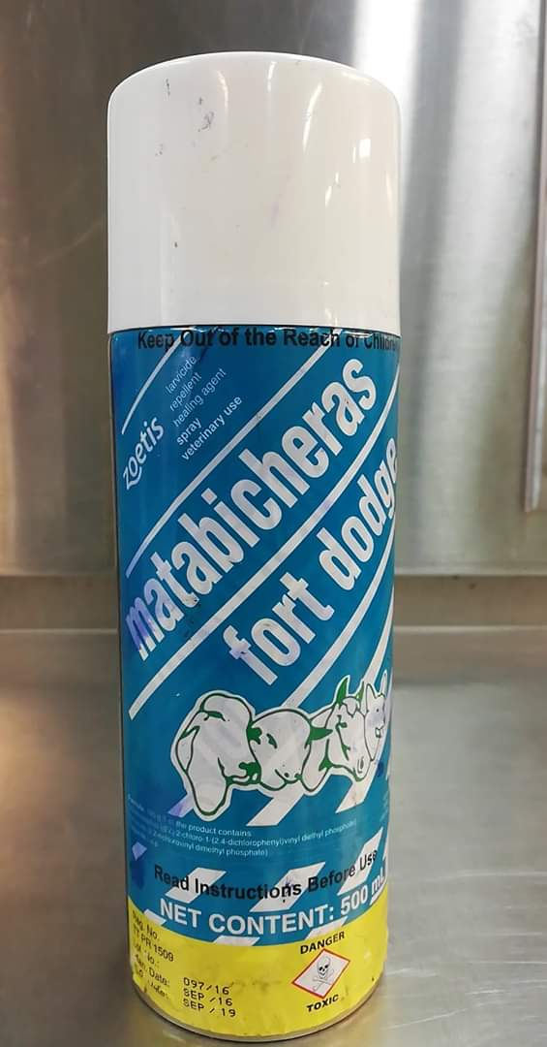 | Larvicide, repellent and healing spray | Chlorfenvinphos: 0.52 g. Dichlorvos: 0.83 g. Formulation agents q.s.p .: 100 g | For Topical Use only.  Once or twice daily for 3-5 days. | - 2 Week old goat @ 5kg  Volume Dose= Sprayed twice daily for 5 days  - 6 Month old calf @ 60 kg  Volume Dose= Sprayed twice daily for 5 days  - 2 Year old ram @ 72 kg  Volume Dose= Sprayed twice daily for 5 days | Recommended in wounds caused by dipteran larvae (Flies), indicated to prevent and cure myiasis in navels of newborn animals and in wounds caused by castration, dehorning, tail docking, marking, abrasions and surgeries.  It is also recommended to be used on lesions produced by larvae of Dermatobia hominis, lesions originating from putrefaction of the foot (pododermatitis), wounds produced by cutting warts (papillomas) and any other type of wound. | N/A | N/A
Analagesics

NAME &  (ACTIVE INGREDIENTS) | CATEGORY | CONCENTRATION | DOSE RATE | CALCULATIONS  FOR  ANIMALS | INDICATIONS | CONTRAINDICATIONS | WITHDRAWAL TIMES FOR FOOD ANIMALS
Banamine (flunixin meglumine) | Analgesic/NSAID | 50 mg/ml | Cattle: 2.2 mg/kg  Sheep/Goats:  2.2 mg/kg I.V. daily for 3–5 days  https://onlinelibrary.wiley.com/doi/pdf/10.1002/9781119073543.app1 | - 2 Week old goat @ 5kg  Volume Dose= 0.22 mls  - 6 Month old calf @ 60 kg  Volume Dose= 2.64 mls  - 2 Year old ram @ 72 kg  Volume Dose= 3.20 mls | 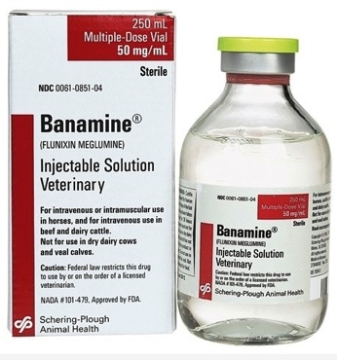  - Potent analgesic, antipyretic and anti-inflammatory  - Treats pain and inflammation as well as to reduce fever  - Treats colic in horses  - Treats pyrexia associated with bovine respiratory disease and endotoxemia  - In ruminants, it is a good analgesic for visceral pain relief  - Treats pyrexia due to mastitis  - Approved for use in food animals  RoA: I.V or I.M Horses only | Cattle:  - Breeding bulls  - Calves to be used for veal  - Dry dairy cows  - Pregnant cows  Horse:  - Horses intended for food.  - Pregnant mares  May be assoc. w/ gastrointestinal & renal toxicity. Risk increases with patients that are;  - Dehydrated  - On concomitant diuretic therapy  - Those with renal, cardiovascular, and/or hepatic dysfunction.  Concomitant use with other NSAIDs and corticosteroids. | Meat: 4 days  Milk: 36 hours
NAME &  (ACTIVE INGREDIENTS) | CATEGORY | CONCENTRATION | DOSE RATE | CALCULATIONS  FOR  ANIMALS | INDICATIONS | CONTRAINDICATIONS | WITHDRAWAL TIMES FOR FOOD ANIMALS
Metacam/Meloxicam 20 | Analgesic/NSAID | 20 mg/ml | Cattle: Single IV or SC injection- 0.5mg/kg (in combination with antibiotic therapy or oral rehydration therapy)  Surgical pain/analgesia- 0.5-1.0mg/kg PO q24-48 hours.  Small ruminants:  2 mg/kg loading dose then  0.5 mg/kg s.c. or i.v. every 36 hours | - 2 Week old goat @ 5kg  Volume Dose= 0.5 mls and then 0.125 mls  - 6 Month old calf @ 60 kg  Volume Dose= 1.5 – 3 mls  - CONTRA-INDICATED! | 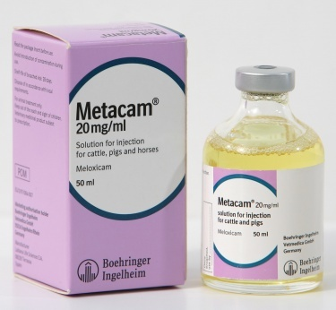  - Treats chronic pain and inflammation  - Postoperative pain associated with surgical procedures such as castrations or dehorning | Should not be used in:  - Bulls, rams or boars intended for breeding  - Do not use in animals suffering from gastrointestinal disorders.  - Do not administer concurrently with steroidal, other nonsteroidal anti-inflammatory drugs or with anti-coagulant agents.  - Concomitant use of NSAIDs with aminoglycoside antimicrobials in very young animals may result in renal toxicity.  - Severely dehydrated, hypovolaemic or hypotensive animals.  - Very young/debilitated animals  - Pregnant animals | Meat:  - Cattle: 20 days  - Sheep & Goats: 11 days  - Swine: 5 days  Milk: 96 hours
NAME &  (ACTIVE INGREDIENTS) | CATEGORY | CONCENTRATION | DOSE RATE | CALCULATIONS  FOR  ANIMALS | INDICATIONS | CONTRAINDICATIONS | WITHDRAWAL TIMES FOR FOOD ANIMALS
Rimadyl (Carprofen) | Analagesic/NSAID | 50 mg/ml | Cattle: 1.4mg/kg IV  Sheep/Goats:1.4 mg/kg s.c. or i.v., repeat once after 48–72 hours | - 2 Week old goat @ 5kg  Volume Dose= 0.14 mls  - 6 Month old calf @ 60 kg  Volume Dose= 1.68 mls  - 2 Year old ram @ 72 kg  Volume Dose= 2 mls | 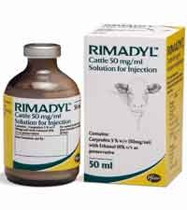  - Used to treat post-operative pain and inflammation  - Used to reduce inflammation associated with bovine respiratory disease  RoA: I.V. or S.C. | Should not be used in:  - Animals suffering from cardiac, hepatic or renal impairment.  - Animals suffering from gastro-intestinal ulceration or bleeding.  - Do not use in animals with known hypersensitivity to the veterinary medicinal product.  - Dehydrated, hypovolaemic or hypotensive animals. Concurrent administration of potentially nephrotoxic drugs should be avoided. | Meat: 21 days  Milk: N/A

Tetanus Antitoxin
NAME | CATEGORY | CONCENTRATION | DOSE RATE | CALCULATIONS  FOR  ANIMALS | INDICATIONS | CONTRAINDICATIONS | WITHDRAWAL TIMES FOR FOOD ANIMALS
Tetanus Antitoxin (Equine origin) | Immune SERA and Immunoglobulins | 1,500 I.U/ 5 ml | Prevention Dose: 1,500 I.U.  Treatment Dose:  - Cattle/Horses: 10,000- 50,000 I.U  - Swine/Sheep/Goats:  3,000-15,000 I.U.  Repeat in 7 days as considered necessary. | - 2 Week old goat @ 5kg  Dose= 1,500 I.U.  - 6 Month old calf @ 60 kg  Dose= 1,500 I.U.  - 2 Year old ram @ 72 kg  Dose= 1,500 I.U. | 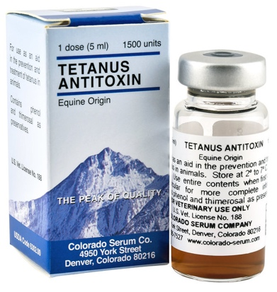  Used to establish short-term passive immunity for tetanus for the following species:  - Beef and Dairy Cattle  - Horses  - Sheep  - Goats  - Swine  RoA: I.M, S.C. | Should not be used;  - In animals with hypersensitivity to drug.  - Epinephrine INJ (1:1,000) should be available in the event of anaphylactic rxn. | Meat: 21 days  Milk: 14 days

