Horn removal for a 2-year-Boer Goat-110kg
Sedation
Xylazine (0.025 – 0.05 mg/kg)
Can be mixed in a syringe and administered via intravenous or intramuscular injection
Butorphanol (0.05 mg /kg)

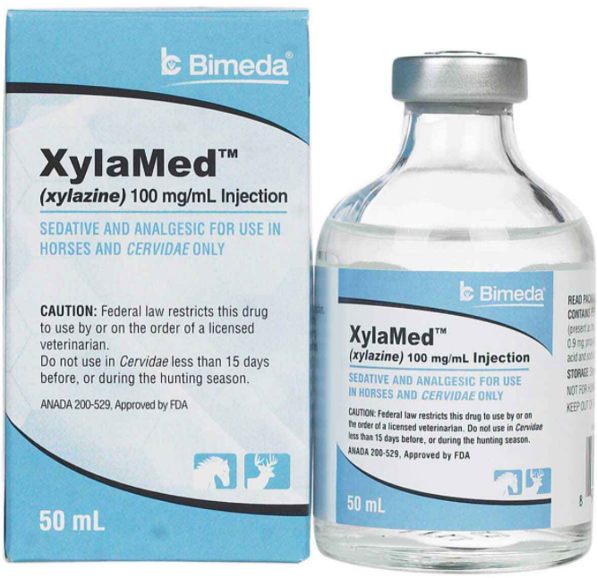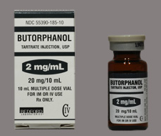
$$concentration of xylazine 100mg/mL÷50mL=2mg/mL$$
$$volume of xylazine \left(\frac{0.05mg}{mL}×110kg\right)÷2=2.75mL$$

$$concentration of butophanol-2mg/mL$$
$$volume of butophanol \left(\frac{0.05mg}{mL}×110kg\right)÷2=2.75mL$$

Xylazine reversal can be achieved with tolazoline, by administration of 2-4 times the xylazine dose of tolazoline
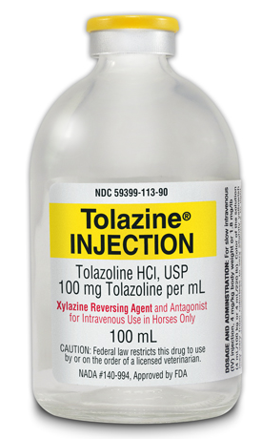

Local or regional analgesia
Valium (Diazapam) with Ketamine
Used in a 1:1 ratio and is administered; 1cc per 20kg
Used for pain treatment
Used for anxiety to calm patient

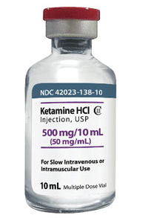
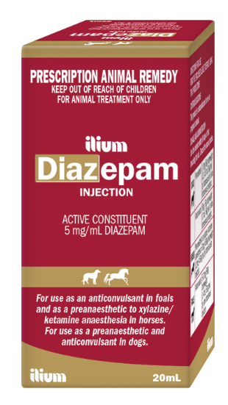
Ketamine-6mg/kg
$(110kg×\frac{6mg}{mL})÷50$=13.2mL (I.V)

Diazapam -0.5mg/kg
$$diazapam concentration-5mg/mL÷20mL=0.2mg$$
$volume of diazapam-(\frac{0.5mg}{kg}×110kg)÷0.2mg=275mL$ (I.V)

Lidocaine- local anesthetic

$$concentration-2/100×100mL=20mg$$
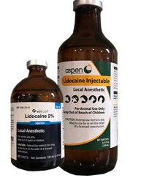
$$volume required=(110kg×\frac{5mg}{kg})÷20mg=27.5mL$$
Post-operative
Banamine- brand name
Flunixin meglumine – injectable NSAID
Used for the treatment of pain as needed.
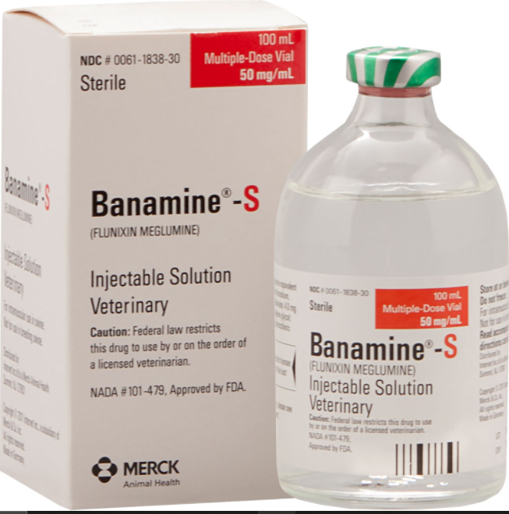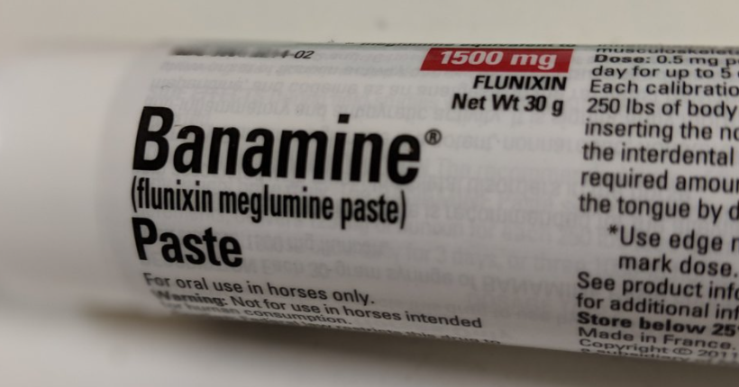

$$concentration-50mg/mL÷100mL=0.5mg$$
$$volume required-(\frac{1.1mg}{kg}×110kg)÷0.5mg=242mL$$

Tetanus anti-toxin – 100 I.U. given via intramuscular injection.
Prevents infection by Clostridium tetani.
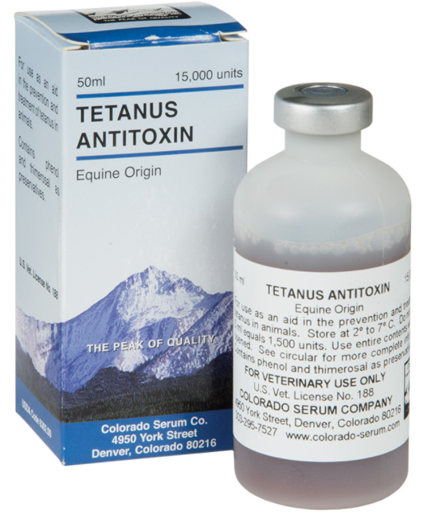

$$\left(110kg×100I.U.\frac{}{kg}\right)÷15000I.U=0.73mL$$

References
1. Goat Breeds Boer – Goats [Internet]. Goats.extension.org. 2019 [cited 26 September 2020]. Available from: https://goats.extension.org/goat-breeds-boer/
2. Smith M, Sherman D, Smith. Goat Medicine. 2nd ed. Somerset: Wiley; 2011.

