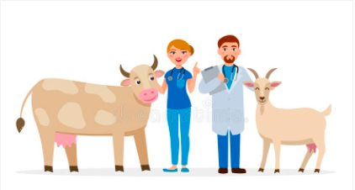

Farmer-Client Communication
- What is Disbudding and Dehorning?
Disbudding is the removal of horn producing cells in cattle, goats and sheep. In cattle this should happen in calves less than 2 months of age. Dehorning involves the cutting out of horns as well as horn producing tissue after they have grown from the horn bud and attached to the skull. This usually occurs in cattle around 2 months or after. Refer to Dehorning and Disbudding.
- Why should these procedures be done?
Refer to Advantages of Dehorning and Advantages of Disbudding
- When is the best time to perform this procedure?
When performing this procedure “the earlier the better.” In goats and sheep dehorning can be done soon after birth and in cattle should be done ideally before 2-3 months. The reason behind this is that less stress and pain will be caused to the animal and they will have a faster healing time from the procedure. The veterinarian should also take a proper history of the animal before suggesting these procedures to the farmer.
- How are these procedures performed?
Refer to Intra-op Procedure for all Scenarios
- What can go wrong in the procedure?
Refer to Possible Complications
- Is this procedure painful? How will the pain be managed?
This procedure can be extremely painful if done without anaesthesia and analgesia. Pain will be managed by the use of sedative, anaesthetic as well as analgesic drugs before, during and after the procedure depending on which one is done. The farmer should be advised that some drugs may be used “extra-label” but advised that they have set withdrawal times in farm animals according to AMDUCA. These extra-label drugs should only be used therapeutically, under veterinary supervision and under no circumstances should be used in feed. If the farmer however, is not comfortable with this the veterinarian needs to make other suggestions as to what can be done for pain management.
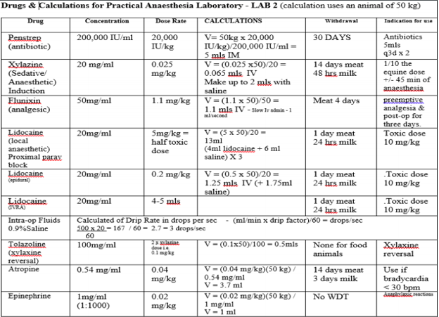
- What would the care of the animal consist of after this procedure?
Refer to Post-op Observation as well as Post-op Farmer-Client Communication
- Is there a cost attached to this procedure?
There will be a cost attached to the procedure but this depends on the veterinarian on call and which procedure is being done. This is a common procedure so therefore it should not be on the expensive side but as stated before it depends on the veterinarian doing the procedure. The cosmetic dehorning method may be the most expensive procedure because of the amount of materials needed as well as it is a longer procedure than other methods. The client should always be advised of costs before the procedures as well as if the veterinarian requires any additional testing before the procedure
- Can I (the farmer) do the procedure on my own?
The disbudding and dehorning of cattle, goats and sheep can be performed by the farmer once he has access to the equipment and is properly trained by a veterinarian to perform the procedure on young animals without causing harm to them. While it can be done, it is suggested that the procedures be done by a veterinarian as anaesthesia and analgesia need to be given to the animal to prevent pain. The cosmetic dehorning of cattle, goats and sheep must be performed by a veterinarian.
- Am I (the farmer) required to sign any consent forms for this procedure?
The farmer is required to sign a consent form stating that he understands the complications associated with this procedure, what the procedure entails and why the drugs being used are chosen as well as the adverse effects that may occur. A consent form should especially be signed for a cosmetic dehorning as it is a more complicated procedure than the others.

References:
- https://www.rcvs.org.uk/setting-standards/advice-and-guidance/code-of-professional-conduct-for-veterinary-surgeons/supporting-guidance/communication-and-consent/

