Procedure:

- Make a small elliptical incision (roughly 2mm away from the base) at the base of each horn preserving as much skin as possible while also ensuring to remove all non haired epithelium to prevent regrowth.
- Using the scalpel and forceps, undermine the skin away from the base of each horn.
- Cut the horns using the Gigli wire/ small hand saw in a rostro-ventral direction.
- Remove small pieces of the frontal bone using the bone ronguers until the skin can close the surgical wound.
- If the clinician doesn't want to remove small pieces of the frontal bone, they can make a release incision in the skin between the horns.
- Control haemorrhage using cautery, pressure or by locating the cornual artery.
- Remove all bone fragments and blood clots by flushing the surgery site using sterile saline.
- Close the incisions using #0 to #1 non-absorbable sutures like vetafil/nylon in a cruciate or continuous suture pattern.
- Apply a triple antibiotic ointment and a gauze pad over the wound for a few days.
- Remove sutures 2-3 weeks post surgery (incision usually heals in 10-14 days by first intention)

Note; some clinicians remove the horns after the elliptical incision is made and then undermine the surrounding skin.
Farmers that cosmetically dehorn their goats, also request the removal of the scent gland/ sebaceous gland in the area caudal to the horns. Descenting and dehorning are simultaneously done.

- Cosmetic dehorning can also involve partial horn removal. The animal is sedated and anesthetized and the horns are cut at the tip, mid-horn or close to the level of the skull using the Gigli wire/ small hand saw. This depends on the owners preference. The horn will regrow since all of the cells aren't removed.

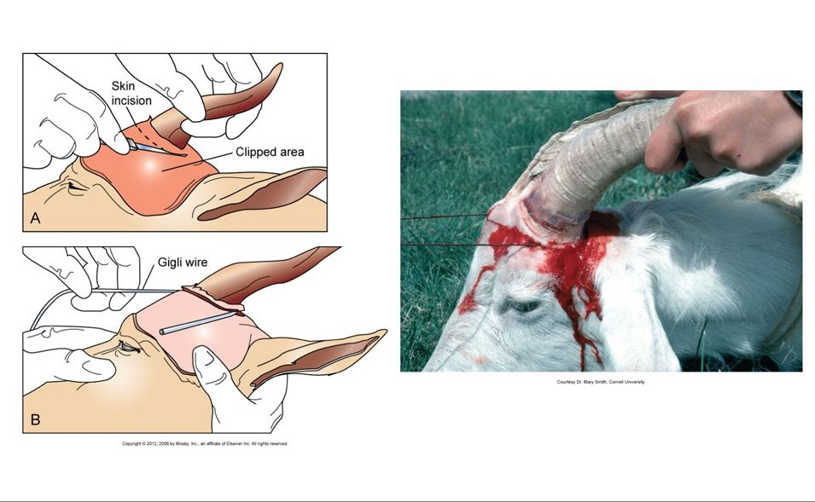

References
https://books.google.tt/books?id=yyzJDwAAQBAJ&pg=PA245&lpg=PA245&dq=intra+op+cosmetic+dehorning+goat&source=bl&ots=tyzXUkT3zy&sig=ACfU3U1UsWJkEwWFy8_iwlTpGp6yaOmuTw&hl=en&sa=X&ved=2ahUKEwiX4Z7ju4TsAhWC2FkKHa2TDe8Q6AEwDnoECAUQAQ&authuser=1#v=onepage&q=intra%20op%20cosmetic%20dehorning%20goat&f=false

https://www.dvm360.com/view/common-surgical-procedures-small-ruminants-proceedings

