Dehorning Procedure

Pre-surgical procedure:
- Fast animal – no food 36-24 hours before surgery, no water 12 hours before surgery.
- Properly restrain using ropes, halter and a dehorning box
- Clip hairs around the site for surgery and prepare area aseptically (Chlorohexidine scrub followed by alternating Povidone iodine 70% solution and isopropyl alcohol).
- Sedate the animal using appropriate drugs. (Xylazine and Butorphanol mixture)
NB: Xylazine can be reversed sing Tolazoline (Tolazoline dose should be 2 to 4 times the amount of Xylazine given)
- Local or regional block is employed to desensitize the cornual branches of the lacrimal and infratrochlear nerves.
- 2% Lidocaine is used to form a ring block around the base of the horn bud. Wait 5 to 10 minutes after administration before making a surgical incision.
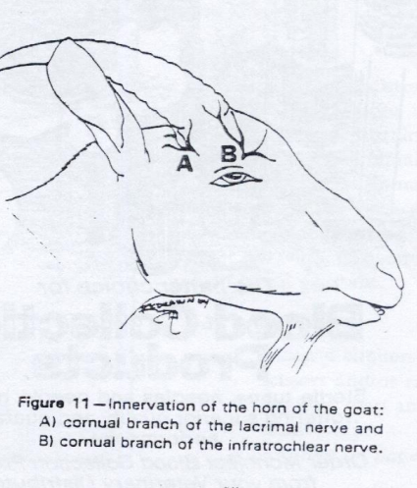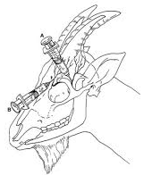

Surgical Procedure:
- Make elliptical incisions around the base of each horn (Cutting on the caudo-medial aspect to remove the skin)
- Ensure all the non-haired epithelium from the base of the horn is removed as this prevents regrowth
- Undermine the skin around the horn as close to the base as possible.
- Remove horn using a small saw or a Gigli wire. With the Gigli wire, pull and cut from a caudal to cranial aspect.
NB: The brain of the goat is located very close to the base of the horn
- Pull, twist and ligate the cornual artery
- Haemorrhage is controlled using haemostats (mosquito) or hot iron.
- Remove excess bone rostrally from around the frontal ridge because this ridge of bone will apply pressure to the skin that is pulled over it and result in pressure necrosis. Therefore, orthopaedic instruments (bone ronguers, bone cutting forceps) are utilized.
- Sterile saline is used to flush bone fragments and blood clots from the surgical site
- Close the incisions with a cruciate suture pattern so that there is no open skin would into the sinus.
- Non absorbable suture is used, such as #0 or #1 Nylon

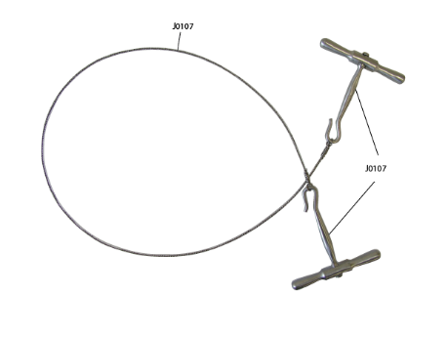Gigli Wire

Using Gigli wire:
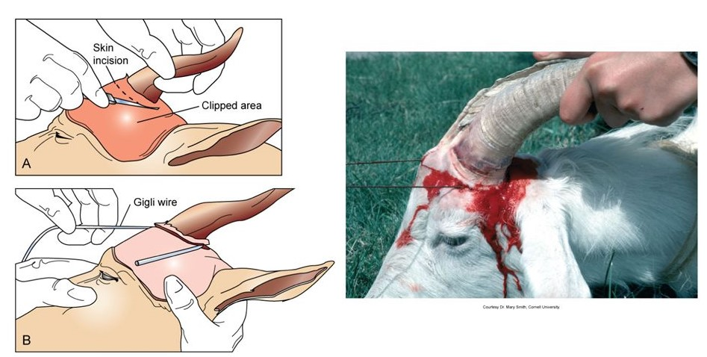
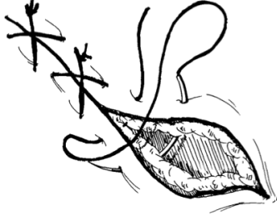Cruciate suture pattern

Post-Surgical Procedure:
- Spray a fly repellent and apply bandage for 2 weeks
- Keep head wrapped for a few days after the procedure to prevent contamination, infection and trauma caused by the goat
- Ensure animal is administered tetanus anti toxin and tetanus toxoid (at 2 different locations)
- Antibiotics is given to reduce the risk of infection
- Banamine is given to provide an analgesic effect (reduces the post operative pain) so the goat does not scratch at the suture.
- Veterinarian revisits after 2 weeks to remove sutures and inspect wound healing progress
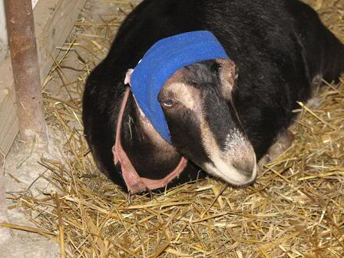 Bandaged head of goat

YouTube video: Surgical dehorning of goat using wire saw
(The language is not in English, however I found it helpful for visualization)
https://www.youtube.com/watch?v=mpSrKXQCjTg
References:
- Common surgical procedures in small ruminants (Proceedings) [Internet]. DVM 360. [cited 2020Sep27]. Available from: https://www.dvm360.com/view/common-surgical-procedures-small-ruminants-proceedings
- Ministry of Agriculture, Food and Rural Affairs [Internet]. Dehorning of Calves. [cited 2020Sep27]. Available from: http://www.omafra.gov.on.ca/english/livestock/dairy/facts/09-003.htm#:~
- Dehorning procedure with pictures [Internet]. The Goat Spot - Your Goat Raising & Owning Headquarters. [cited 2020Sep27]. Available from: https://www.thegoatspot.net/threads/dehorning-procedure-with-pictures.101583/

