**1. Methods of physical restraint**

|  |  |
| --- | --- |
| **Halter and lead rope: Minimum restraint required**   * A Physical Exam should never be attempted without a halter and lead rope in place with someone holding the horse. * Never wrap lead around your hand, arm or any other body part * Never tie a horse unless you know it is accustomed to being tied. |  |
| **Chain shank: for further restraint.**  The chain may be placed either:   1. **Through the mouth** and attached to the cheek ring on the opposite side, serving as a bit or bridle. If the mouth is jerked or otherwise injured by the chain, the animal will thereafter resist any bit. 2. **Over the bridge of the nose**. By gently tugging the shank, one can divert the animal’s attention. The pressure exerted tends to pull the nose down. | http://cal.vet.upenn.edu/projects/fieldservice/Equine/physexam/gumchn.jpghttp://cal.vet.upenn.edu/projects/fieldservice/Equine/eqrestr/nosech.jpg |
| **The twitch** = based on reaction to pressure applied to the lip causing discomfort thus, diverting attention from other procedures taking place on elsewhere on the horse.  **Application**:  Grasp the twitch and the cheek piece of the halter with the right hand. Place the fingers of the left hand partially through the loop of the twitch. Bring the left hand over the bridge of the nose and gently move it to the upper lip. Grab the lip firmly to prevent the horse from pulling away.  Once the fingers have a firm grasp of the nose, the rope or chain is brought over the lip and the right hand begins to twist the loop. Twist firmly to maintain a grip, but not so tightly that severe pain is felt, or the horse will resist by pulling away or even striking. It is important for the operator to maintain a grip on the handle with both hands or the handle may be pulled away |  |
| **The hand twitch:**   * A horse’s attention may be diverted by grasping a fold of skin at the shoulder. * Some horses will fight a twitch but can be restrained by applying pressure to one or both ears. | http://cal.vet.upenn.edu/projects/fieldservice/Equine/eqrestr/necktw.jpg |
| **Lifting a limb:**  The foreleg may be lifted by a rear or front approach. With the rear approach on a left foreleg, place the right shoulder against the horse’s left chest. Press the right forearm forward against the back of the knee and run the hand down the leg to grasp the pastern or cannon bone. When approaching from the front, pull the knee forward to make the horse lift its leg |  |
| **Stocks**  Very helpful for rectal exams and reproductive evaluations.  Not foolproof—horses may try to jump out or go down | |

**2. Estimation and measurement of body weight**

* 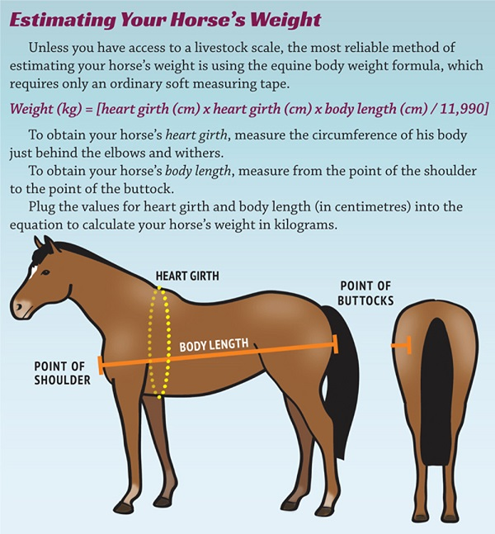**Weight Scale:** most accurate way to determine a horses weight.
* **Weight Tape:** is a simple and effective way to estimate a horses weight with minimal effort. Wrap the tape around the girth of the horse, directly below the elbow, overlapping the ends of the tape and read the resultant weight. Take the reading with the tape snugly in place when the horse exhales. Accuracy is dependant on the user, size of withers, breed and age.
* **Girth and body measurements:** using the girth measurement together with the length measurement in the following calculation:

**= (girth measurement in cm)2 x (length measurement in cm)  
                                        11,900**

***3. Lay equine terminology / 4. Identification of horses – notes from year 1 and 2 that I cannot be bothered to dig up.***

**5. Determination of normal ranges of basic clinical values (TPR)**

|  |  |  |
| --- | --- | --- |
| Temperature (oC) | 37.2 – 38.3 | Measure using a thermometer, apply lubricant and insert into the anus. Move the tip of the thermometer to the side of the colon wall (so you don’t get the temp of poo!) |
| Pulse (beats/min) | 30 – 40 | Measure using stethoscope of your fingers against the facial artery just under the jaw bone behind the cheek |
| Respiration (breaths/min) | 10 – 20 | Measure by counting either inhalation or exhalation. |
| CRT (seconds) | Less than 2 – 3 | Press your thumb against the gum and remove. |

**6. Routes and sites of drug administration**

The three best sites for intramuscular injection (IM) are:

1. 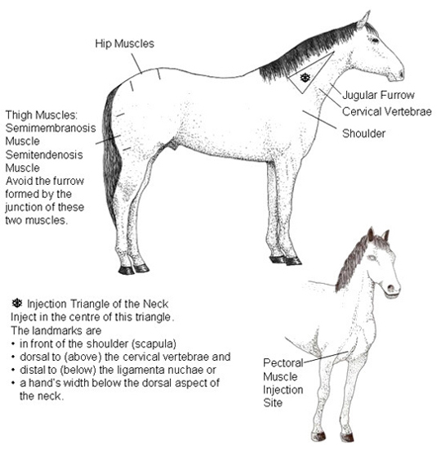**Neck:** Both sides. Ventral border is the dorsal aspect of the vertebral bodies, dorsal border is nuchal ligament, caudal border is the cranial aspect of the scapula.
2. **Pectoral muscles**
3. **Semi-membranosis/semi-tendinosis** muscles

For subcutaneous injections (SQ) the skin along the side of the neck is a good place to use. Intravenous injections are given into the jugular vein.

**7. Blood sample collection techniques**

The **jugular vein** is used most commonly for venipuncture and intravenous injection. The cranial 1/3 of the vein should be used, distal to the bifurcation. Alternative sites include the **transverse facial vein, lateral thoracic vein, cephalic, and femoral veins**.

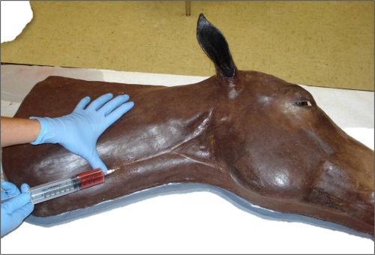

**8. Perform a distance exam concentrating on the following:**

Always stand back and look at the horse, assessing such parameters. Use **OBSERVED**

|  |  |  |
| --- | --- | --- |
| **O** | **Outline** | What does the overall appearance look like? Both from the side and behind: **Symmetry, Coat and Skin**, Bloating, Muscle mass, Abdominal shape |
| **B** | **Body Condition** | Determination of BCS see below for parameters |
| **S** | **Stance** | Is the horse standing normally? **This can be an indicator of pain = possibly Colic**. Observe for any sweating, quivering, flared nostrils, pawing, rolling, biting at the flank, kicking at the belly or stretching. |
| **E** | **Eating behaviour** | Is the horse interested in eating? |
| **R** | **Respiration** | How is the horse breathing? And nasal discharges? **Nostrils flared = Pain** |
| **V** | **Vaginal discharge** | Identify the absence or presence of vaginal discharge from the reproductive tract, the quality and character |
| **E** | **Eyes and Ears** | Are the **Eyes Bright or Dull**? **Position of Ears; Erect or droopy**? Evaluates attitude, demeanour and pain |
| **D** | **Defecation** | What does the manure look like? Define colour, consistency, contents |

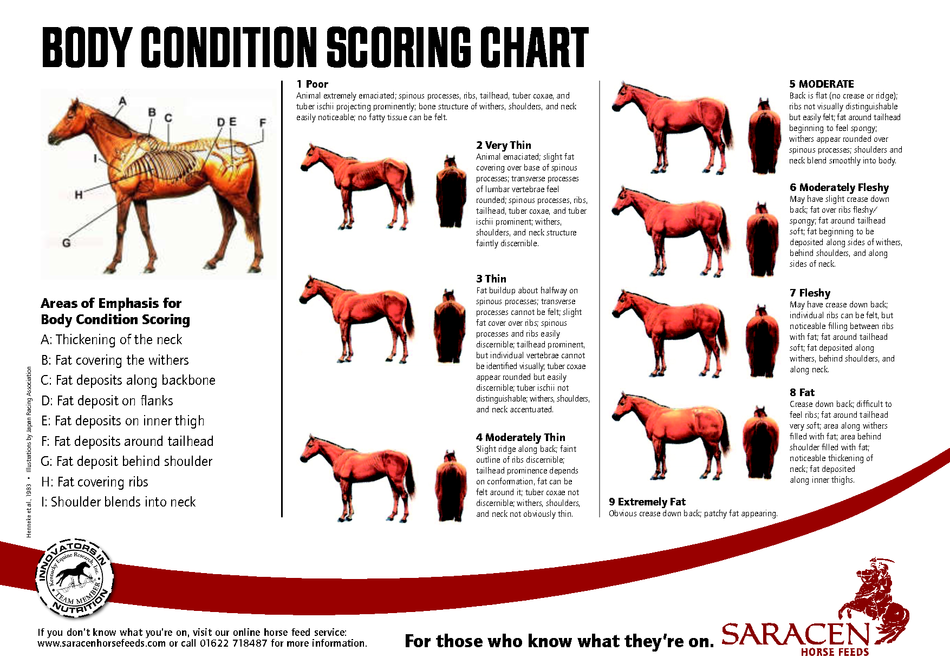

**9. Perform a physical exam concentrating on the following:**

**The physical examination of the horse may be either generalized or focused.** The **general physical examination** is an examination that will be performed when it is necessary to evaluate all organ systems with the intention of **detecting additional abnormalities that may potentially be remote from the primary problem**. Ex. horse with a severe bacT pneumonia may subsequently develop laminitis, although the animal may present for a cough, depression, and fever.

The **focused physical examination** is a physical examination in which an effort is made to detect the possible abnormalities that may be **associated with a certain organ system or that may be related to the differential diagnoses for a presenting complaint**. For example, the horse presenting with a cough will have a focus examination of the respiratory tract.

**Examining the horse from nose to tail along the left side and then tail to nose along the right side**

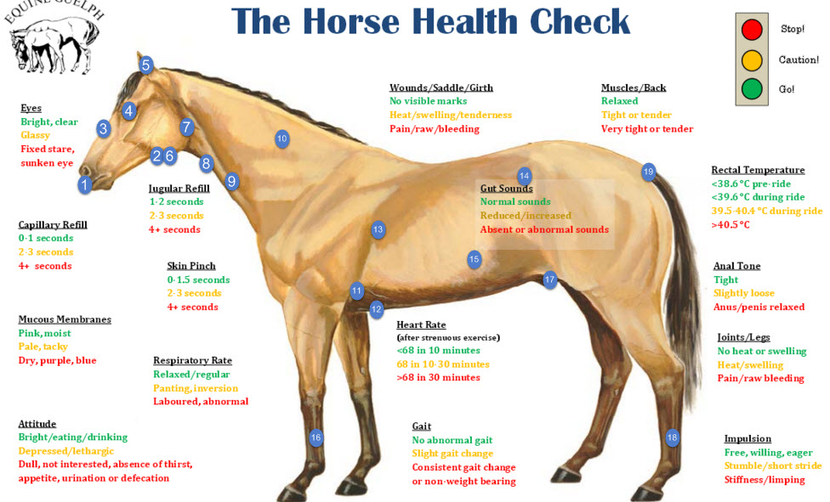

**Head:**

1. **Mouth and Nose:** 
   1. **Mucous membranes** = **(Cardio/Respiratory/GIT (colic))** by raising the upper lip = CPR, moistness, icterus, hyperemia, cyanosis, pallor, ulceration, and petechial.
   2. **Tongue** – grasped through the interdental space to evaluate for oral ulceration.
   3. 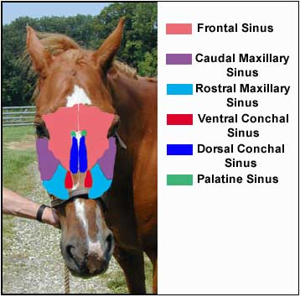**Check nostrils and mouth for odour – (Respiratory)** presence of bacterial infection
2. **Submandibular Lymph Nodes** in the intramandibular space for any enlargement of painful response.
3. **Percuss the sinuses = (Respiratory)** Resonance will be greatly increased if the tongue is held out of the mouth. Compare the resonance on both sides while also noting if the horse seems painful or objects to this procedure. Also check for facial symmetry, general attitude and expression.
4. **Eyes:** 
   1. **Sclera** = Icterus, petechia, vesicles, or injection by placing the thumb over the upper lid and grasping the bottom of the halter and rotating the horse’s head away to expose the sclera
   2. **Manice reflex (Neuro)** can be conducted to check for nervous signs

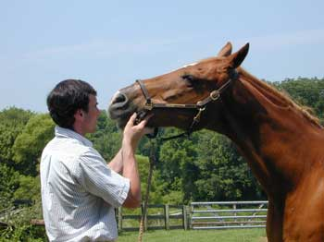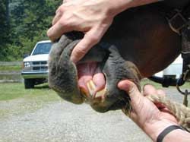 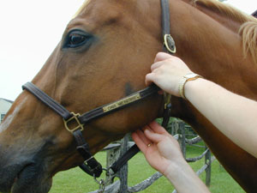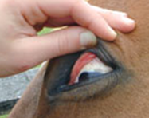

1. 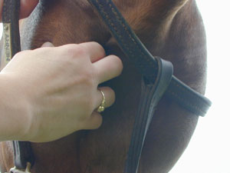**Ears** = slowly and gently palpate the ear for temperature if there is a suspicion that the horse may be in cardiovascular shock and experiencing poor peripheral perfusion, fungal infections.
2. **Facial artery = (Cardio)** Palpated at the ventral aspect of the mandible for pulse rate. Increased pulse = colic.

**Neck:**

1. **Palpate the dorsal aspect of the larynx** on both sides noting any asymmetry or muscle atrophy. If laryngeal hemiplegia is present the muscular process of the arytenoid cartilage may feel more pronounced with muscle atrophy
2. **Palpate the trachea** for any abnormalities such as irregular cartilage rings or fractures.
3. **Left jugular vein = (Cardio)** occlude and palpate to evaluate jugular fill, possible blockage to the heart if it remains distended.
4. **Skin tent =** on neck to evaluatehydration status

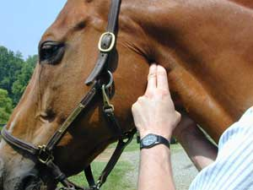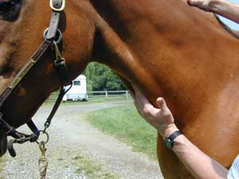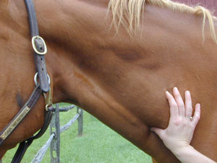

**Left side exam:**

1. **Heart is then auscultated** **on the left cranial ventral thorax**:
   1. **Pulmonary valve** (L - 3rd) space at costochondral junction
   2. **Aortic valve** (L - 4th) space just below level of shoulder
   3. **Mitral valve or Left AV** (L - 4th) space at level of olecranon
      1. *Note. On the right side =* ***Tricuspid valve/Right AV*** *(R - 3-4th) space between olecranon and costochondral junction*
2. **Ventral thorax midline** = Firm, upward pressure on midline to evaluate for ventral edema
3. **Auscultate the lungs = (Respiratory)** = Compare lungs sounds in the ventral, dorsal and mid thorax.

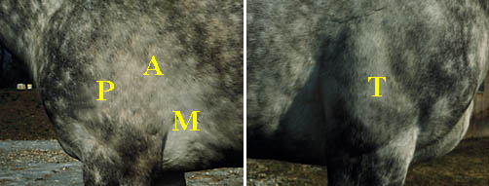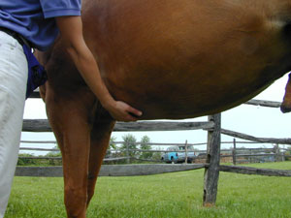 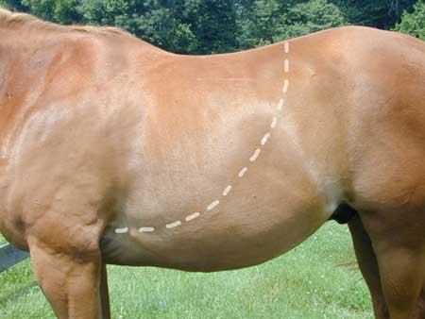

1. **Auscultate and Percuss the abdomin for GIT sounds = (GIT (colic))** = GIT motility. Note: Frequency, duration, intensity and location of intestinal sounds. You will be listening to the Cecum OR Ventral Colon. Mixing contractions are weak, low to moderately pitched and last 10-20 seconds. These sounds are present at any one site and have been described as equal to **10 contractions every 3-5 minutes**
   1. **L**eft Side = Distal left Ventral Co**L**on
   2. Right Side = Cecum and segments of the small colon
2. **Percuss the abdomen while ausculting** for high-pitched resonant sounds associated with gas-distended bowel.

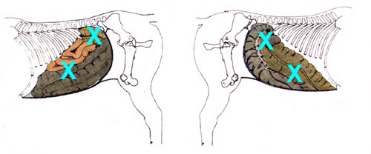

1. **The hand is then run down the forelimb** to evaluate temperature of the distal extremities if cardiovascular shock is a concern and also to palpate temperature of the hoof and evaluate digital pulses if laminitis is a concern.
2. **The inguinal area** is then carefully palpated to evaluate testicles in stallions, scrotal remnants in geldings, and the mammary gland in mares.
3. **Distal hind limbs** are visually inspected for joint effusion or distal limb edema

**The tail end:**

1. **Tail** = carefully raised from the side and rectal temperature taken. Note tail tone, anal reflexes and faecal staining and vaginal discharge.

**The process is then repeated to the right side. Remember areas of auscultation for the GIT, Lungs and Heart below:**

