Drug | Active ingredient | Uses | Contraindication | Adverse effects | Dose calculation
LIDOCAINE  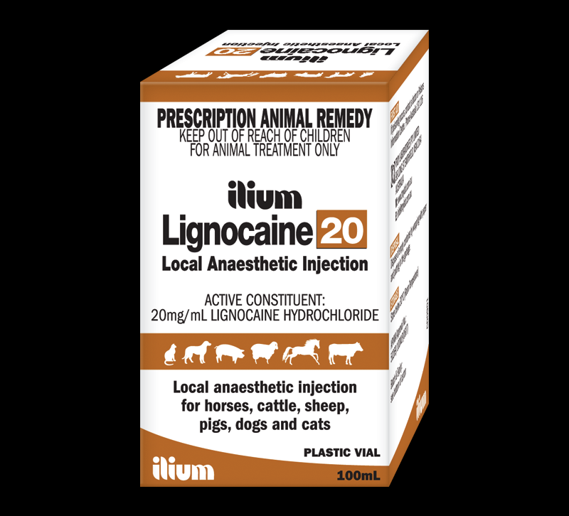 | Lidocaine hydrochloride (HCL) | a local and topical anaesthetic and is used to treat ventricular arrhythmias. | Used if immediate onset of action is needed but has the shortest duration (1-2 hours) is the only local anaesthetic that can be administered as an IV CRI | Weakness, recumbency, excitability, muscle tremors, and convulsions | Weight of horse: 500kg  Dose: 0.22mg/kg  Concentration: 20 mg/ml  Volume (ml) =Dose (mg/kg) x Weight(kg)  Concentration (mg/ml)  = (0.22 x 500)/20  = 5.5 ml
MEPIVACAINE  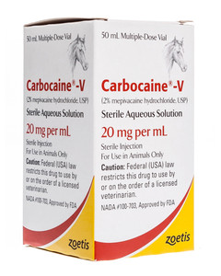 | Mepivacaine hydrochloride (HCL) | Used for infiltration, nerve blocking, intra-articular and epidural anaesthesia for horses | has a longer duration of action than lidocaine (2-3 hours) and is recommended for longer surgeries than that of lidocaine. Causes less tissue irritation less vasoconstriction and less occurrences of oedema than lidocaine | Weakness, recumbency, excitability, muscle tremors, and convulsions | Weight of horse: 500kg  Dose: 0.2mg/kg  Concentration: 20 mg/ml  Volume (ml) =Dose (mg/kg) x Weight(kg)  Concentration (mg/ml)  = (0.14 x 500)/20  =5ml
BUPIVACAINE  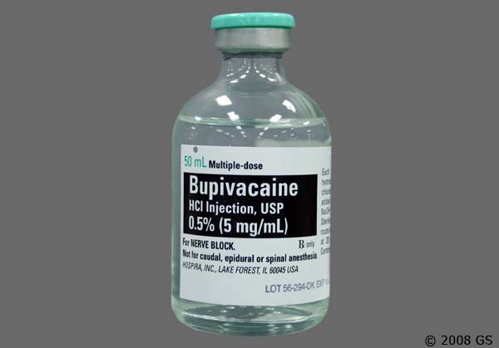 | Bupivacaine hydrochloride (HCL) | Used for infiltration, nerve blocking, intra-articular and epidural anaesthesia for horses | has the longest duration of action (2-3 hours) of these three local anaesthetic drugs and is recommended for any surgery lasting longer than 30–60 minutes. | Weakness, recumbency, excitability, muscle tremors, and convulsions | Weight of horse: 500kg  Dose: 0.06mg/kg  Concentration: 15 mg/ml  Volume (ml) =Dose (mg/kg) x Weight(kg)  Concentration (mg/ml)  = (0.06 x 500)/ 15  =2 ml

https://veteriankey.com/sedation-and-analgesia-in-the-standing-horse/
https://www.zoetisus.com/products/horses/carbocaine-v.aspx
https://equimed.com/drugs-and-medications/reference/mepivacaine-hydrochloride

