General anatomy of scrotum and testes
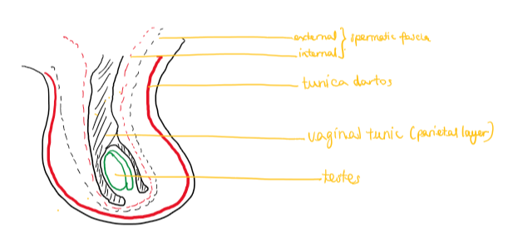

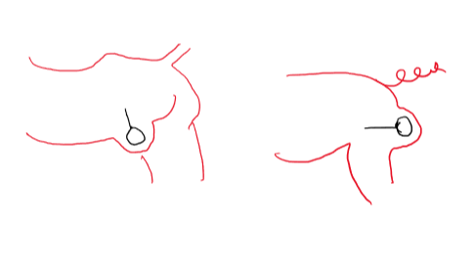
comparison between boar and bull testes positions

bull – inguinal boar - perineal

