Inguinal hernia repair
An inguinal hernia occurs when a defect permits intestines or other abdominal organs to pass into the inguinal canal. This is a result of an abnormally large and patent vaginal ring that allows free communication between the vaginal tunic and peritoneal cavities. If the organs protrude into the scrotum it is termed a scrotal hernia a more exaggerated form of the defect.
Prior to castration, animals with such a disorder must undergo surgery to repair. This is to prevent a reoccurrence of the hernia after castration or to avoid offspring from being predisposed to hernias. The surgical repair is as follow:
- The pig was restrained in dorsal recumbency
- The hernia was located by palpation and the area (inguinal and scrotal) was scrubbed using an antiseptic solution
- An oblique incision was made above the inguinal ring, penetrating the subcutaneous layer
- The tunica vaginalis is also isolated using a blunt dissection but is left intact to keep the intestine contained.
- While external pressure is put on the scrotum, the tunics are gently pulled free from their scrotal attachment.
- The tunic and testis are then twisted to force the intestines into the peritoneal cavity). The tunics and spermatic cord are then transfixated as close to the superficial inguinal ring as possible.
- The tunic and cord are cut, and the superficial inguinal ring is closed using a horizontal mattress sutures (an interrupted mattress suture could have also been used)
- The herniorrhaphy site is checked by applying external pressure on the abdomen.
- The opposite inguinal ring is checked for possible bilateral herniation before performing a castration.
Note: If the surgery was done to repair a large hernia in which marked serum accumulation in the scrotum is expected, an incision in the most ventral aspect of the scrotum should be performed to provide ventral drainage. If intestinal adhesion and incarceration are observed during surgical correction, the vaginal tunic should be opened and the intestine dissected free or an intestinal resection and end-to-end anastomosis performed. If an inguinal hernia occurs after castration, one needs to clean and lavage the herniated bowel, enlarge the vaginal and superficial inguinal ring, and replace the prolapsed intestine (if it is judged still viable) before suturing the superficial inguinal ring closed.

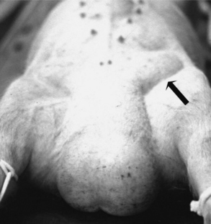

Castration
- The incision made to repair the hernia was used to retrieve one of the testicles from the scrotum
- The spermatic cord and vaginal tunic are twisted until there is compression. The cord was then severed using a scalpel (roughly 1cm distal to the ligature)
- The same is done with the second testicle
- Some antibiotics are applied to the wound and the wound was left open.
Note: In some cases, the wound is closed using a simple continuous pattern to maintain asepsis
- The animal is observed for 3 days for any complications

References
- https://www.ncbi.nlm.nih.gov/pmc/articles/PMC5585944/
- http://www.carrsconsulting.com/thepig/disorders/reproductive/Surgerygeneral/surgerygeneralinthepig06.htm
- https://www.intechopen.com/books/theriogenology/immunocastration-as-alternative-to-surgical-castration-in-pigs

