Restraint

Restraints can be done in both Standing position and lateral recumbent position
Standing restraint
- Head of the animal is restraint using a nose tongs and the leg of which the digital amputation is going to be carried out on is lifted using ropes or a pulley system and then the leg is restrained using ropes by tying it to the side of the crush. The cattle given
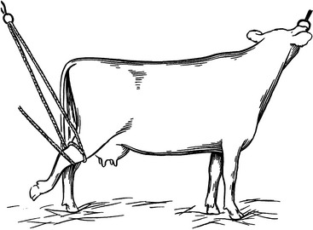

Recumbent animal:
- The animal is given a general anesthetic or the procedure is carried out in an animal that is under heavy sedation and has been cast.

Anesthesia
- A tourniquet is applied to the distal limb below the tarsus for hindlimbs and below the carpus for forelimbs.
  - The tourniquet also aids with hemostasis .
- Anesthetic options:
  - Intravenous regional anesthesia (intravenous injection of local anesthetic, such as lignocaine hydrochloride or Procaine Procaine) is then carried out once the limb has been surgically prepped.
    - 20ml of a 2% lignocaine hydrochloride solution is injected into the vein (generally the medial branch of the cephalic vein in the forelimb and the lateral branch of the saphenous vein in the hindlimb) using a 19 gauge needle.
    - Anesthesia commences at once and is complete within 10 minutes and may remain so for up to an hour with the tourniquet present. After releasing the tourniquet sensation returns to normal in approximately 5 minutes .

