Materials List:

Name of Material/ Instrument | Purpose | Picture
Rope + halter | For handling and moving the animal | 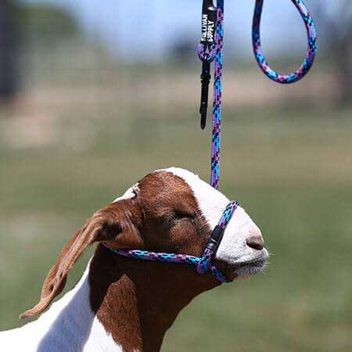
Spinal needle and 20G Needle + syringe | To administer drugs eg. Sedative | 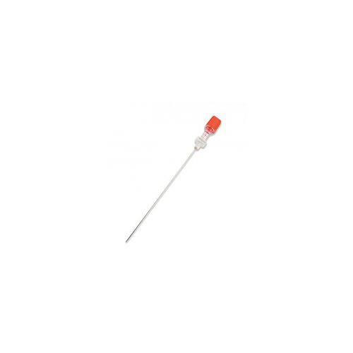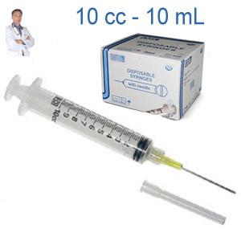
Suture material  Eg PDS (absorbable)  And nylon (non-absorbable) | For suturing skin and ligating blood vessels | 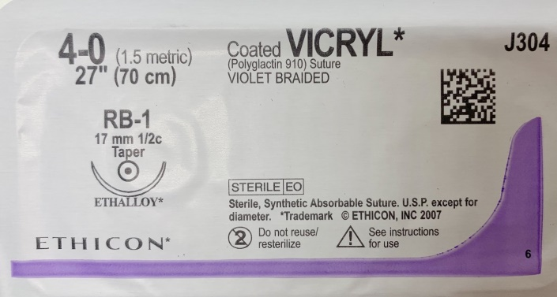
Basic Surgical Pack including:  - Scalpel blade + handle  - Haemostats  - Tissue forceps  - Towel clamps | To perform the mastectomy | 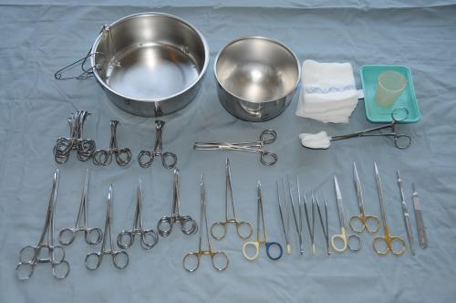
Penrose drain | a  Allows for drainage of blood and other fluids from the surgical site that would delay wound healing a | kefj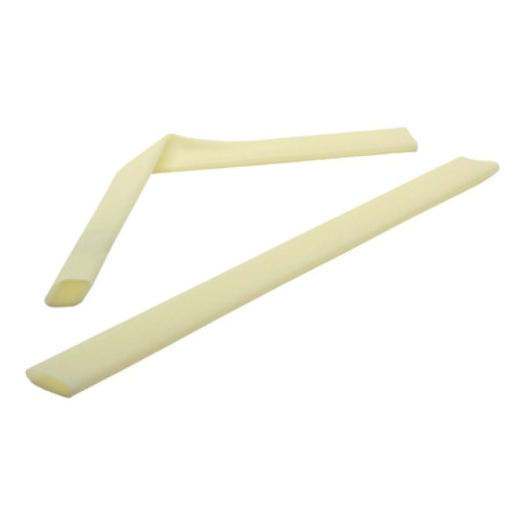
 | Cl
Clippers | t Clips hairs from on and around the surgical site in order to prepare the skin for sterile surgery
Galley pot | Small stainless steel pots for holding solutions | 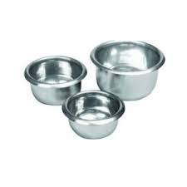
Sterile gauze | For surgical scrubbing as well as to absorb blood during surgery | 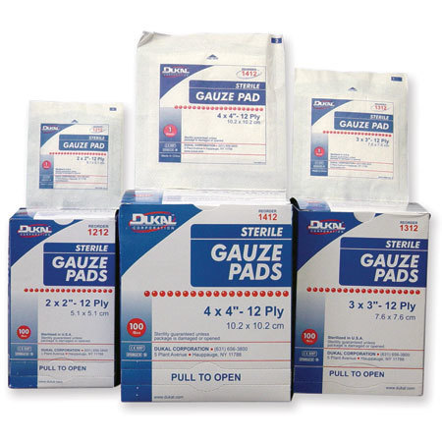
Chlorhexidine | For surgical scrubbing of hands and patient | jjjj 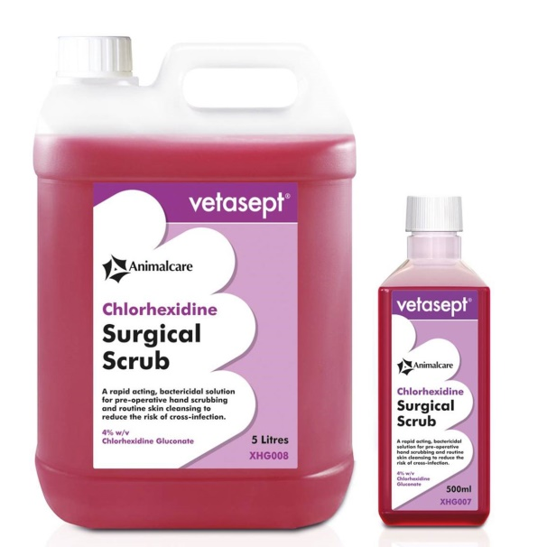
Povidone iodine | For aseptic preparation of thesurgical site | 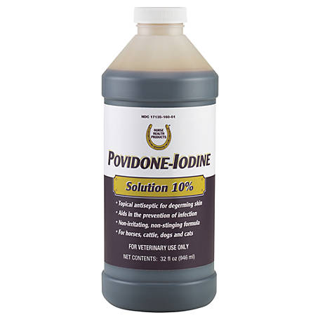
Sterile surgical drapes | For surgical preparation | 